**SUPPORTING INFORMATION**

**for**

**Computational Investigation of the Reactions of Sulfenic Acids with Amines, Thiols, and Thiolates**

Students and Ryan D. McCulla*

Department of Chemistry, Saint Louis University, St. Louis MO 63103, United States

*Corresponding author: phone: (314) 977-2850, E-mail: rmccull2@slu.edu

**ABSTRACT**

Biological sensor molecules of oxidative stress often rely on the oxidation of thiols to sulfenic acid intermediates. How this transformation induces a physiological response often relies on the fate of the sulfenic acid. Sulfenic acids will react with other biologically relevant nucleophiles such as amines, thiols, and thiolates. Additionally, in the presence of excess oxidants the sulfenic acid can be further oxidized. The free energy of reaction (∆G) and free energies of activation (∆G‡) were determined for the reaction of sulfenic acid with amines, thiols, and thiolates. The methods employed included B3LYP, B3P86, HF, M06-2X, and MP2. The effect of electronics on these reaction was examined by varying the substituents on the sulfenic acid and nucleophiles. For all the reactions, a front-side approach of the sulfenic acid by the nucleophiles was observed.

**Table S1.** Comparison of computed sulfenic acid geometries of 2,6-methylbenzene sulfenic acid (**1M**) to geometries from the crystal structure of (**1**).

|  |  |  |  |  |  |  |
| --- | --- | --- | --- | --- | --- | --- |
| Method | S–O (Å)a | ∆S–O (Å)b | S–C (Å)a | ∆S–C (Å)b | C–S–O (˚)c | ∆C–S–O (˚)b |
| Crystal Structure of **1**1e | 1.679 |  | 1.770 |  | 100.3 |  |
| HF/6-31G | 1.765 | 0.086 | 1.838 | 0.068 | 100.4 | 0.1 |
| HF/6-31G(d) | 1.662 | -0.017 | 1.782 | 0.012 | 102.3 | 2.0 |
| HF/6-31G** | 1.660 | -0.019 | 1.782 | 0.012 | 102.3 | 2.0 |
| HF/6-31++G | 1.768 | 0.089 | 1.837 | 0.067 | 100.0 | -0.3 |
| HF/6-311++G** | 1.659 | -0.020 | 1.782 | 0.012 | 102.1 | 1.8 |
| HF/6-311G(d,p) | 1.659 | -0.020 | 1.782 | 0.012 | 102.1 | 1.8 |
| HF/6-311G(df,p) | 1.645 | -0.034 | 1.781 | 0.011 | 102.3 | 2.0 |
| HF/6-311++G (2d,2p) | 1.651 | -0.028 | 1.780 | 0.010 | 102.4 | 2.1 |
| HF/6-311+G (2df,p) | 1.641 | -0.038 | 1.777 | 0.007 | 102.5 | 2.2 |
| MP2/6-31G | 1.837 | 0.158 | 1.862 | 0.092 | 100.2 | -0.1 |
| MP2/6-31G(d) | 1.702 | 0.023 | 1.776 | 0.006 | 101.6 | 1.3 |
| MP2/6-31G** | 1.701 | 0.022 | 1.776 | 0.006 | 101.5 | 1.2 |
| MP2/6-31++G | 1.849 | 0.170 | 1.858 | 0.088 | 98.9 | -1.4 |
| MP2/6-311++G** | 1.702 | 0.023 | 1.772 | 0.002 | 100.9 | 0.6 |
| MP2/6-311G(d,p) | 1.696 | 0.017 | 1.772 | 0.002 | 101.3 | 1.0 |
| MP2/6-311G(df,p) | 1.667 | -0.012 | 1.765 | -0.005 | 102.0 | 1.7 |
| MP2/6-311++G (2d,2p) | 1.698 | 0.019 | 1.774 | 0.004 | 101.5 | 1.2 |
| MP2/6-311+G(2df,p) | 1.680 | 0.001 | 1.766 | -0.004 | 101.8 | 1.5 |
| M06-2X/6-31G | 1.792 | 0.113 | 1.833 | 0.063 | 99.5 | -0.8 |
| M06-2X/6-31G(d) | 1.681 | 0.002 | 1.781 | 0.011 | 101.6 | 1.3 |
| M06-2X/6-31G** | 1.679 | 0.000 | 1.781 | 0.011 | 101.7 | 1.4 |
| M06-2X/6-31++G | 1.797 | 0.118 | 1.832 | 0.062 | 98.9 | -1.4 |
| M06-2X/6-311++G** | 1.685 | 0.006 | 1.781 | 0.011 | 101.2 | 0.9 |
| M06-2X/6-311G(d,p) | 1.683 | 0.004 | 1.781 | 0.011 | 101.2 | 0.9 |
| M06-2X/6-311G(df,p) | 1.670 | -0.009 | 1.779 | 0.009 | 101.6 | 1.3 |
| M06-2X/6-311++G (2d,2p) | 1.675 | -0.004 | 1.777 | 0.007 | 101.8 | 1.5 |
| M06-2X/6-311+G(2df,p) | 1.664 | -0.015 | 1.773 | 0.003 | 101.9 | 1.6 |
| B3LYP/6-31G | 1.829 | 0.150 | 1.849 | 0.079 | 101.1 | 0.8 |
| B3LYP/6-31G(d) | 1.707 | 0.028 | 1.790 | 0.02 | 103.1 | 2.8 |
| B3LYP/6-31G** | 1.705 | 0.026 | 1.790 | 0.02 | 103.1 | 2.8 |
| B3LYP/6-31++G | 1.838 | 0.159 | 1.847 | 0.077 | 100.3 | 0.0 |
| B3LYP/6-311++G** | 1.714 | 0.035 | 1.790 | 0.02 | 102.5 | 2.2 |
| B3LYP/6-311G(d,p) | 1.714 | 0.035 | 1.790 | 0.02 | 102.5 | 2.2 |
| B3LYP/6-311G(df,p) | 1.695 | 0.016 | 1.789 | 0.019 | 102.8 | 2.5 |
| B3LYP/6-311++G (2d,2p) | 1.702 | 0.023 | 1.786 | 0.016 | 102.9 | 2.6 |
| B3LYP/6-311+G(2df,p) | 1.689 | 0.010 | 1.782 | 0.012 | 103.0 | 2.7 |
| B3P86/6-31G | 1.814 | 0.135 | 1.834 | 0.064 | 100.9 | 0.6 |
| B3P86/6-31G(d) | 1.692 | 0.013 | 1.777 | 0.007 | 103.0 | 2.7 |
| B3P86/6-31G** | 1.692 | 0.013 | 1.776 | 0.006 | 103.0 | 2.7 |
| B3P86/6-31++G | 1.821 | 0.142 | 1.833 | 0.063 | 100.2 | -0.1 |
| B3P86/6-311++G** | 1.696 | 0.017 | 1.776 | 0.006 | 102.4 | 2.1 |
| B3P86/6-311G(d,p) | 1.696 | 0.017 | 1.776 | 0.006 | 102.4 | 2.1 |
| B3P86/6-311G(df,p) | 1.680 | 0.001 | 1.774 | 0.004 | 102.7 | 2.4 |
| B3P86/6-311++G (2d,2p) | 1.686 | 0.007 | 1.772 | 0.002 | 102.9 | 2.6 |
| B3P86/6-311+G(2df,p) | 1.674 | -0.005 | 1.768 | -0.002 | 103.0 | 2.7 |

a Bond lengths for the sulfenic acid. b Difference between computed and crystal structure geometries (i.e. computed value – experimental value). c C–S–O bond angle for the sulfenic acid. d Average difference between the crystal structure and computed and crystal structure geometries expressed as a percentage. e crystal structure data from Goto, K.; Holler, M.; Okazaki, R., *J. Am. Chem. Soc.* **1997**, *119*, 1460.

**Table S2.** Comparison of computed sulfenic acid geometries of 2,6-diphenylbenzene sulfenic acid to geometries from the crystal structure of 3,5-bis(2,6-diisopropylphenyl)phenyl sulfenic acid (**1**).

|  |  |  |  |  |  |  |
| --- | --- | --- | --- | --- | --- | --- |
| Method | S–O (Å)a | ∆S–O (Å)b | S–C (Å)a | ∆S–C (Å)b | C–S–O (˚)c | ∆C–S–O (˚)b |
| Crystal Structure of **2**1e | 1.5590 |  | 1.7790 |  | 106.8 |  |
| HF/6-31G | 1.7572 | 0.1982 | 1.8426 | 0.0636 | 99.98 | -6.82 |
| HF/6-31G(d) | 1.6517 | 0.0927 | 1.7883 | 0.0093 | 102.05 | -4.75 |
| HF/6-31G** | 1.6500 | 0.0910 | 1.7879 | 0.0089 | 102.09 | -4.71 |
| HF/6-31++G | 1.7592 | 0.2002 | 1.8400 | 0.0610 | 99.52 | -7.28 |
| HF/6-311++G** | 1.6550 | 0.0960 | 1.7840 | 0.0050 | 101.82 | -4.98 |
| HF/6-311G(d,p) | 1.6576 | 0.0986 | 1.7812 | 0.0022 | 102.13 | -4.67 |
| HF/6-311G(df,p) | 1.6354 | 0.0764 | 1.7855 | 0.0065 | 102.43 | -4.37 |
| HF/6-311++G (2d,2p) | 1.6400 | 0.0810 | 1.7860 | 0.0070 | 102.25 | -4.55 |
| HF/6-311+G (2df,p) | 1.6297 | 0.0707 | 1.7824 | 0.0034 | 102.36 | -4.44 |
| MP2/6-31G | 1.8248 | 0.2658 | 1.8710 | 0.0920 | 99.59 | -7.21 |
| MP2/6-31G(d) | 1.6889 | 0.1299 | 1.7836 | 0.0046 | 101.4 | -5.4 |
| MP2/6-31G** | 1.6881 | 0.1291 | 1.7832 | 0.0042 | 101.4 | -5.4 |
| MP2/6-31++G | 1.8390 | 0.2800 | 1.8670 | 0.0880 | 98.61 | -8.19 |
| MP2/6-311++G** | 1.6954 | 0.1364 | 1.7808 | 0.0018 | 100.29 | -6.51 |
| MP2/6-311G(d,p) | 1.6831 | 0.1241 | 1.7778 | -0.0012 | 101.37 | -5.43 |
| MP2/6-311G(df,p) | 1.6566 | 0.0976 | 1.7714 | -0.0076 | 102.01 | -4.79 |
| MP2/6-311++G (2d,2p) | 1.6840 | 0.1250 | 1.7830 | 0.0040 | 101.46 | -5.34 |
| MP2/6-311+G(2df,p) | 1.6663 | 0.1073 | 1.7745 | -0.0045 | 101.82 | -4.98 |
| M06-2X/6-31G | 1.7827 | 0.2237 | 1.8445 | 0.0655 | 99.22 | -7.58 |
| M06-2X/6-31G(d) | 1.6670 | 0.1080 | 1.7903 | 0.0113 | 101.99 | -4.81 |
| M06-2X/6-31G** | 1.6649 | 0.1059 | 1.7895 | 0.0105 | 102.03 | -4.77 |
| M06-2X/6-31++G | 1.7869 | 0.2279 | 1.8445 | 0.0655 | 98.78 | -8.02 |
| M06-2X/6-311++G** | 1.6700 | 0.1110 | 1.7890 | 0.0100 | 101.61 | -5.19 |
| M06-2X/6-311G(d,p) | 1.6690 | 0.1100 | 1.7887 | 0.0097 | 101.71 | -5.09 |
| M06-2X/6-311G(df,p) | 1.6562 | 0.0972 | 1.7867 | 0.0077 | 102.10 | -4.7 |
| M06-2X/6-311++G (2d,2p) | 1.6600 | 0.1010 | 1.7860 | 0.0070 | 101.95 | -4.85 |
| M06-2X/6-311+G(2df,p) | 1.6505 | 0.0915 | 1.7821 | 0.0031 | 102.07 | -4.73 |
| B3LYP/6-31G | 1.8212 | 0.2622 | 1.8587 | 0.0797 | 99.86 | -6.94 |
| B3LYP/6-31G(d) | 1.7080 | 0.1490 | 1.7920 | 0.0130 | 103.99 | -2.81 |
| B3LYP/6-31G** | 1.6865 | 0.1275 | 1.7988 | 0.0198 | 103.05 | -3.75 |
| B3LYP/6-31++G | 1.8220 | 0.2630 | 1.8570 | 0.0780 | 99.85 | -6.95 |
| B3LYP/6-311++G** | 1.6960 | 0.1370 | 1.7980 | 0.0190 | 102.25 | -4.55 |
| B3LYP/6-311G(d,p) | 1.6924 | 0.1334 | 1.7976 | 0.0186 | 102.65 | -4.15 |
| B3LYP/6-311G(df,p) | 1.6776 | 0.1186 | 1.7959 | 0.0169 | 103.02 | -3.78 |
| B3LYP/6-311++G (2d,2p) | 1.6840 | 0.1250 | 1.7950 | 0.0160 | 102.69 | -4.11 |
| B3LYP/6-311+G(2df,p) | 1.6721 | 0.1131 | 1.7897 | 0.0107 | 102.85 | -3.95 |
| B3P86/6-31G | 1.8055 | 0.2465 | 1.8438 | 0.0648 | 99.78 | -7.02 |
| B3P86/6-31G(d) | 1.6751 | 0.1161 | 1.7854 | 0.0064 | 102.87 | -3.93 |
| B3P86/6-31G** | 1.6726 | 0.1136 | 1.7845 | 0.0055 | 102.93 | -3.87 |
| B3P86/6-31++G | 1.804 | 0.2450 | 1.842 | 0.0630 | 99.88 | -6.92 |
| B3P86/6-311++G** | 1.6791 | 0.1201 | 1.7831 | 0.0041 | 102.28 | -4.52 |
| B3P86/6-311G(d,p) | 1.6771 | 0.1181 | 1.7824 | 0.0034 | 102.6 | -4.2 |
| B3P86/6-311G(df,p) | 1.6634 | 0.1044 | 1.7805 | 0.0015 | 102.92 | -3.88 |
| B3P86/6-311++G (2d,2p) | 1.6838 | 0.1248 | 1.7946 | 0.0156 | 102.69 | -4.11 |
| B3P86/6-311+G(2df,p) | 1.6572 | 0.0982 | 1.7751 | -0.0039 | 102.82 | -3.98 |

a Bond lengths for the sulfenic acid. b Difference between computed and crystal structure geometries expressed as percentage i.e. (100 x (computed value – experimental value)/experimental value). c C–S–O bond angle for the sulfenic acid. d Average difference between the crystal structure and computed structure for all reported parameters. e crystal structure data from Goto, K.; Shimada, K.; Furukawa, S.; Miyasaka, S.; Takahashi, Y.; Kawashima, T. *Chemistry Letters* **2006**, *35*, 862.

**Table S3.** Matrix of average percent difference between the crystal structure of and computed structure for all reported sulfenic acid geometric parameters (S–O Å, S–C Å, and C–S–O ˚) for all computational methods.a

|  |  |  |  |  |  |  |  |
| --- | --- | --- | --- | --- | --- | --- | --- |
|  | HF | MP2 | M06-2X | B3LYP | B3P86 |  | Average for basis setc |
| 6-31G | 3.03 | 4.90 | 3.67 | 4.73 | 4.08 |  | 4.08 |
| 6-31G(d) | 1.23 | 1.00 | 0.68 | 1.85 | 1.27 |  | 1.21 |
| 6-31G(d,p) | 1.27 | 0.94 | 0.66 | 1.82 | 1.25 |  | 1.19 |
| 6-31++G | 3.10 | 5.50 | 3.95 | 4.64 | 4.02 |  | 4.24 |
| 6-311++G(d,p) | 1.23 | 0.71 | 0.63 | 1.79 | 1.14 |  | 1.10 |
| 6-311G(d,p) | 1.22 | 0.69 | 0.60 | 1.79 | 1.14 |  | 1.09 |
| 6-311G(df,p) | 1.56 | 0.91 | 0.79 | 1.50 | 0.92 |  | 1.14 |
| 6-311++G (2d,2p) | 1.46 | 0.87 | 0.70 | 1.62 | 1.03 |  | 1.14 |
| 6-311+G(2df,p) | 1.61 | 0.59 | 0.88 | 1.32 | 1.03 |  | 1.09 |
|  |  |  |  |  |  |  |  |
| Average for methodc | 1.75 | 1.79 | 1.40 | 2.34 | 1.76 |  |  |

a percent difference determined by the following formula (100 x (computed value – experimental value)/experimental value)) for the S–O bond length, S–C bond length, and C–S–O bond angle. b Value of the average percent difference for all three geometric parameters. c  Mean of average percent difference for all three geometric parameters for the basis set for all methods considered. d Mean of average percent difference for all three geometric parameters for the method for all basis sets considered.

**REACTANT AND PRODUCT OPTIMIZED GEOMETRIES AND ENERGIES**

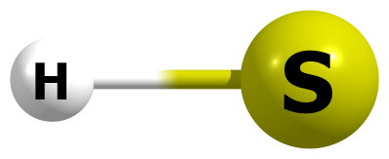

HF/6-311+G(2df,p)

S 0.000000000 0.000000000 0.078590000

H 0.000000000 0.000000000 -1.257432000

HF=-398.1377256

Zero-point correction= 0.006286

Thermal correction to Energy= 0.008647

Thermal correction to Enthalpy= 0.009591

Thermal correction to Gibbs Free Energy= -0.011547

Sum of electronic and zero-point Energies= -398.131439

Sum of electronic and thermal Energies= -398.129079

Sum of electronic and thermal Enthalpies= -398.128134

Sum of electronic and thermal Free Energies= -398.149273

Frequencies -- 2759.4483

|  |  |
| --- | --- |
| Method | Energy |
| Gas-MP2/aug-ccpV(T+d)z | -398.3465749 |
| Gas-M062X/aug-ccpV(T+d)z | -398.8243251 |
| PCM-Water-MP2/aug-ccpV(T+d)z | -398.453134 |
| PCM-Water-M062X/aug-ccpV(T+d)z | -398.931632 |

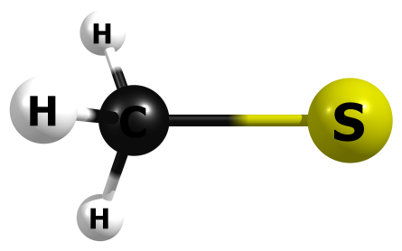

HF/6-311+G(2df,p)

S -0.706224000 0.000000000 0.000001000

C 1.122372000 0.000005000 -0.000015000

H 1.521780000 0.906583000 -0.450932000

H 1.521781000 -0.062700000 1.010508000

H 1.521786000 -0.843905000 -0.559502000

HF=-437.1666831

Zero-point correction= 0.038185 (Hartree/Particle)

Thermal correction to Energy= 0.041194

Thermal correction to Enthalpy= 0.042138

Thermal correction to Gibbs Free Energy= 0.014610

Sum of electronic and zero-point Energies= -437.128498

Sum of electronic and thermal Energies= -437.125489

Sum of electronic and thermal Enthalpies= -437.124545

Sum of electronic and thermal Free Energies= -437.152073

Frequencies -- 750.7201 1012.4827 1012.6446

Frequencies -- 1440.7191 1594.8767 1594.9273

Frequencies -- 3096.5214 3128.9645 3129.2420

|  |  |
| --- | --- |
| Method | Energy |
| Gas-MP2/aug-ccpV(T+d)z | -437.5553673 |
| Gas-M062X/aug-ccpV(T+d)z | -438.1168508 |
| PCM-Water-MP2/aug-ccpV(T+d)z | -437.6601079 |
| PCM-Water-M062X/aug-ccpV(T+d)z | -438.2221841 |

M06-2X/6-311+G(2df,p)

S 0.707643000 -0.000003000 -0.000005000

C -1.123182000 -0.000019000 -0.000009000

H -1.527703000 0.925963000 -0.423332000

H -1.527893000 -0.829587000 -0.590062000

H -1.527600000 -0.096216000 1.013537000

HF=-438.1077763

Zero-point correction= 0.036271 (Hartree/Particle)

Thermal correction to Energy= 0.039324

Thermal correction to Enthalpy= 0.040269

Thermal correction to Gibbs Free Energy= 0.012676

Sum of electronic and zero-point Energies= -438.071505

Sum of electronic and thermal Energies= -438.068452

Sum of electronic and thermal Enthalpies= -438.067508

Sum of electronic and thermal Free Energies= -438.095101

|  |  |
| --- | --- |
| Method | Energy |
| Gas-M062X/aug-ccpV(T+d)z | -438.1169114 |
| Water-(IEP-PCM)M062X/aug-ccpV(T+d)z | -438.222138 |

(IEP-PCM)M06-2X/6-311+G(2df,p)

S -0.708477000 -0.000014000 0.000009000

C 1.128123000 -0.000002000 -0.000027000

H 1.522459000 -0.796721000 -0.632656000

H 1.521922000 0.946689000 -0.373330000

H 1.522522000 -0.149725000 1.006000000

HF=-438.2135574

Zero-point correction= 0.036800 (Hartree/Particle)

Thermal correction to Energy= 0.039847

Thermal correction to Enthalpy= 0.040791

Thermal correction to Gibbs Free Energy= 0.013204

Sum of electronic and zero-point Energies= -438.176758

Sum of electronic and thermal Energies= -438.173711

Sum of electronic and thermal Enthalpies= -438.172766

Sum of electronic and thermal Free Energies= -438.200354

|  |  |
| --- | --- |
| Method | Energy |
| Gas-M062X/aug-ccpV(T+d)z | -438.1168664 |
| Water-(IEP-PCM)M062X/aug-ccpV(T+d)z | -438.2222026 |

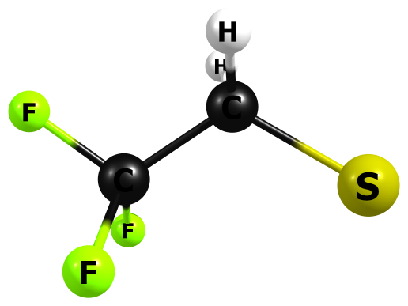

HF/6-311+G(2df,p)

C -0.749910000 0.006391000 -0.000211000

F -0.886763000 -0.766019000 1.060488000

F -1.836589000 0.797725000 -0.001194000

F -0.886830000 -0.768970000 -1.058421000

C 0.505654000 0.834572000 -0.000668000

H 0.420761000 1.473699000 0.873180000

H 0.421153000 1.473042000 -0.874931000

S 2.069704000 -0.084821000 -0.000052000

HF=-772.9305027

Zero-point correction= 0.045923 (Hartree/Particle)

Thermal correction to Energy= 0.051365

Thermal correction to Enthalpy= 0.052310

Thermal correction to Gibbs Free Energy= 0.015864

Sum of electronic and zero-point Energies= -772.884580

Sum of electronic and thermal Energies= -772.879137

Sum of electronic and thermal Enthalpies= -772.878193

Sum of electronic and thermal Free Energies= -772.914638

Frequencies -- 116.0867 201.6091 374.6834

Frequencies -- 381.3799 576.4537 586.2449

Frequencies -- 685.9300 838.2587 910.8325

Frequencies -- 940.3650 1187.4572 1195.4726

Frequencies -- 1380.5866 1414.4636 1441.1050

Frequencies -- 1591.9853 3151.4143 3183.3273

|  |  |
| --- | --- |
| Method | Energy |
| Gas-MP2/aug-ccpV(T+d)z | -774.2443564 |
| Gas-M062X/aug-ccpV(T+d)z | -775.230037 |
| PCM-Water-MP2/aug-ccpV(T+d)z | -774.3381204 |
| PCM-Water-M062X/aug-ccpV(T+d)z | -775.3238713 |

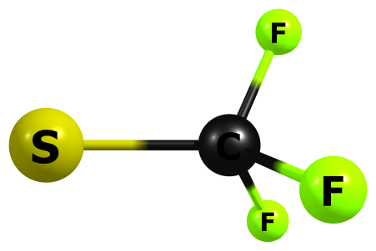

HF/6-311+G(2df,p)

C 0.264233000 0.000553000 -0.000215000

F 0.825870000 -0.278584000 1.186162000

F 0.824219000 -0.889944000 -0.833815000

F 0.826910000 1.167092000 -0.352674000

S -1.492400000 0.000601000 0.000265000

HF=-733.8936146

Zero-point correction= 0.015536 (Hartree/Particle)

Thermal correction to Energy= 0.019716

Thermal correction to Enthalpy= 0.020660

Thermal correction to Gibbs Free Energy= -0.012496

Sum of electronic and zero-point Energies= -733.878078

Sum of electronic and thermal Energies= -733.873899

Sum of electronic and thermal Enthalpies= -733.872955

Sum of electronic and thermal Free Energies= -733.906111

Frequencies -- 369.8540 370.2420 513.9846

Frequencies -- 593.5622 594.3753 816.7907

Frequencies -- 1166.5181 1166.9994 1227.2927

|  |  |
| --- | --- |
| Method | Energy |
| Gas-MP2/aug-ccpV(T+d)z | -735.0322735 |
| Gas-M062X/aug-ccpV(T+d)z | -735.9349546 |
| PCM-Water-MP2/aug-ccpV(T+d)z | -735.1226146 |
| PCM-Water-M062X/aug-ccpV(T+d)z | -736.0253799 |

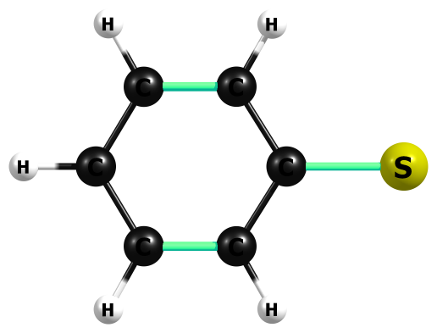

HF/6-311+G(2df,p)

C 0.164259000 1.188317000 -0.000012000

C -0.581738000 -0.000002000 -0.000022000

C 1.543974000 1.186962000 -0.000007000

H 2.070689000 2.127505000 0.000008000

C 0.164259000 -1.188317000 -0.000012000

C 2.257932000 0.000000000 0.000024000

H -0.367831000 -2.121770000 -0.000014000

H 3.333796000 0.000001000 0.000043000

C 1.543976000 -1.186960000 -0.000007000

H 2.070691000 -2.127504000 0.000008000

H -0.367834000 2.121768000 -0.000014000

S -2.330967000 0.000000000 0.000012000

HF=-627.7549571

Zero-point correction= 0.095284 (Hartree/Particle)

Thermal correction to Energy= 0.100497

Thermal correction to Enthalpy= 0.101441

Thermal correction to Gibbs Free Energy= 0.065723

Sum of electronic and zero-point Energies= -627.659673

Sum of electronic and thermal Energies= -627.654460

Sum of electronic and thermal Enthalpies= -627.653516

Sum of electronic and thermal Free Energies= -627.689234

Frequencies -- 188.9202 313.4931 445.4662

Frequencies -- 459.7797 535.3544 674.0997

Frequencies -- 756.6571 757.6074 804.6040

Frequencies -- 931.9159 977.9883 1062.2460

Frequencies -- 1072.5043 1083.6983 1110.6822

Frequencies -- 1148.8055 1183.0231 1193.3086

Frequencies -- 1274.9188 1291.0915 1434.1922

Frequencies -- 1569.9466 1610.3444 1714.0712

Frequencies -- 1736.9204 3265.5180 3274.1039

Frequencies -- 3306.1464 3321.5417 3325.7748

|  |  |
| --- | --- |
| Method | Energy |
| Gas-MP2/aug-ccpV(T+d)z | -628.9240621 |
| Gas-M062X/aug-ccpV(T+d)z | -629.8740359 |
| PCM-Water-MP2/aug-ccpV(T+d)z | -629.015161 |
| PCM-Water-M062X/aug-ccpV(T+d)z | -629.9657565 |

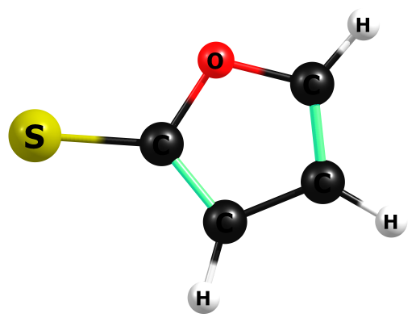

HF/6-311+G(2df,p)

C -0.158048000 -1.877972000 0.000000000

O -0.861770000 -0.731389000 0.000000000

C 0.000000000 0.316294000 0.000000000

C 1.265818000 -0.185016000 0.000000000

C 1.152385000 -1.613642000 0.000000000

H -0.718758000 -2.787558000 0.000000000

H 2.158903000 0.401616000 0.000000000

H 1.942544000 -2.338100000 0.000000000

S -0.628091000 1.921073000 0.000000000

HF=-625.691533

Zero-point correction= 0.063684 (Hartree/Particle)

Thermal correction to Energy= 0.068200

Thermal correction to Enthalpy= 0.069145

Thermal correction to Gibbs Free Energy= 0.035208

Sum of electronic and zero-point Energies= -625.627849

Sum of electronic and thermal Energies= -625.623333

Sum of electronic and thermal Enthalpies= -625.622388

Sum of electronic and thermal Free Energies= -625.656325

Frequencies -- 246.0533 340.1209 517.8402

Frequencies -- 659.2296 729.4243 781.7067

Frequencies -- 828.4599 959.5233 964.8354

Frequencies -- 988.1027 1074.4567 1165.6212

Frequencies -- 1193.5967 1255.3389 1310.1666

Frequencies -- 1506.8364 1582.1421 1704.5134

Frequencies -- 3349.5247 3391.7702 3404.7750

|  |  |
| --- | --- |
| Method | Energy |
| Gas-MP2/aug-ccpV(T+d)z | -626.7741245 |
| Gas-M062X/aug-ccpV(T+d)z | -627.669545 |
| PCM-Water-MP2/aug-ccpV(T+d)z | -626.8679318 |
| PCM-Water-M062X/aug-ccpV(T+d)z | -627.7638471 |

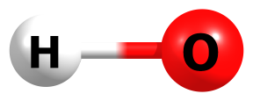

HF/6-311+G(2df,p)

O 0.000000000 0.000000000 0.104950000

H 0.000000000 0.000000000 -0.839597000

HF=-75.4068015

Zero-point correction= 0.009242 (Hartree/Particle)

Thermal correction to Energy= 0.011602

Thermal correction to Enthalpy= 0.012547

Thermal correction to Gibbs Free Energy= -0.006970

Sum of electronic and zero-point Energies= -75.397560

Sum of electronic and thermal Energies= -75.395199

Sum of electronic and thermal Enthalpies= -75.394255

Sum of electronic and thermal Free Energies= -75.413772

Frequencies -- 4056.7453

|  |  |
| --- | --- |
| Method | Energy |
| Gas-MP2/aug-ccpV(T+d)z | -75.7017817 |
| Gas-M062X/aug-ccpV(T+d)z | -75.7954821 |
| PCM-Water-MP2/aug-ccpV(T+d)z | -75.8295096 |
| PCM-Water-M062X/aug-ccpV(T+d)z | -75.9254621 |

M06-2X/6-311+G(2df,p)

O 0.000000000 0.000000000 0.107025000

H 0.000000000 0.000000000 -0.856198000

HF=-75.7857734

Zero-point correction= 0.008750 (Hartree/Particle)

Thermal correction to Energy= 0.011110

Thermal correction to Enthalpy= 0.012055

Thermal correction to Gibbs Free Energy= -0.007499

Sum of electronic and zero-point Energies= -75.777023

Sum of electronic and thermal Energies= -75.774663

Sum of electronic and thermal Enthalpies= -75.773719

Sum of electronic and thermal Free Energies= -75.793273

|  |  |
| --- | --- |
| Method | Energy |
| Gas-M062X/aug-ccpV(T+d)z | -75.7957796 |
| Water-(IEP-PCM)M062X/aug-ccpV(T+d)z | -75.9256943 |

(IEP-PCM)M06-2X/6-311+G(2df,p)

O 0.000000000 0.000000000 0.106787000

H 0.000000000 0.000000000 -0.854292000

HF=-75.9189952

Zero-point correction= 0.008867 (Hartree/Particle)

Thermal correction to Energy= 0.011228

Thermal correction to Enthalpy= 0.012172

Thermal correction to Gibbs Free Energy= -0.007378

Sum of electronic and zero-point Energies= -75.910128

Sum of electronic and thermal Energies= -75.907768

Sum of electronic and thermal Enthalpies= -75.906823

Sum of electronic and thermal Free Energies= -75.926373

|  |  |
| --- | --- |
| Method | Energy |
| Gas-M062X/aug-ccpV(T+d)z | -75.7957802 |
| Water-(IEP-PCM)M062X/aug-ccpV(T+d)z | -75.9257027 |

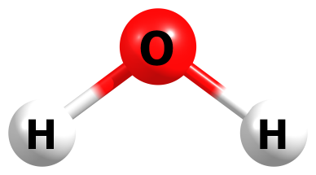

HF/6-311+G(2df,p)

O 0.000000000 0.000000000 0.112442000

H 0.000000000 0.755223000 -0.449770000

H 0.000000000 -0.755223000 -0.449770000

HF=-76.0552928

Zero-point correction= 0.023000 (Hartree/Particle)

Thermal correction to Energy= 0.025834

Thermal correction to Enthalpy= 0.026778

Thermal correction to Gibbs Free Energy= 0.005425

Sum of electronic and zero-point Energies= -76.032293

Sum of electronic and thermal Energies= -76.029459

Sum of electronic and thermal Enthalpies= -76.028514

Sum of electronic and thermal Free Energies= -76.049868

Frequencies -- 1729.8194 4131.2576 4234.6495

|  |  |
| --- | --- |
| Method | Energy |
| Gas-MP2/aug-ccpV(T+d)z | -76.3281562 |
| Gas-M062X/aug-ccpV(T+d)z | -76.4294502 |
| PCM-Water-MP2/aug-ccpV(T+d)z | -76.3345898 |
| PCM-Water-M062X/aug-ccpV(T+d)z | -76.4360528 |

M06-2X/6-311+G(2df,p)

O 0.000000000 0.000000000 0.116290000

H 0.000000000 0.763762000 -0.465159000

H 0.000000000 -0.763762000 -0.465159000

HF=-76.4229612

Zero-point correction= 0.021587 (Hartree/Particle)

Thermal correction to Energy= 0.024422

Thermal correction to Enthalpy= 0.025367

Thermal correction to Gibbs Free Energy= 0.003952

Sum of electronic and zero-point Energies= -76.401375

Sum of electronic and thermal Energies= -76.398539

Sum of electronic and thermal Enthalpies= -76.397595

Sum of electronic and thermal Free Energies= -76.419009

|  |  |
| --- | --- |
| Method | Energy |
| Gas-M062X/aug-ccpV(T+d)z | -76.4300912 |
| Water-(IEP-PCM)M062X/aug-ccpV(T+d)z | -76.4368315 |

(IEP-PCM)M06-2X/6-311+G(2df,p)

O 0.000000000 0.000000000 0.117263000

H 0.000000000 0.762101000 -0.469054000

H 0.000000000 -0.762101000 -0.469054000

HF=-76.4305837

Zero-point correction= 0.021473 (Hartree/Particle)

Thermal correction to Energy= 0.024309

Thermal correction to Enthalpy= 0.025253

Thermal correction to Gibbs Free Energy= 0.003831

Sum of electronic and zero-point Energies= -76.409111

Sum of electronic and thermal Energies= -76.406275

Sum of electronic and thermal Enthalpies= -76.405331

Sum of electronic and thermal Free Energies= -76.426753

|  |  |
| --- | --- |
| Method | Energy |
| Gas-M062X/aug-ccpV(T+d)z | -76.4300793 |
| Water-(IEP-PCM)M062X/aug-ccpV(T+d)z | -76.436843 |

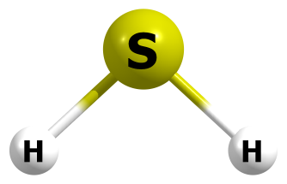

HF/6-311+G(2df,p)

S 0.000000000 0.000000000 0.100470000

H 0.000000000 0.972827000 -0.803761000

H 0.000000000 -0.972827000 -0.803761000

HF=-398.7067136

Zero-point correction= 0.016010 (Hartree/Particle)

Thermal correction to Energy= 0.018853

Thermal correction to Enthalpy= 0.019797

Thermal correction to Gibbs Free Energy= -0.003511

Sum of electronic and zero-point Energies= -398.690704

Sum of electronic and thermal Energies= -398.687861

Sum of electronic and thermal Enthalpies= -398.686917

Sum of electronic and thermal Free Energies= -398.710225

Frequencies -- 1317.4829 2850.4944 2859.5080

|  |  |
| --- | --- |
| Method | Energy |
| Gas-MP2/aug-ccpV(T+d)z | -398.9108834 |
| Gas-M062X/aug-ccpV(T+d)z | -399.388538 |
| PCM-Water-MP2/aug-ccpV(T+d)z | -398.9137795 |
| PCM-Water-M062X/aug-ccpV(T+d)z | -399.3913968 |

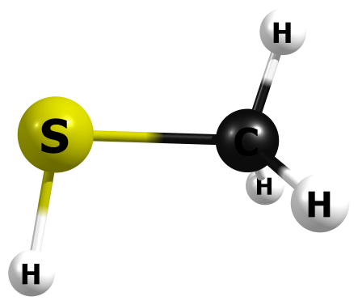

HF/6-311+G(2df,p)

S -0.658237000 -0.086648000 0.000005000

C 1.151998000 0.020679000 0.000007000

H 1.512451000 0.520923000 0.886707000

H 1.517779000 -0.996731000 -0.001158000

H 1.512168000 0.522848000 -0.885694000

H -0.922587000 1.215258000 0.000024000

HF=-437.7486318

Zero-point correction= 0.048711 (Hartree/Particle)

Thermal correction to Energy= 0.052235

Thermal correction to Enthalpy= 0.053179

Thermal correction to Gibbs Free Energy= 0.024553

Sum of electronic and zero-point Energies= -437.699921

Sum of electronic and thermal Energies= -437.696397

Sum of electronic and thermal Enthalpies= -437.695453

Sum of electronic and thermal Free Energies= -437.724079

Frequencies -- 255.3673 762.3307 855.7344

Frequencies -- 1056.7220 1195.4849 1484.5510

Frequencies -- 1590.5572 1605.4687 2840.7129

Frequencies -- 3190.0531 3271.0481 3273.7272

|  |  |
| --- | --- |
| Method | Energy |
| Gas-MP2/aug-ccpV(T+d)z | -438.1303699 |
| Gas-M062X/aug-ccpV(T+d)z | -438.6918279 |
| PCM-Water-MP2/aug-ccpV(T+d)z | -438.1336788 |
| PCM-Water-M062X/aug-ccpV(T+d)z | -438.6951095 |

M06-2X/6-311+G(2df,p)

S 0.047803000 -0.664235000 0.000000000

C 0.047803000 1.151171000 0.000000000

H -0.431349000 1.544242000 0.893131000

H 1.092868000 1.453921000 0.000000000

H -0.431349000 1.544242000 -0.893131000

H -1.281828000 -0.821668000 0.000000000

HF=-438.6816706

Zero-point correction= 0.046151 (Hartree/Particle)

Thermal correction to Energy= 0.049846

Thermal correction to Enthalpy= 0.050790

Thermal correction to Gibbs Free Energy= 0.021761

Sum of electronic and zero-point Energies= -438.635520

Sum of electronic and thermal Energies= -438.631825

Sum of electronic and thermal Enthalpies= -438.630880

Sum of electronic and thermal Free Energies= -438.659910

|  |  |
| --- | --- |
| Method | Energy |
| Gas-M062X/aug-ccpV(T+d)z | -438.6919775 |
| Water-(IEP-PCM)M062X/aug-ccpV(T+d)z | -438.6952096 |

(IEP-PCM)M06-2X/6-311+G(2df,p)

S -0.659431000 -0.087031000 0.000000000

C 1.153142000 0.019604000 0.000000000

H 1.510920000 0.525457000 0.892629000

H 1.518045000 -1.005171000 -0.000001000

H 1.510920000 0.525457000 -0.892629000

H -0.907834000 1.229124000 -0.000001000

HF=-438.6851176

Zero-point correction= 0.045517 (Hartree/Particle)

Thermal correction to Energy= 0.048624

Thermal correction to Enthalpy= 0.049569

Thermal correction to Gibbs Free Energy= 0.021656

Sum of electronic and zero-point Energies= -438.639601

Sum of electronic and thermal Energies= -438.636493

Sum of electronic and thermal Enthalpies= -438.635549

Sum of electronic and thermal Free Energies= -438.663461

|  |  |
| --- | --- |
| Method | Energy |
| Gas-M062X/aug-ccpV(T+d)z | -438. 6919593 |
| Water-(IEP-PCM)M062X/aug-ccpV(T+d)z | -438.6952166 |

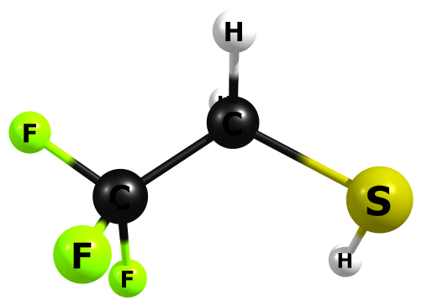

HF/6-311+G(2df,p)

C -0.799648000 0.004452000 0.002894000

F -0.901905000 -0.432982000 1.233795000

F -1.874172000 0.725392000 -0.249010000

F -0.835697000 -1.039065000 -0.796853000

C 0.438267000 0.840093000 -0.215944000

H 0.405773000 1.666985000 0.479228000

H 0.402551000 1.237692000 -1.219135000

S 1.995000000 -0.025628000 0.080797000

H 1.945918000 -0.841995000 -0.965933000

HF=-773.4884018

Frequencies -- 108.0163 197.5455 237.2221

Frequencies -- 384.1994 389.3400 581.2928

Frequencies -- 587.1412 694.1037 814.0977

Frequencies -- 873.1991 930.2187 1090.4366

Frequencies -- 1251.0710 1294.7757 1399.3377

Frequencies -- 1437.2759 1483.8498 1585.6466

Frequencies -- 2847.7650 3232.3991 3287.0253

Zero-point correction= 0.056284 (Hartree/Particle)

Thermal correction to Energy= 0.062259

Thermal correction to Enthalpy= 0.063203

Thermal correction to Gibbs Free Energy= 0.025804

Sum of electronic and zero-point Energies= -773.432117

Sum of electronic and thermal Energies= -773.426143

Sum of electronic and thermal Enthalpies= -773.425199

Sum of electronic and thermal Free Energies= -773.462598

|  |  |
| --- | --- |
| Method | Energy |
| Gas-MP2/aug-ccpV(T+d)z | -774.7958444 |
| Gas-M062X/aug-ccpV(T+d)z | -775.7799818 |
| PCM-Water-MP2/aug-ccpV(T+d)z | -774.8005428 |
| PCM-Water-M062X/aug-ccpV(T+d)z | -775.7848306 |

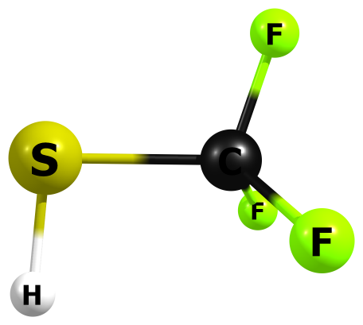

HF/6-311+G(2df,p)

C 0.360262000 0.001398000 -0.000035000

F 0.837655000 -0.614789000 -1.052724000

F 0.823617000 1.225052000 -0.000666000

F 0.837531000 -0.613436000 1.053470000

S -1.440369000 0.078774000 -0.000094000

H -1.604898000 -1.240207000 0.000995000

HF=-734.4274085

Zero-point correction= 0.025668 (Hartree/Particle)

Thermal correction to Energy= 0.030451

Thermal correction to Enthalpy= 0.031395

Thermal correction to Gibbs Free Energy= -0.002858

Sum of electronic and zero-point Energies= -734.401741

Sum of electronic and thermal Energies= -734.396958

Sum of electronic and thermal Enthalpies= -734.396014

Sum of electronic and thermal Free Energies= -734.430267

Frequencies -- 211.1374 337.2179 366.3523

Frequencies -- 493.5514 591.9528 598.6951

Frequencies -- 845.4700 1002.3220 1279.3112

Frequencies -- 1326.3675 1365.2767 2849.1738

|  |  |
| --- | --- |
| Method | Energy |
| Gas-MP2/aug-ccpV(T+d)z | -735.5588356 |
| Gas-M062X/aug-ccpV(T+d)z | -736.4599011 |
| PCM-Water-MP2/aug-ccpV(T+d)z | -735.5615936 |
| PCM-Water-M062X/aug-ccpV(T+d)z | -736.4627744 |

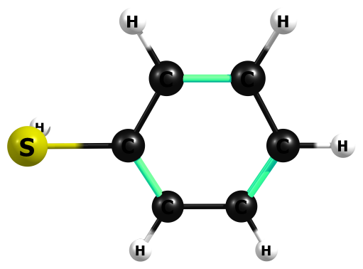

HF/6-311+G(2df,p)

C 0.201554000 1.196595000 -0.012396000

C -0.495161000 -0.000008000 -0.013463000

C 1.583279000 1.195614000 0.005669000

H 2.116614000 2.128229000 0.008793000

C 0.201548000 -1.196592000 -0.012403000

C 2.275549000 -0.000003000 0.015939000

H -0.337478000 -2.124634000 -0.026595000

H 3.349901000 0.000005000 0.027938000

C 1.583292000 -1.195607000 0.005690000

H 2.116617000 -2.128228000 0.008821000

H -0.337490000 2.124627000 -0.026584000

S -2.281092000 0.000008000 -0.072759000

H -2.511062000 -0.000122000 1.23756500

HF=-628.3112785

Zero-point correction= 0.105423 (Hartree/Particle)

Thermal correction to Energy= 0.111470

Thermal correction to Enthalpy= 0.112414

Thermal correction to Gibbs Free Energy= 0.074561

Sum of electronic and zero-point Energies= -628.205856

Sum of electronic and thermal Energies= -628.199809

Sum of electronic and thermal Enthalpies= -628.198865

Sum of electronic and thermal Free Energies= -628.236718

Frequencies -- 63.9172 192.8687 308.4646

Frequencies -- 439.7623 457.0565 504.7518

Frequencies -- 674.4803 755.3820 761.6394

Frequencies -- 822.1022 952.8239 1010.1611

Frequencies -- 1067.6451 1084.7018 1106.3426

Frequencies -- 1114.0133 1118.3661 1160.8218

Frequencies -- 1188.6328 1198.8049 1288.7387

Frequencies -- 1312.5757 1450.3660 1586.9905

Frequencies -- 1637.9939 1752.7670 1767.6268

Frequencies -- 2820.9955 3314.1457 3325.3090

Frequencies -- 3337.3684 3346.7157 3350.9568

|  |  |
| --- | --- |
| Method | Energy |
| Gas-MP2/aug-ccpV(T+d)z | -629.4685995 |
| Gas-M062X/aug-ccpV(T+d)z | -630.4188999 |
| PCM-Water-MP2/aug-ccpV(T+d)z | -629.4722767 |
| PCM-Water-M062X/aug-ccpV(T+d)z | -630.4227467 |

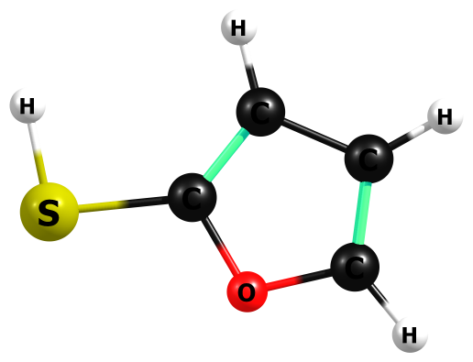

HF/6-311+G(2df,p)

C -1.772373000 -0.719524000 0.000016000

O -0.461945000 -1.039448000 0.000021000

C 0.226269000 0.103030000 -0.000002000

C -0.595759000 1.158613000 -0.000030000

C -1.925938000 0.603827000 -0.000004000

H -2.457677000 -1.537004000 0.000038000

H -0.317708000 2.190133000 -0.000064000

H -2.851956000 1.137784000 -0.000012000

S 1.967422000 -0.096923000 -0.000033000

H 2.250959000 1.199755000 0.000523000

HF=-626.239778

Zero-point correction= 0.073928 (Hartree/Particle)

Thermal correction to Energy= 0.079208

Thermal correction to Enthalpy= 0.080152

Thermal correction to Gibbs Free Energy= 0.044513

Sum of electronic and zero-point Energies= -626.165850

Sum of electronic and thermal Energies= -626.160571

Sum of electronic and thermal Enthalpies= -626.159626

Sum of electronic and thermal Free Energies= -626.195265

Frequencies -- 109.2893 241.6773 300.5253

Frequencies -- 510.2763 651.5206 720.3832

Frequencies -- 843.2682 903.3269 969.2941

Frequencies -- 990.1176 1001.5585 1029.3731

Frequencies -- 1089.0011 1183.0717 1225.7263

Frequencies -- 1300.2614 1361.5232 1522.7612

Frequencies -- 1655.8664 1743.8369 2859.2296

Frequencies -- 3393.2458 3406.9234 3438.5976

|  |  |
| --- | --- |
| Method | Energy |
| Gas-MP2/aug-ccpV(T+d)z | -627.3120045 |
| Gas-M062X/aug-ccpV(T+d)z | -628.2081891 |
| PCM-Water-MP2/aug-ccpV(T+d)z | -627.3165047 |
| PCM-Water-M062X/aug-ccpV(T+d)z | -628.2128108 |

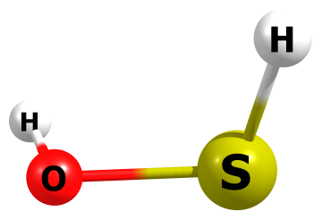

HF/6-311+G(2df,p)

S -0.566143000 -0.088701000 0.010986000

H -0.859881000 1.210699000 0.002181000

H 1.449034000 0.043085000 0.742270000

O 1.058642000 0.020680000 -0.115028000

HF=-473.5646069

Zero-point correction= 0.024492 (Hartree/Particle)

Thermal correction to Energy= 0.027642

Thermal correction to Enthalpy= 0.028587

Thermal correction to Gibbs Free Energy= 0.001066

Sum of electronic and zero-point Energies= -473.540115

Sum of electronic and thermal Energies= -473.536964

Sum of electronic and thermal Enthalpies= -473.536020

Sum of electronic and thermal Free Energies= -473.563541

Frequencies -- 497.4243 879.1720 1130.0354

Frequencies -- 1291.7893 2804.4100 4147.8060

|  |  |
| --- | --- |
| Method | Energy |
| Gas-MP2/aug-ccpV(T+d)z | -474.011308 |
| Gas-M062X/aug-ccpV(T+d)z | -474.5918791 |
| PCM-Water-MP2/aug-ccpV(T+d)z | -474.0166748 |
| PCM-Water-M062X/aug-ccpV(T+d)z | -474.5973172 |

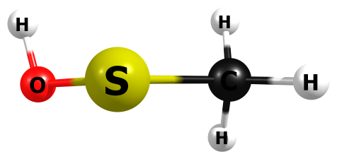

HF/6-311+G(2df,p)

S -0.101419000 -0.596407000 0.011139000

C 1.372758000 0.421976000 0.001078000

H 1.422101000 1.059666000 0.873562000

H 2.212395000 -0.263880000 0.016721000

H 1.414588000 1.016570000 -0.900735000

O -1.263034000 0.548741000 -0.114520000

H -1.558655000 0.808367000 0.741923000

HF=-512.6141433

Zero-point correction= 0.055665 (Hartree/Particle)

Thermal correction to Energy= 0.059978

Thermal correction to Enthalpy= 0.060922

Thermal correction to Gibbs Free Energy= 0.029331

Sum of electronic and zero-point Energies= -512.558478

Sum of electronic and thermal Energies= -512.554166

Sum of electronic and thermal Enthalpies= -512.553221

Sum of electronic and thermal Free Energies= -512.584812

Frequencies -- 209.8839 325.0438 396.9156

Frequencies -- 762.3031 876.5345 1055.1250

Frequencies -- 1061.7875 1277.4205 1476.5914

Frequencies -- 1568.4060 1600.1946 3170.9578

Frequencies -- 3248.3032 3262.8413 4141.9260

|  |  |
| --- | --- |
| Method | Energy |
| Gas-MP2/aug-ccpV(T+d)z | -513.2404797 |
| Gas-M062X/aug-ccpV(T+d)z | -513.904244 |
| PCM-Water-MP2/aug-ccpV(T+d)z | -513.2462864 |
| PCM-Water-M062X/aug-ccpV(T+d)z | -513.9101508 |

M06-2X/6-311+G(2df,p)

S -0.092357000 -0.606725000 0.011200000

C 1.367242000 0.435683000 0.002030000

H 1.437670000 1.039206000 0.905988000

H 2.221217000 -0.242289000 -0.043666000

H 1.364760000 1.069495000 -0.883175000

O -1.274050000 0.553298000 -0.117424000

H -1.556998000 0.800708000 0.768873000

HF=-513.8890638

Zero-point correction= 0.052586 (Hartree/Particle)

Thermal correction to Energy= 0.057036

Thermal correction to Enthalpy= 0.057980

Thermal correction to Gibbs Free Energy= 0.026108

Sum of electronic and zero-point Energies= -513.836478

Sum of electronic and thermal Energies= -513.832028

Sum of electronic and thermal Enthalpies= -513.831084

Sum of electronic and thermal Free Energies= -513.862956

|  |  |
| --- | --- |
| Method | Energy |
| Gas-M062X/aug-ccpV(T+d)z | -513.9049518 |
| Water-(IEP-PCM)M062X/aug-ccpV(T+d)z | -513.9108994 |

(IEP-PCM)M06-2X/6-311+G(2df,p)

S -0.089917000 -0.605181000 0.013398000

C 1.368629000 0.437223000 -0.001637000

H 1.414814000 1.059374000 0.890279000

H 2.221357000 -0.243451000 -0.012393000

H 1.384887000 1.048826000 -0.901880000

O -1.284045000 0.543568000 -0.118343000

H -1.521792000 0.846266000 0.766195000

HF=-513.8954467

Zero-point correction= 0.052528 (Hartree/Particle)

Thermal correction to Energy= 0.056963

Thermal correction to Enthalpy= 0.057907

Thermal correction to Gibbs Free Energy= 0.026094

Sum of electronic and zero-point Energies= -513.842918

Sum of electronic and thermal Energies= -513.838484

Sum of electronic and thermal Enthalpies= -513.837539

Sum of electronic and thermal Free Energies= -513.869353

|  |  |
| --- | --- |
| Method | Energy |
| Gas-M062X/aug-ccpV(T+d)z | -513.9049182 |
| Water-(IEP-PCM)M062X/aug-ccpV(T+d)z | -513.9109937 |

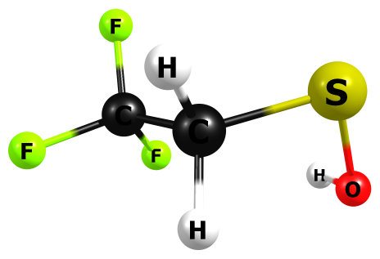

HF/6-311+G(2df,p)

C 1.076697000 0.023281000 0.009643000

F 0.807708000 1.267717000 -0.331711000

F 2.149107000 0.051411000 0.772125000

F 1.391860000 -0.624167000 -1.087027000

C -0.074068000 -0.622872000 0.743000000

H -0.198864000 -0.134540000 1.699192000

H 0.179770000 -1.661638000 0.913059000

S -1.636435000 -0.604056000 -0.136984000

O -2.142625000 0.911654000 0.170249000

H -1.810800000 1.510752000 -0.478837000

HF= -848.3542467

Zero-point correction= 0.063099 (Hartree/Particle)

Thermal correction to Energy= 0.070032

Thermal correction to Enthalpy= 0.070976

Thermal correction to Gibbs Free Energy= 0.030960

Sum of electronic and zero-point Energies= -848.291148

Sum of electronic and thermal Energies= -848.284214

Sum of electronic and thermal Enthalpies= -848.283270

Sum of electronic and thermal Free Energies= -848.323287

Frequencies -- 73.4027 117.0645 192.4670

Frequencies -- 293.4118 387.9453 416.5877

Frequencies -- 450.3489 582.6170 585.5576

Frequencies -- 701.0830 823.9898 886.9539

Frequencies -- 923.9271 965.6148 1217.1092

Frequencies -- 1289.1321 1303.4880 1393.7928

Frequencies -- 1429.3751 1472.8749 1564.1828

Frequencies -- 3217.6724 3277.1847 4131.5488

|  |  |
| --- | --- |
| Method | Energy |
| Gas-MP2/aug-ccpV(T+d)z | -849.9063756 |
| Gas-M062X/aug-ccpV(T+d)z | -850.9931613 |
| PCM-Water-MP2/aug-ccpV(T+d)z | -849.9124027 |
| PCM-Water-M062X/aug-ccpV(T+d)z | -850.9993487 |

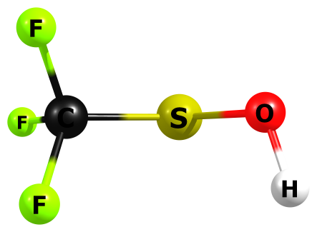

HF/6-311+G(2df,p)

C -0.646642000 -0.037243000 0.002630000

F -0.798830000 -0.884910000 -0.986508000

F -0.896301000 -0.687457000 1.106771000

F -1.532420000 0.918692000 -0.127748000

S 0.980929000 0.737114000 -0.008696000

O 1.893539000 -0.592213000 0.115948000

H 2.084624000 -0.949584000 -0.736856000

HF=-809.291196

Zero-point correction= 0.032770 (Hartree/Particle)

Thermal correction to Energy= 0.038537

Thermal correction to Enthalpy= 0.039481

Thermal correction to Gibbs Free Energy= 0.002524

Sum of electronic and zero-point Energies= -809.258426

Sum of electronic and thermal Energies= -809.252659

Sum of electronic and thermal Enthalpies= -809.251715

Sum of electronic and thermal Free Energies= -809.288672

Frequencies -- 91.9694 201.7680 347.3308

Frequencies -- 379.8335 460.0461 523.3824

Frequencies -- 597.8541 622.3762 845.6510

Frequencies -- 907.1251 1292.6577 1297.8885

Frequencies -- 1336.2405 1356.8149 4123.5172

|  |  |
| --- | --- |
| Method | Energy |
| Gas-MP2/aug-ccpV(T+d)z | -810.6661611 |
| Gas-M062X/aug-ccpV(T+d)z | -811.669979 |
| PCM-Water-MP2/aug-ccpV(T+d)z | -810.6708039 |
| PCM-Water-M062X/aug-ccpV(T+d)z | -811.6748011 |

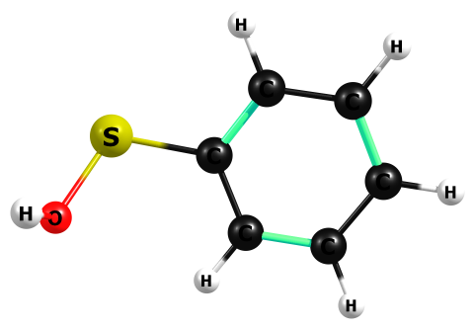

HF/6-311+G(2df,p)

C -0.723072000 -1.251269000 0.102389000

C 0.135451000 -0.186557000 -0.103748000

C -2.087582000 -1.035571000 0.179013000

H -2.749145000 -1.868005000 0.332903000

C -0.372480000 1.099393000 -0.212412000

C -2.593310000 0.244208000 0.083556000

H 0.293672000 1.924296000 -0.376805000

H -3.651477000 0.413658000 0.157658000

C -1.730623000 1.310766000 -0.103885000

H -2.119724000 2.309465000 -0.179776000

H -0.329130000 -2.245091000 0.210345000

S 1.863662000 -0.520377000 -0.297409000

O 2.544184000 0.762729000 0.446362000

H 2.613446000 0.604065000 1.373832000

HF=-703.1760124

Zero-point correction= 0.112592 (Hartree/Particle)

Thermal correction to Energy= 0.119509

Thermal correction to Enthalpy= 0.120454

Thermal correction to Gibbs Free Energy= 0.079637

Sum of electronic and zero-point Energies= -703.063420

Sum of electronic and thermal Energies= -703.056503

Sum of electronic and thermal Enthalpies= -703.055559

Sum of electronic and thermal Free Energies= -703.096375

Frequencies -- 20.3646 156.9319 243.7074

Frequencies -- 349.5216 420.2001 445.8134

Frequencies -- 477.2845 550.0663 673.1767

Frequencies -- 759.4211 765.7493 837.3922

Frequencies -- 878.9878 950.0950 1034.8280

Frequencies -- 1080.2080 1102.9414 1114.1319

Frequencies -- 1116.6369 1163.8083 1190.3644

Frequencies -- 1200.6268 1284.3862 1289.9079

Frequencies -- 1318.3441 1455.9134 1588.2906

Frequencies -- 1638.4023 1752.7220 1768.8774

Frequencies -- 3313.3429 3322.1432 3332.7199

Frequencies -- 3343.8065 3353.3659 4127.8739

|  |  |
| --- | --- |
| Method | Energy |
| Gas-MP2/aug-ccpV(T+d)z | -704.579322 |
| Gas-M062X/aug-ccpV(T+d)z | -705.6320132 |
| PCM-Water-MP2/aug-ccpV(T+d)z | -704.5852684 |
| PCM-Water-M062X/aug-ccpV(T+d)z | -705.6381831 |

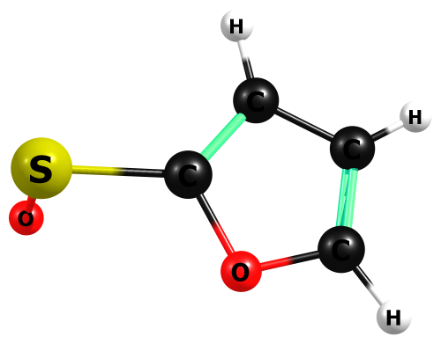

HF/6-311+G(2df,p)

C -2.054580000 -0.782479000 0.026133000

O -0.773000000 -1.017683000 -0.236143000

C -0.122074000 0.161671000 -0.160832000

C -0.989794000 1.141714000 0.137194000

C -2.273888000 0.518708000 0.257291000

H -2.705722000 -1.629328000 0.018050000

H -0.747358000 2.175758000 0.256499000

H -3.210241000 0.979837000 0.486283000

S 1.570865000 0.227370000 -0.523213000

O 2.250444000 -0.434775000 0.807513000

H 2.351939000 0.217794000 1.480898000

HF=-701.1078338

Zero-point correction= 0.081273 (Hartree/Particle)

Thermal correction to Energy= 0.087350

Thermal correction to Enthalpy= 0.088294

Thermal correction to Gibbs Free Energy= 0.050426

Sum of electronic and zero-point Energies= -701.026560

Sum of electronic and thermal Energies= -701.020484

Sum of electronic and thermal Enthalpies= -701.019540

Sum of electronic and thermal Free Energies= -701.057408

Frequencies -- 87.1658 148.0390 304.0821

Frequencies -- 367.1404 428.6668 538.8449

Frequencies -- 658.6380 741.0110 863.2543

Frequencies -- 868.0928 971.4160 980.4189

Frequencies -- 1010.1590 1024.9037 1088.8487

Frequencies -- 1191.7325 1233.8424 1277.7114

Frequencies -- 1286.9313 1347.0176 1527.4259

Frequencies -- 1621.5716 1743.7904 3395.0707

Frequencies -- 3408.3648 3426.1560 4134.5978

|  |  |
| --- | --- |
| Method | Energy |
| Gas-MP2/aug-ccpV(T+d)z | -702.4264991 |
| Gas-M062X/aug-ccpV(T+d)z | -703.4232207 |
| PCM-Water-MP2/aug-ccpV(T+d)z | -702.4334963 |
| PCM-Water-M062X/aug-ccpV(T+d)z | -703.4305885 |

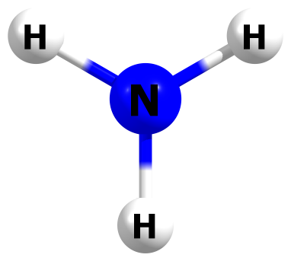

HF/6-311+G(2df,p)

N 0.000000000 0.000000000 0.000001000

H 0.000000000 0.854289000 0.493199000

H 0.000000000 -0.854289000 0.493199000

H 0.000000000 0.000000000 -0.986406000

HF=-56.2089861

Zero-point correction= 0.034751 (Hartree/Particle)

Thermal correction to Energy= 0.037588

Thermal correction to Enthalpy= 0.038532

Thermal correction to Gibbs Free Energy= 0.016434

Sum of electronic and zero-point Energies= -56.174235

Sum of electronic and thermal Energies= -56.171398

Sum of electronic and thermal Enthalpies= -56.170454

Sum of electronic and thermal Free Energies= -56.192552

Frequencies -- -861.7010 1699.5027 1699.5205

Frequencies -- 3809.1468 4022.7971 4023.0159

|  |  |
| --- | --- |
| Method | Energy |
| Gas-MP2/aug-ccpV(T+d)z | -56.4522309 |
| Gas-M062X/aug-ccpV(T+d)z | -56.5450766 |
| PCM-Water-MP2/aug-ccpV(T+d)z | -56.4561074 |
| PCM-Water-M062X/aug-ccpV(T+d)z | -56.5488196 |

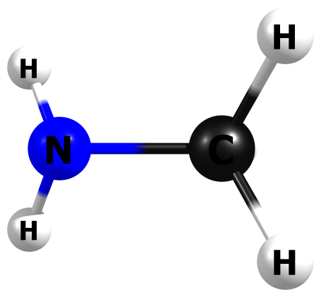

HF/6-311+G(2df,p)

N 0.742378000 0.000098000 -0.115565000

C -0.702691000 0.000048000 0.016598000

H -1.060851000 -0.001862000 1.045768000

H -1.109570000 0.873997000 -0.478455000

H -1.108943000 -0.872804000 -0.480776000

H 1.149471000 -0.806222000 0.311005000

H 1.149394000 0.805917000 0.311826000

HF=-95.2498861

Zero-point correction= 0.067898 (Hartree/Particle)

Thermal correction to Energy= 0.071267

Thermal correction to Enthalpy= 0.072212

Thermal correction to Gibbs Free Energy= 0.045026

Sum of electronic and zero-point Energies= -95.181988

Sum of electronic and thermal Energies= -95.178619

Sum of electronic and thermal Enthalpies= -95.177674

Sum of electronic and thermal Free Energies= -95.204860

Frequencies -- 317.6683 892.9493 1039.8122

Frequencies -- 1135.4388 1266.0974 1453.6879

Frequencies -- 1581.2435 1615.3285 1633.1692

Frequencies -- 1794.7871 3117.5452 3193.5386

Frequencies -- 3225.6591 3730.0851 3806.8030

|  |  |
| --- | --- |
| Method | Energy |
| Gas-MP2/aug-ccpV(T+d)z | -95.6667536 |
| Gas-M062X/aug-ccpV(T+d)z | -95.8451697 |
| PCM-Water-MP2/aug-ccpV(T+d)z | -95.6709754 |
| PCM-Water-M062X/aug-ccpV(T+d)z | -95.8492524 |

M06-2X/6-311+G(2df,p)

N 0.747212000 0.000012000 -0.120007000

C -0.706327000 -0.000003000 0.017809000

H -1.071547000 -0.000277000 1.051513000

H -1.112112000 0.878040000 -0.485160000

H -1.112150000 -0.877753000 -0.485643000

H 1.151647000 -0.814125000 0.326154000

H 1.151641000 0.814054000 0.326330000

HF =-95.8383142

Zero-point correction= 0.064305 (Hartree/Particle)

Thermal correction to Energy= 0.067751

Thermal correction to Enthalpy= 0.068695

Thermal correction to Gibbs Free Energy= 0.041368

Sum of electronic and zero-point Energies= -95.774010

Sum of electronic and thermal Energies= -95.770563

Sum of electronic and thermal Enthalpies= -95.769619

Sum of electronic and thermal Free Energies= -95.796946

|  |  |
| --- | --- |
| Method | Energy |
| Gas-M062X/aug-ccpV(T+d)z | -95.8455167 |
| Water-(IEP-PCM)M062X/aug-ccpV(T+d)z | -95.8496792 |

(IEP-PCM)M06-2X/6-311+G(2df,p)

N 0.749941000 -0.000006000 -0.125856000

C -0.707059000 -0.000004000 0.017162000

H -1.057825000 -0.000315000 1.054714000

H -1.118126000 0.879928000 -0.478468000

H -1.118231000 -0.879556000 -0.479058000

H 1.143479000 -0.810087000 0.340429000

H 1.143470000 0.810095000 0.340408000

HF=-95.8428549

Zero-point correction= 0.064258 (Hartree/Particle)

Thermal correction to Energy= 0.067681

Thermal correction to Enthalpy= 0.068625

Thermal correction to Gibbs Free Energy= 0.041335

Sum of electronic and zero-point Energies= -95.778597

Sum of electronic and thermal Energies= -95.775174

Sum of electronic and thermal Enthalpies= -95.774230

Sum of electronic and thermal Free Energies= -95.801520

|  |  |
| --- | --- |
| Method | Energy |
| Gas-M062X/aug-ccpV(T+d)z | -95.84547 |
| Water-(IEP-PCM)M062X/aug-ccpV(T+d)z | -95.849758 |

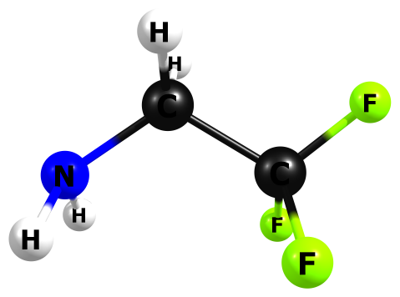

HF/6-311+G(2df,p)

C 0.432331000 0.014711000 -0.000029000

F 0.542302000 -0.761522000 -1.059730000

F 1.464685000 0.830533000 0.000233000

F 0.541753000 -0.761239000 1.059908000

C -0.869545000 0.785546000 -0.000481000

H -0.860990000 1.423786000 -0.875065000

H -0.861048000 1.424953000 0.873234000

N -2.051263000 -0.029712000 0.000011000

H -2.117339000 -0.605316000 0.813018000

H -2.117162000 -0.606930000 -0.811901000

HF=-430.9977852

Zero-point correction= 0.075678 (Hartree/Particle)

Thermal correction to Energy= 0.081344

Thermal correction to Enthalpy= 0.082288

Thermal correction to Gibbs Free Energy= 0.046260

Sum of electronic and zero-point Energies= -430.922107

Sum of electronic and thermal Energies= -430.916441

Sum of electronic and thermal Enthalpies= -430.915497

Sum of electronic and thermal Free Energies= -430.951525

Frequencies -- 126.1736 243.1188 297.5009

Frequencies -- 406.1090 451.3124 585.8484

Frequencies -- 594.2971 707.9918 868.7691

Frequencies -- 942.0616 956.1636 1204.8645

Frequencies -- 1208.6990 1324.6120 1391.4089

Frequencies -- 1415.3463 1506.6789 1549.4012

Frequencies -- 1603.2662 1802.5903 3209.3040

Frequencies -- 3253.9438 3742.8407 3826.6201

|  |  |
| --- | --- |
| Method | Energy |
| Gas-MP2/aug-ccpV(T+d)z | -432.3383838 |
| Gas-M062X/aug-ccpV(T+d)z | -432.9404251 |
| PCM-Water-MP2/aug-ccpV(T+d)z | -432.3436154 |
| PCM-Water-M062X/aug-ccpV(T+d)z | -432.9456415 |

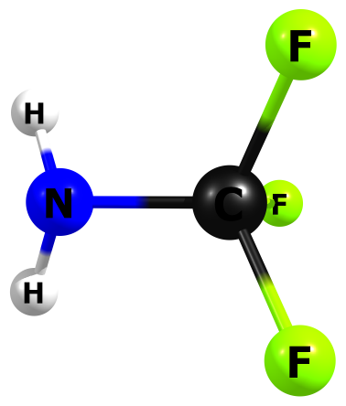

HF/6-311+G(2df,p)

Gas-HF-6-311+G2dfp-Freq-Opt-CF3NH2.log

symmetry c1

C -0.006014000 0.000189000 -0.016557000

F -0.432549000 -0.002549000 1.238736000

F -0.518510000 1.065421000 -0.580467000

F -0.515433000 -1.064827000 -0.583557000

N 1.379897000 0.001929000 -0.150769000

H 1.788580000 -0.820945000 0.239176000

H 1.786649000 0.823912000 0.243137000

HF=-391.960409

Zero-point correction= 0.045001 (Hartree/Particle)

Thermal correction to Energy= 0.049401

Thermal correction to Enthalpy= 0.050345

Thermal correction to Gibbs Free Energy= 0.017536

Sum of electronic and zero-point Energies= -391.915408

Sum of electronic and thermal Energies= -391.911008

Sum of electronic and thermal Enthalpies= -391.910064

Sum of electronic and thermal Free Energies= -391.942873

Frequencies -- 240.5453 432.6121 488.2820

Frequencies -- 622.6542 629.0196 686.9156

Frequencies -- 868.8394 967.7766 1165.7627

Frequencies -- 1293.3017 1461.0126 1503.5776

Frequencies -- 1785.5632 3757.9768 3849.2310

|  |  |
| --- | --- |
| Method | Energy |
| Gas-MP2/aug-ccpV(T+d)z | -393.1226232 |
| Gas-M062X/aug-ccpV(T+d)z | -393.6406605 |
| PCM-Water-MP2/aug-ccpV(T+d)z | -393.1284796 |
| PCM-Water-M062X/aug-ccpV(T+d)z | -393.6466393 |

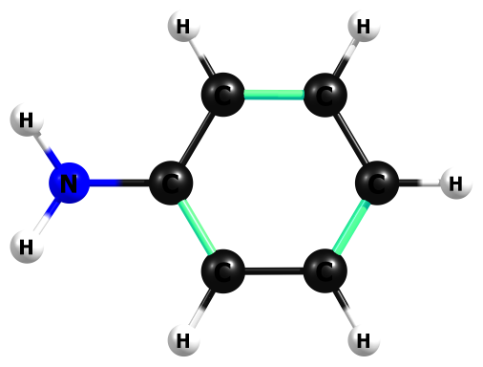

HF/6-311+G(2df,p)

C 0.219188000 1.194780000 -0.007386000

C 0.926858000 -0.000050000 -0.011687000

C -1.160436000 1.188879000 0.003994000

H -1.688527000 2.125260000 0.007943000

C 0.219131000 -1.194800000 -0.007355000

C -1.864889000 0.000024000 0.010019000

H 0.752211000 -2.128991000 -0.017979000

H -2.938444000 0.000075000 0.019091000

C -1.160521000 -1.188824000 0.003923000

H -1.688616000 -2.125202000 0.008053000

H 0.752368000 2.128916000 -0.017851000

N 2.317975000 -0.000036000 -0.071731000

H 2.754607000 -0.822913000 0.277150000

H 2.754594000 0.823053000 0.276673000

HF=-285.8241985

Zero-point correction= 0.124274 (Hartree/Particle)

Thermal correction to Energy= 0.129737

Thermal correction to Enthalpy= 0.130681

Thermal correction to Gibbs Free Energy= 0.095305

Sum of electronic and zero-point Energies= -285.699924

Sum of electronic and thermal Energies= -285.694462

Sum of electronic and thermal Enthalpies= -285.693518

Sum of electronic and thermal Free Energies= -285.728894

Frequencies -- 242.6427 271.7860 409.9881

Frequencies -- 456.4280 550.5064 571.8921

Frequencies -- 664.1407 678.2337 764.9590

Frequencies -- 841.5484 883.7434 921.6651

Frequencies -- 988.4299 1076.7808 1088.6768

Frequencies -- 1100.3862 1117.2765 1130.9948

Frequencies -- 1175.8627 1239.0751 1286.3696

Frequencies -- 1342.4307 1377.6622 1483.2701

Frequencies -- 1620.1512 1653.2837 1766.7679

Frequencies -- 1778.0960 1802.5962 3302.3446

Frequencies -- 3304.8443 3320.1577 3326.5922

Frequencies -- 3344.3822 3784.9277 3881.1551

|  |  |
| --- | --- |
| Method | Energy |
| Gas-MP2/aug-ccpV(T+d)z | -287.0145157 |
| Gas-M062X/aug-ccpV(T+d)z | -287.585309 |
| PCM-Water-MP2/aug-ccpV(T+d)z | -287.0209199 |
| PCM-Water-M062X/aug-ccpV(T+d)z | -287.5919182 |

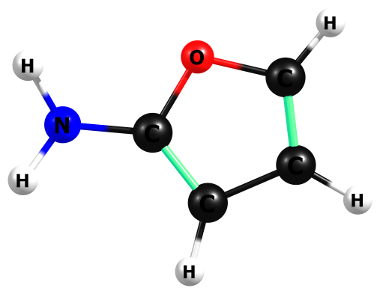

HF/6-311+G(2df,p)

C -1.357935000 -0.721003000 0.003222000

O -0.035358000 -1.038812000 -0.009347000

C 0.647968000 0.099534000 -0.010125000

C -0.174653000 1.160452000 0.004981000

C -1.505034000 0.600583000 0.009112000

H -2.039383000 -1.540768000 0.009338000

H 0.105301000 2.191574000 0.007471000

H -2.431868000 1.133805000 0.018825000

N 2.015592000 -0.034328000 -0.080426000

H 2.361446000 -0.853207000 0.369982000

H 2.516151000 0.781986000 0.189006000

HF= -283.7572296

Zero-point correction= 0.092694 (Hartree/Particle)

Thermal correction to Energy= 0.097543

Thermal correction to Enthalpy= 0.098487

Thermal correction to Gibbs Free Energy= 0.064703

Sum of electronic and zero-point Energies= -283.664536

Sum of electronic and thermal Energies= -283.659687

Sum of electronic and thermal Enthalpies= -283.658743

Sum of electronic and thermal Free Energies= -283.692527

Frequencies -- 217.8778 304.7538 430.5546

Frequencies -- 651.5014 673.4304 738.2316

Frequencies -- 776.8687 817.1011 863.0792

Frequencies -- 967.5195 994.6472 1046.9985

Frequencies -- 1078.4641 1148.5892 1206.2208

Frequencies -- 1265.0532 1363.5072 1409.1367

Frequencies -- 1583.7944 1707.8859 1751.5300

Frequencies -- 1802.5180 3388.4921 3402.1763

Frequencies -- 3442.7255 3776.5318 3878.6464

|  |  |
| --- | --- |
| Method | Energy |
| Gas-MP2/aug-ccpV(T+d)z | -284.8595687 |
| Gas-M062X/aug-ccpV(T+d)z | -285.3756057 |
| PCM-Water-MP2/aug-ccpV(T+d)z | -284.8659681 |
| PCM-Water-M062X/aug-ccpV(T+d)z | -285.3821776 |

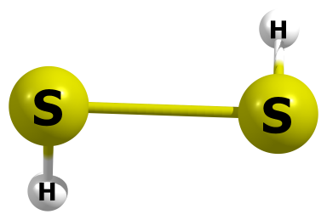

HF/6-311+G(2df,p)

S 0.000000000 1.029341000 -0.054660000

H 0.929412000 1.233888000 0.874565000

S 0.000000000 -1.029341000 -0.054660000

H -0.929412000 -1.233888000 0.874565000

HF=-796.2494958

Zero-point correction= 0.019682 (Hartree/Particle)

Thermal correction to Energy= 0.023031

Thermal correction to Enthalpy= 0.023976

Thermal correction to Gibbs Free Energy= -0.004486

Sum of electronic and zero-point Energies= -796.229814

Sum of electronic and thermal Energies= -796.226464

Sum of electronic and thermal Enthalpies= -796.225520

Sum of electronic and thermal Free Energies= -796.253982

Frequencies -- 458.3319 561.7995 982.9438

Frequencies -- 988.1052 2823.8771 2824.2903

|  |  |
| --- | --- |
| Method | Energy |
| Gas-MP2/aug-ccpV(T+d)z | -796.6317801 |
| Gas-M062X/aug-ccpV(T+d)z | -797.5861947 |
| PCM-Water-MP2/aug-ccpV(T+d)z | -796.6347291 |
| PCM-Water-M062X/aug-ccpV(T+d)z | -797.5891157 |

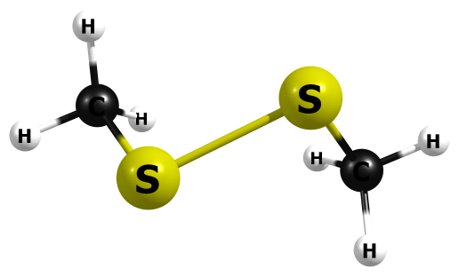

HF/6-311+G(2df,p)

C 1.847223000 0.786863000 -0.374735000

H 1.394954000 1.760574000 -0.254151000

H 2.829734000 0.793478000 0.081576000

H 1.939092000 0.545116000 -1.423123000

S 0.897485000 -0.488772000 0.490021000

S -0.897484000 -0.488770000 -0.490022000

C -1.847225000 0.786860000 0.374737000

H -1.395003000 1.760585000 0.254084000

H -2.829762000 0.793415000 -0.081519000

H -1.939023000 0.545155000 1.423140000

HF=-874.3410394

Zero-point correction= 0.082099 (Hartree/Particle)

Thermal correction to Energy= 0.088294

Thermal correction to Enthalpy= 0.089239

Thermal correction to Gibbs Free Energy= 0.051998

Sum of electronic and zero-point Energies= -874.258940

Sum of electronic and thermal Energies= -874.252745

Sum of electronic and thermal Enthalpies= -874.251801

Sum of electronic and thermal Free Energies= -874.289041

Frequencies -- 104.7237 170.0607 178.1211

Frequencies -- 254.2692 285.6494 552.1470

Frequencies -- 754.4072 761.4233 1050.4281

Frequencies -- 1059.6515 1060.5135 1064.7169

Frequencies -- 1472.0242 1480.1779 1577.7814

Frequencies -- 1582.6317 1596.0257 1599.5023

Frequencies -- 3179.2666 3181.2384 3258.3368

Frequencies -- 3259.4970 3276.8637 3278.0371

|  |  |
| --- | --- |
| Method | Energy |
| Gas-MP2/aug-ccpV(T+d)z | -875.0855804 |
| Gas-M062X/aug-ccpV(T+d)z | -876.2047712 |
| PCM-Water-MP2/aug-ccpV(T+d)z | -875.089567 |
| PCM-Water-M062X/aug-ccpV(T+d)z | -876.2085088 |

M06-2X/6-311+G(2df,p)

C 0.973326000 1.561305000 0.809093000

H 0.732564000 1.112949000 1.771050000

H 1.983987000 1.968909000 0.847301000

H 0.267488000 2.354093000 0.572725000

S 0.973326000 0.310198000 -0.502852000

S -0.973326000 -0.310198000 -0.502852000

C -0.973326000 -1.561305000 0.809093000

H -0.732564000 -1.112949000 1.771050000

H -1.983987000 -1.968909000 0.847301000

H -0.267488000 -2.354093000 0.572725000

HF=-876.1862784

Zero-point correction= 0.077511 (Hartree/Particle)

Thermal correction to Energy= 0.083979

Thermal correction to Enthalpy= 0.084923

Thermal correction to Gibbs Free Energy= 0.047649

Sum of electronic and zero-point Energies= -876.108767

Sum of electronic and thermal Energies= -876.102299

Sum of electronic and thermal Enthalpies= -876.101355

Sum of electronic and thermal Free Energies= -876.138629

|  |  |
| --- | --- |
| Method | Energy |
| Gas-M062X/aug-ccpV(T+d)z | -876.204776 |
| Water-(IEP-PCM)M062X/aug-ccpV(T+d)z | -876.2087465 |

(IEP-PCM)M06-2X/6-311+G(2df,p)

C 1.809139000 0.808872000 -0.379734000

H 1.316915000 1.769106000 -0.242646000

H 2.799329000 0.843683000 0.074869000

H 1.899111000 0.571254000 -1.436896000

S 0.902917000 -0.502329000 0.481823000

S -0.902917000 -0.502329000 -0.481823000

C -1.809139000 0.808872000 0.379734000

H -1.316916000 1.769106000 0.242645000

H -2.799329000 0.843682000 -0.074868000

H -1.899110000 0.571254000 1.436896000

HF=-876.1902501

Zero-point correction= 0.077536 (Hartree/Particle)

Thermal correction to Energy= 0.083960

Thermal correction to Enthalpy= 0.084905

Thermal correction to Gibbs Free Energy= 0.047118

Sum of electronic and zero-point Energies= -876.112714

Sum of electronic and thermal Energies= -876.106290

Sum of electronic and thermal Enthalpies= -876.105345

Sum of electronic and thermal Free Energies= -876.143132

|  |  |
| --- | --- |
| Method | Energy |
| Gas-M062X/aug-ccpV(T+d)z | -876.2047436 |
| Water-(IEP-PCM)M062X/aug-ccpV(T+d)z | -876.2087719 |

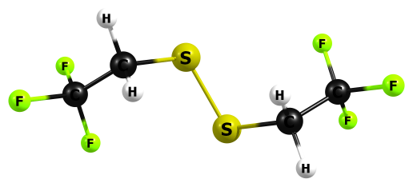

HF/6-311+G(2df,p)

C -3.079200000 -0.048854000 0.151999000

F -2.832014000 -1.240668000 -0.335299000

F -3.983492000 -0.190044000 1.100607000

F -3.621153000 0.669350000 -0.803090000

C -1.846352000 0.612590000 0.723511000

H -1.495399000 0.027995000 1.559956000

H -2.140729000 1.590186000 1.082824000

S -0.514150000 0.886070000 -0.472195000

S 0.514131000 -0.885942000 -0.472323000

C 1.846323000 -0.612640000 0.723441000

H 1.495373000 -0.028110000 1.559933000

H 2.140650000 -1.590283000 1.082664000

C 3.079210000 0.048807000 0.152016000

F 3.621140000 -0.669320000 -0.803144000

F 2.832082000 1.240684000 -0.335158000

F 3.983495000 0.189858000 1.100650000

HF=-1545.814068

Zero-point correction= 0.096167 (Hartree/Particle)

Thermal correction to Energy= 0.108103

Thermal correction to Enthalpy= 0.109047

Thermal correction to Gibbs Free Energy= 0.054494

Sum of electronic and zero-point Energies= -1545.717901

Sum of electronic and thermal Energies= -1545.705965

Sum of electronic and thermal Enthalpies= -1545.705021

Sum of electronic and thermal Free Energies= -1545.759574

Frequencies -- 31.3244 40.0381 42.1924

Frequencies -- 71.2456 77.5749 155.2994

Frequencies -- 193.0782 245.7272 261.5360

Frequencies -- 382.8893 383.6660 396.2528

Frequencies -- 406.7826 552.1612 581.2011

Frequencies -- 584.1642 585.3511 586.8114

Frequencies -- 695.9494 701.6626 822.6028

Frequencies -- 826.1956 926.7346 927.7690

Frequencies -- 962.0639 966.5585 1219.1416

Frequencies -- 1224.7023 1284.2801 1292.9905

Frequencies -- 1396.7078 1399.4933 1435.0639

Frequencies -- 1437.5624 1471.0553 1476.7627

Frequencies -- 1572.4124 1573.5639 3223.0380

Frequencies -- 3223.3325 3287.4077 3288.1646

|  |  |
| --- | --- |
| Method | Energy |
| Gas-MP2/aug-ccpV(T+d)z | -1548.4119068 |
| Gas-M062X/aug-ccpV(T+d)z | -1550.3754463 |
| PCM-Water-MP2/aug-ccpV(T+d)z | -1548.4193682 |
| PCM-Water-M062X/aug-ccpV(T+d)z | -1550.3833605 |

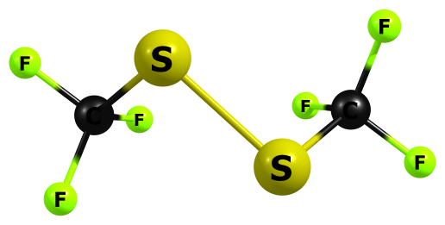

HF/6-311+G(2df,p)

C 1.928247000 0.226987000 0.047256000

F 1.457969000 1.439090000 0.123732000

F 2.312988000 -0.127224000 1.242704000

F 2.974423000 0.235833000 -0.739115000

S 0.754545000 -0.955754000 -0.683690000

S -0.754648000 -0.955694000 0.683806000

C -1.928254000 0.227026000 -0.047327000

F -2.313340000 -0.127627000 -1.242537000

F -2.974189000 0.236393000 0.739364000

F -1.457663000 1.438989000 -0.124308000

HF= -1467.6910476

Zero-point correction= 0.035452 (Hartree/Particle)

Thermal correction to Energy= 0.044896

Thermal correction to Enthalpy= 0.045840

Thermal correction to Gibbs Free Energy= -0.001912

Sum of electronic and zero-point Energies= -1467.655596

Sum of electronic and thermal Energies= -1467.646151

Sum of electronic and thermal Enthalpies= -1467.645207

Sum of electronic and thermal Free Energies= -1467.692960

Frequencies -- 36.8113 49.4651 75.8680

Frequencies -- 150.4267 155.4810 308.6564

Frequencies -- 350.4407 369.4301 393.2623

Frequencies -- 496.8365 501.9239 580.8285

Frequencies -- 596.2693 602.6310 617.2321

Frequencies -- 632.7888 844.3583 846.8546

Frequencies -- 1243.2193 1278.4117 1342.2514

Frequencies -- 1354.4600 1354.8960 1378.7901

|  |  |
| --- | --- |
| Method | Energy |
| Gas-MP2/aug-ccpV(T+d)z | -1469.9346726 |
| Gas-M062X/aug-ccpV(T+d)z | -1471.7336224 |
| PCM-Water-MP2/aug-ccpV(T+d)z | -1469.9361877 |
| PCM-Water-M062X/aug-ccpV(T+d)z | -1471.7354089 |

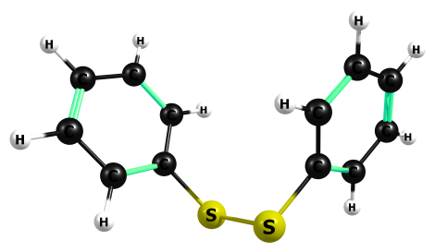

HF/6-311+G(2df,p)

C -2.834717000 -0.595343000 0.521300000

C -1.812655000 -0.390638000 -0.393466000

C -3.736715000 0.413550000 0.787368000

H -4.525704000 0.250521000 1.498072000

C -1.710076000 0.824977000 -1.046850000

C -3.630810000 1.629136000 0.134026000

H -0.921017000 0.981703000 -1.757399000

H -4.337434000 2.412189000 0.339042000

C -2.620419000 1.832917000 -0.783665000

H -2.536273000 2.774069000 -1.294845000

H -2.919576000 -1.541887000 1.020550000

S -0.670240000 -1.697808000 -0.785120000

S 0.670702000 -1.698306000 0.784795000

C 1.812728000 -0.390548000 0.393843000

C 2.834757000 -0.595163000 -0.521099000

C 1.709928000 0.825059000 1.047079000

H 2.919712000 -1.541727000 -1.020275000

H 0.920925000 0.981750000 1.757709000

C 3.736494000 0.413893000 -0.787338000

C 2.620072000 1.833160000 0.783684000

H 4.525431000 0.250971000 -1.498128000

H 2.535751000 2.774342000 1.294782000

C 3.630410000 1.629526000 -0.134065000

H 4.336812000 2.412740000 -0.339235000

HF=-1255.4651225

Zero-point correction= 0.195554 (Hartree/Particle)

Thermal correction to Energy= 0.207165

Thermal correction to Enthalpy= 0.208109

Thermal correction to Gibbs Free Energy= 0.154040

Sum of electronic and zero-point Energies= -1255.269569

Sum of electronic and thermal Energies= -1255.257957

Sum of electronic and thermal Enthalpies= -1255.257013

Sum of electronic and thermal Free Energies= -1255.311082

Frequencies -- 22.4721 23.2064 34.5021

Frequencies -- 102.3589 102.4532 220.9021

Frequencies -- 290.2934 304.4497 330.8309

Frequencies -- 431.8528 440.7170 453.8477

Frequencies -- 455.0273 525.7362 558.1644

Frequencies -- 569.8973 673.7976 673.8522

Frequencies -- 760.3830 760.9943 767.6146

Frequencies -- 768.3483 843.8390 845.0366

Frequencies -- 949.8177 951.1587 1049.1649

Frequencies -- 1049.5496 1083.6817 1083.9356

Frequencies -- 1105.7775 1105.8382 1112.6609

Frequencies -- 1112.9262 1121.2922 1121.4528

Frequencies -- 1161.2089 1161.6498 1189.1736

Frequencies -- 1189.9073 1194.9396 1196.1570

Frequencies -- 1288.0508 1288.6318 1314.4261

Frequencies -- 1314.7950 1450.5686 1451.6631

Frequencies -- 1586.1739 1587.3025 1635.9328

Frequencies -- 1636.7392 1751.4698 1751.9664

Frequencies -- 1765.9257 1766.0079 3313.9636

Frequencies -- 3314.0149 3325.4739 3325.5424

Frequencies -- 3336.9603 3337.0519 3346.5381

Frequencies -- 3346.7207 3350.7315 3350.7745

|  |  |
| --- | --- |
| Method | Energy |
| Gas-MP2/aug-ccpV(T+d)z | -1257.7677637 |
| Gas-M062X/aug-ccpV(T+d)z | -1259.659387 |
| PCM-Water-MP2/aug-ccpV(T+d)z | -1257.7732042 |
| PCM-Water-M062X/aug-ccpV(T+d)z | -1259.6652405 |

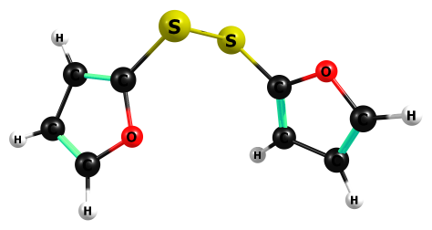

HF/6-311+G(2df,p)

C 3.514146000 0.621452000 -0.707320000

O 2.725904000 -0.442671000 -0.550219000

C 1.808761000 -0.127046000 0.381920000

C 2.010743000 1.120356000 0.827059000

C 3.146348000 1.618027000 0.106148000

H 4.295592000 0.531728000 -1.429647000

H 1.425960000 1.625438000 1.564829000

H 3.605893000 2.579315000 0.188477000

C -1.906998000 -0.237398000 -0.269283000

O -1.662131000 1.065168000 -0.503867000

C -2.752892000 1.744916000 -0.146801000

C -3.706759000 0.922717000 0.304944000

C -3.142814000 -0.393477000 0.225493000

H -4.679059000 1.199824000 0.651196000

H -3.595553000 -1.321148000 0.501329000

H -2.713702000 2.805170000 -0.268797000

S 0.657251000 -1.334712000 0.874794000

S -0.699284000 -1.416387000 -0.694023000

HF=-1251.326916

Zero-point correction= 0.132568 (Hartree/Particle)

Thermal correction to Energy= 0.142657

Thermal correction to Enthalpy= 0.143601

Thermal correction to Gibbs Free Energy= 0.093586

Frequencies -- 28.2283 48.4966 48.8081

Frequencies -- 109.7924 114.7722 274.0564

Frequencies -- 307.3749 337.0035 360.8582

Frequencies -- 507.5959 521.3831 548.5627

Frequencies -- 656.9376 658.2411 731.4186

Frequencies -- 734.4040 863.1793 863.9241

Frequencies -- 965.9770 966.9351 970.6298

Frequencies -- 970.7658 1009.0144 1009.7117

Frequencies -- 1017.9737 1019.2722 1089.5967

Frequencies -- 1089.9488 1189.1101 1189.8418

Frequencies -- 1226.7689 1229.1680 1284.6409

Frequencies -- 1285.7614 1347.4712 1349.2473

Frequencies -- 1523.8094 1525.3411 1625.6350

Frequencies -- 1628.9361 1744.5685 1746.2826

Frequencies -- 3395.2063 3395.3345 3410.6100

Frequencies -- 3411.7384 3427.8797 3428.4777

|  |  |
| --- | --- |
| Method | Energy |
| Gas-MP2/aug-ccpV(T+d)z | -1253.4579796 |
| Gas-M062X/aug-ccpV(T+d)z | -1255.2412108 |
| PCM-Water-MP2/aug-ccpV(T+d)z | -1253.4639412 |
| PCM-Water-M062X/aug-ccpV(T+d)z | -1255.2477095 |

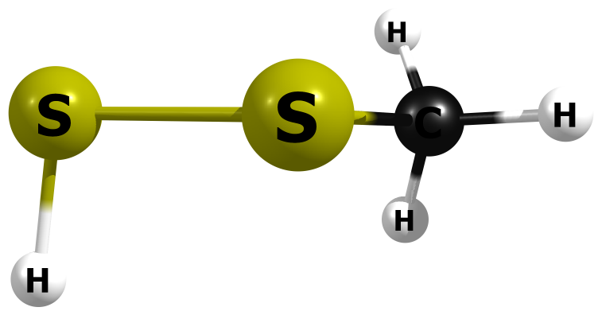

HF/6-311+G(2df,p)

16 -0.472763000 -0.699539000 0.015177000

16 1.347696000 0.242466000 -0.086780000

1 1.557322000 0.447858000 1.211746000

6 -1.645379000 0.677928000 -0.005689000

1 -1.543570000 1.285741000 0.881534000

1 -1.508374000 1.281254000 -0.890677000

1 -2.632042000 0.230737000 -0.022814000

HF=-835.2955341

Zero-point correction= 0.050985 (Hartree/Particle)

Thermal correction to Energy= 0.055635

Thermal correction to Enthalpy= 0.056579

Thermal correction to Gibbs Free Energy= 0.023409

Sum of electronic and zero-point Energies= -835.244550

Sum of electronic and thermal Energies= -835.239899

Sum of electronic and thermal Enthalpies= -835.238955

Sum of electronic and thermal Free Energies= -835.272125

Frequencies -- 190.4381 261.9995 330.1138

Frequencies -- 555.6345 758.0466 974.1131

Frequencies -- 1058.8521 1065.8658 1477.6827

Frequencies -- 1578.4227 1597.6731 2811.7793

Frequencies -- 3179.8181 3260.2727 3278.9334

|  |  |
| --- | --- |
| Method | Energy |
| Gas-MP2/aug-ccpV(T+d)z | -835.85878 |
| Gas-M062X/aug-ccpV(T+d)z | -836.8955542 |
| PCM-Water-MP2/aug-ccpV(T+d)z | -835.8621856 |
| PCM-Water-M062X/aug-ccpV(T+d)z | -836.898966 |

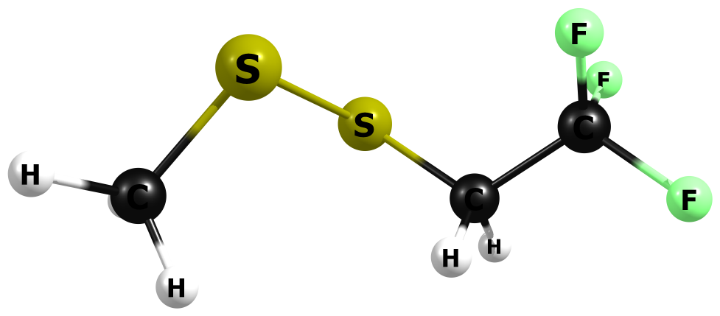

HF/6-311+G(2df,p)

C -1.743291000 -0.169759000 0.057884000

F -1.391807000 -1.066113000 -0.831127000

F -2.639892000 -0.729402000 0.847755000

F -2.342310000 0.810581000 -0.578096000

C -0.578713000 0.323316000 0.884342000

H -0.180701000 -0.505429000 1.449308000

H -0.964234000 1.060954000 1.576061000

S 0.732397000 1.131730000 -0.068210000

S 1.972449000 -0.398464000 -0.623926000

C 3.158099000 -0.471761000 0.742174000

H 2.675215000 -0.756517000 1.665829000

H 3.878965000 -1.232992000 0.469537000

H 3.662725000 0.475351000 0.860262000

HF=-1210.0780074

Zero-point correction= 0.089165 (Hartree/Particle)

Thermal correction to Energy= 0.098198

Thermal correction to Enthalpy= 0.099142

Thermal correction to Gibbs Free Energy= 0.053200

Sum of electronic and zero-point Energies= -1209.988842

Sum of electronic and thermal Energies= -1209.979810

Sum of electronic and thermal Enthalpies= -1209.978865

Sum of electronic and thermal Free Energies= -1210.024807

Frequencies -- 45.7092 66.7498 84.0667

Frequencies -- 171.0776 181.0814 244.4454

Frequencies -- 278.3249 382.8568 400.5464

Frequencies -- 552.0814 583.0484 585.9042

Frequencies -- 698.2704 756.0791 826.0000

Frequencies -- 926.9201 962.8889 1056.9777

Frequencies -- 1063.2680 1220.7193 1284.5760

Frequencies -- 1397.4228 1436.0549 1471.5339

Frequencies -- 1479.7743 1573.6624 1579.7057

Frequencies -- 1596.7053 3180.9178 3223.4559

Frequencies -- 3260.2717 3279.4987 3288.2778

|  |  |
| --- | --- |
| Method | Energy |
| Gas-MP2/aug-ccpV(T+d)z | -1211.749146 |
| Gas-M062X/aug-ccpV(T+d)z | -1213.290498 |
| PCM-Water-MP2/aug-ccpV(T+d)z | -1211.754837 |
| PCM-Water-M062X/aug-ccpV(T+d)z | -1213.296437 |

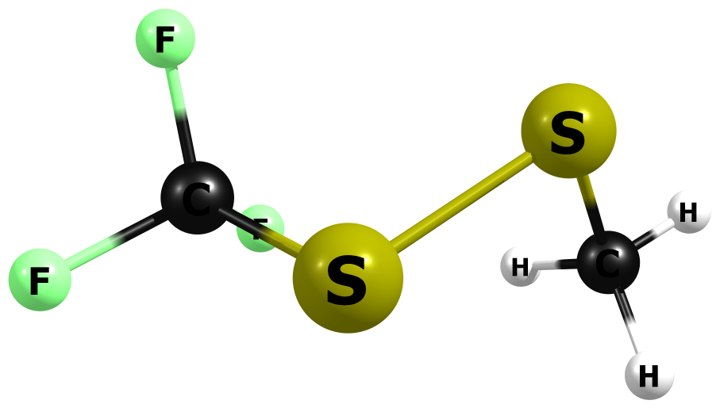

HF/6-311+G(2df,p)

6 2.420644000 0.929276000 -0.441831000

1 1.766942000 1.785729000 -0.493250000

1 3.331932000 1.200040000 0.077150000

1 2.662899000 0.574284000 -1.432059000

16 1.676440000 -0.394758000 0.545132000

16 0.064610000 -0.961010000 -0.570325000

6 -1.230166000 0.151949000 0.036536000

9 -0.941501000 1.416657000 -0.149180000

9 -2.321793000 -0.117759000 -0.637507000

9 -1.487977000 -0.005023000 1.307021000

HF=-1171.0191698

Zero-point correction= 0.058871 (Hartree/Particle)

Thermal correction to Energy= 0.066638

Thermal correction to Enthalpy= 0.067582

Thermal correction to Gibbs Free Energy= 0.025208

Sum of electronic and zero-point Energies= -1170.960299

Sum of electronic and thermal Energies= -1170.952532

Sum of electronic and thermal Enthalpies= -1170.951587

Sum of electronic and thermal Free Energies= -1170.993962

Frequencies -- 58.0194 95.6857 149.7958

Frequencies -- 188.8330 253.4395 351.5791

Frequencies -- 372.0312 500.6059 568.6549

Frequencies -- 598.4418 621.6066 752.5690

Frequencies -- 842.0308 1061.8462 1069.1372

Frequencies -- 1269.1511 1330.3560 1345.1093

Frequencies -- 1480.2007 1578.8550 1599.9385

Frequencies -- 3187.5425 3269.9690 3296.0842

|  |  |
| --- | --- |
| Method | Energy |
| Gas-MP2/aug-ccpV(T+d)z | -1172.513231 |
| Gas-M062X/aug-ccpV(T+d)z | -1173.97237 |
| PCM-Water-MP2/aug-ccpV(T+d)z | -1172.515932 |
| PCM-Water-M062X/aug-ccpV(T+d)z | -1173.975237 |

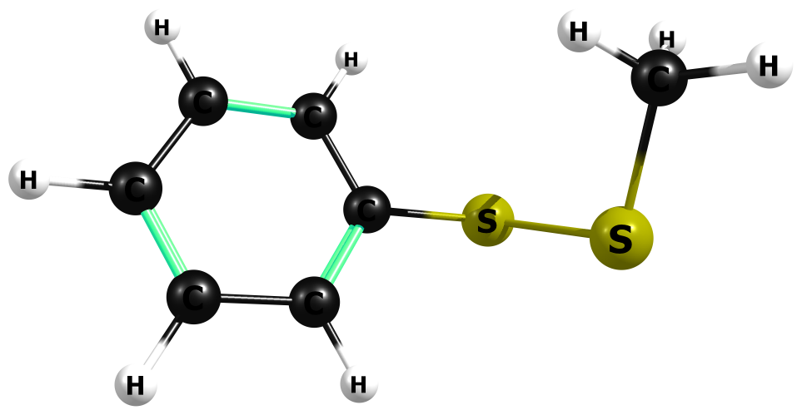

HF/6-311+G(2df,p)

C 1.179856000 -1.193876000 -0.167350000

C 0.553330000 -0.127679000 0.460689000

C 2.453572000 -1.045678000 -0.673150000

H 2.932645000 -1.873781000 -1.161976000

C 1.218848000 1.077765000 0.590272000

C 3.118395000 0.161971000 -0.542368000

H 0.736687000 1.902203000 1.080893000

H 4.113342000 0.272644000 -0.932449000

C 2.502645000 1.220315000 0.092228000

H 3.014199000 2.159057000 0.198512000

H 0.667959000 -2.132817000 -0.259748000

S -1.071062000 -0.306211000 1.172895000

S -2.322847000 -0.494225000 -0.442655000

C -2.570124000 1.215321000 -0.977981000

H -3.266125000 1.174391000 -1.807224000

H -2.994675000 1.806445000 -0.179932000

H -1.640610000 1.649997000 -1.315952000

HF=-1064.9030797

Zero-point correction= 0.138852 (Hartree/Particle)

Thermal correction to Energy= 0.147714

Thermal correction to Enthalpy= 0.148659

Thermal correction to Gibbs Free Energy= 0.102925

Sum of electronic and zero-point Energies= -1064.764228

Sum of electronic and thermal Energies= -1064.755365

Sum of electronic and thermal Enthalpies= -1064.754421

Sum of electronic and thermal Free Energies= -1064.800154

Frequencies -- 27.2428 64.7514 118.7773

Frequencies -- 188.5012 222.1986 289.9218

Frequencies -- 319.2992 436.8356 453.8688

Frequencies -- 538.3942 568.3871 674.0074

Frequencies -- 758.3899 760.1917 767.9998

Frequencies -- 843.0242 950.1709 1046.4347

Frequencies -- 1056.4537 1061.0138 1083.1412

Frequencies -- 1104.8736 1112.6829 1120.2430

Frequencies -- 1161.8206 1189.0775 1196.2998

Frequencies -- 1288.6956 1315.0453 1451.4493

Frequencies -- 1474.4443 1578.4392 1586.9783

Frequencies -- 1599.4055 1636.7910 1752.2871

Frequencies -- 1766.6552 3179.1092 3258.9003

Frequencies -- 3277.1661 3314.1006 3324.7624

Frequencies -- 3336.0910 3344.6098 3350.0086

|  |  |
| --- | --- |
| Method | Energy |
| Gas-MP2/aug-ccpV(T+d)z | -1066.426336 |
| Gas-M062X/aug-ccpV(T+d)z | -1067.932089 |
| PCM-Water-MP2/aug-ccpV(T+d)z | -1066.430919 |
| PCM-Water-M062X/aug-ccpV(T+d)z | -1067.936902 |

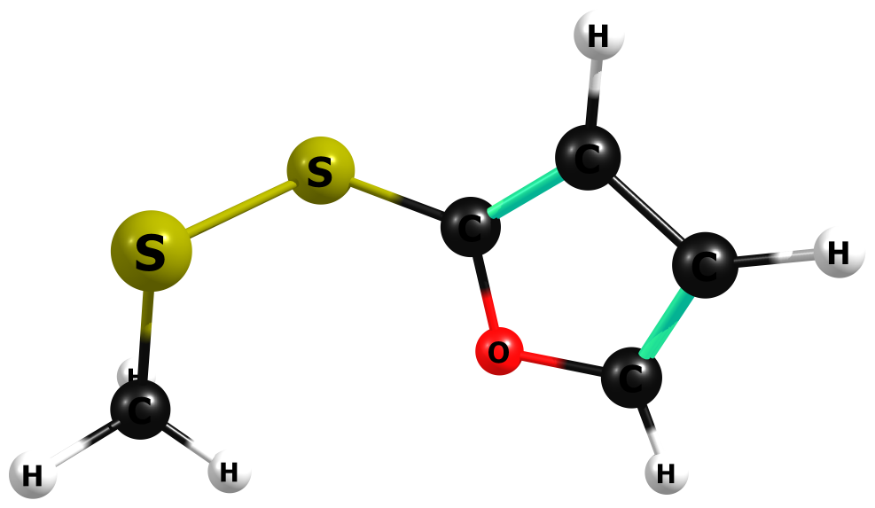

HF/6-311+G(2df,p)

C 0.851663000 -0.370441000 0.193940000

O 1.133784000 0.917263000 0.468474000

C 2.381666000 1.148501000 0.050114000

C 2.923042000 0.045950000 -0.477368000

C 1.904581000 -0.961434000 -0.385164000

H 3.906474000 -0.051544000 -0.884170000

H 1.952887000 -1.977662000 -0.711456000

H 2.754284000 2.139401000 0.190243000

S -2.020956000 -0.215242000 -0.671972000

S -0.691590000 -1.020040000 0.677036000

C -2.480942000 1.356473000 0.098802000

H -3.232942000 1.795271000 -0.545940000

H -2.901175000 1.190330000 1.079563000

H -1.629126000 2.016313000 0.160982000

HF=-1062.83478

Zero-point correction= 0.107418 (Hartree/Particle)

Thermal correction to Energy= 0.115520

Thermal correction to Enthalpy= 0.116464

Thermal correction to Gibbs Free Energy= 0.072929

Sum of electronic and zero-point Energies= -1062.727362

Sum of electronic and thermal Energies= -1062.719260

Sum of electronic and thermal Enthalpies= -1062.718316

Sum of electronic and thermal Free Energies= -1062.761851

Frequencies -- 52.9594 74.7940 115.2291

Frequencies -- 181.7603 246.2385 309.8170

Frequencies -- 348.4064 514.0907 553.9565

Frequencies -- 657.4228 734.2040 756.8786

Frequencies -- 861.9985 963.2915 970.0231

Frequencies -- 1008.1768 1017.4474 1060.0039

Frequencies -- 1065.6141 1089.4403 1187.9899

Frequencies -- 1223.5868 1283.8928 1347.2072

Frequencies -- 1476.6999 1523.0418 1578.1276

Frequencies -- 1600.6162 1632.9907 1747.7997

Frequencies -- 3182.5197 3263.5522 3286.8094

Frequencies -- 3395.0591 3410.8742 3428.4117

|  |  |
| --- | --- |
| Method | Energy |
| Gas-MP2/aug-ccpV(T+d)z | -1064.272214 |
| Gas-M062X/aug-ccpV(T+d)z | -1065.723542 |
| PCM-Water-MP2/aug-ccpV(T+d)z | -1064.276704 |
| PCM-Water-M062X/aug-ccpV(T+d)z | -1065.72828 |

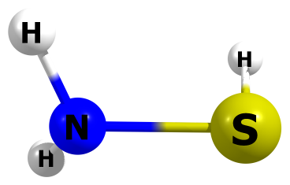

HF/6-311+G(2df,p)

N 1.079240000 -0.076068000 -0.000073000

H 1.492394000 0.298107000 0.825504000

S -0.602789000 -0.080593000 -0.000029000

H -0.893720000 1.224319000 0.000879000

H 1.491277000 0.299536000 -0.825412000

HF=-453.738044

Zero-point correction= 0.037797 (Hartree/Particle)

Thermal correction to Energy= 0.041030

Thermal correction to Enthalpy= 0.041974

Thermal correction to Gibbs Free Energy= 0.014168

Sum of electronic and zero-point Energies= -453.700247

Sum of electronic and thermal Energies= -453.697014

Sum of electronic and thermal Enthalpies= -453.696070

Sum of electronic and thermal Free Energies= -453.723876

Frequencies -- 561.4087 666.2405 925.6292

Frequencies -- 1119.4949 1192.8660 1754.3351

Frequencies -- 2757.9138 3754.5497 3858.5038

|  |  |
| --- | --- |
| Method | Energy |
| Gas-MP2/aug-ccpV(T+d)z | -454.1572893 |
| Gas-M062X/aug-ccpV(T+d)z | -454.7274069 |
| PCM-Water-MP2/aug-ccpV(T+d)z | -454.1626856 |
| PCM-Water-M062X/aug-ccpV(T+d)z | -454.7327415 |

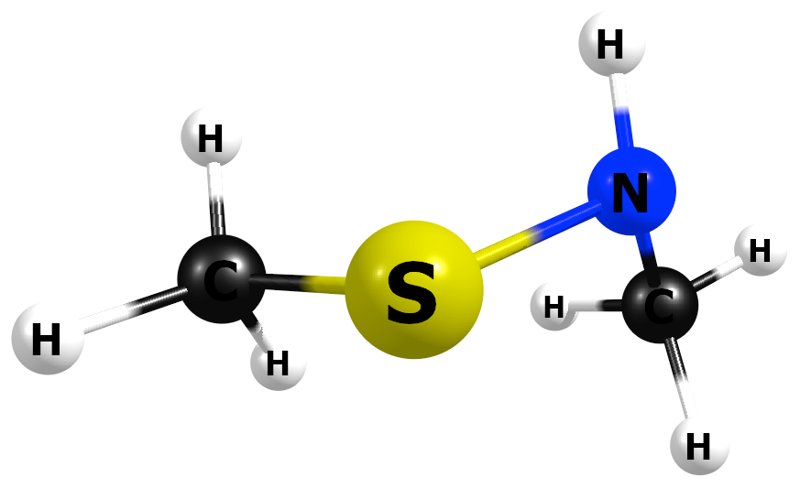

|  |  |
| --- | --- |
| Method | Energy |
| Gas-MP2/aug-ccpV(T+d)z | -1064.272214 |
| Gas-M062X/aug-ccpV(T+d)z | -1065.723542 |
| PCM-Water-MP2/aug-ccpV(T+d)z | -1064.276704 |
| PCM-Water-M062X/aug-ccpV(T+d)z | -1065.72828 |

M06-2X/6-311+G(2df,p)

C 1.763163000 0.530958000 -0.219964000

H 1.405115000 1.560081000 -0.097499000

H 2.768852000 0.463283000 0.197822000

H 1.816390000 0.308640000 -1.285666000

N 0.917683000 -0.464099000 0.420015000

S -0.636986000 -0.681805000 -0.191067000

C -1.461848000 0.902176000 0.114856000

H -0.993288000 1.714994000 -0.438440000

H -2.486512000 0.785286000 -0.239403000

H -1.480477000 1.131076000 1.180400000

H 0.930027000 -0.404598000 1.430406000

HF=-533.3200993

Zero-point correction= 0.093507 (Hartree/Particle)

Thermal correction to Energy= 0.099393

Thermal correction to Enthalpy= 0.100337

Thermal correction to Gibbs Free Energy= 0.064664

Sum of electronic and zero-point Energies= -533.226592

Sum of electronic and thermal Energies= -533.220707

Sum of electronic and thermal Enthalpies= -533.219763

Sum of electronic and thermal Free Energies= -533.255435

|  |  |
| --- | --- |
| Method | Energy |
| Gas-M062X/aug-ccpV(T+d)z | -533.3361688 |
| Water-(IEP-PCM)M062X/aug-ccpV(T+d)z | -533.3413191 |

(IEP-PCM)M06-2X/6-311+G(2df,p)

C 1.757406000 0.535281000 -0.220966000

H 1.373351000 1.553525000 -0.100936000

H 2.757821000 0.490145000 0.210844000

H 1.827590000 0.312921000 -1.285765000

N 0.925369000 -0.478720000 0.418256000

S -0.638435000 -0.680674000 -0.191210000

C -1.457666000 0.904133000 0.115859000

H -0.999207000 1.709848000 -0.454665000

H -2.489383000 0.780606000 -0.214329000

H -1.447640000 1.137516000 1.179839000

H 0.916402000 -0.379224000 1.427215000

HF=-533.3255396

Zero-point correction= 0.093479 (Hartree/Particle)

Thermal correction to Energy= 0.099365

Thermal correction to Enthalpy= 0.100309

Thermal correction to Gibbs Free Energy= 0.064596

Sum of electronic and zero-point Energies= -533.232061

Sum of electronic and thermal Energies= -533.226175

Sum of electronic and thermal Enthalpies= -533.225231

Sum of electronic and thermal Free Energies= -533.260944

|  |  |
| --- | --- |
| Method | Energy |
| Gas-M062X/aug-ccpV(T+d)z | -533.336077 |
| Water-(IEP-PCM)M062X/aug-ccpV(T+d)z | -533.3414546 |

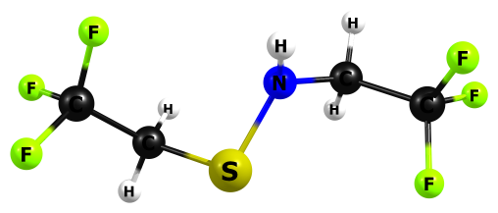

HF/6-311+G(2df,p)

C -2.899598000 -0.154139000 -0.001812000

F -2.454977000 -1.289854000 -0.492170000

F -3.944555000 -0.436361000 0.750991000

F -3.328644000 0.569635000 -1.009693000

C -1.855711000 0.571634000 0.812942000

H -1.623177000 -0.020594000 1.685576000

H -2.288266000 1.511278000 1.132857000

S -0.341162000 0.967650000 -0.078825000

N 0.493702000 -0.482690000 0.023435000

C 1.719433000 -0.570517000 0.766057000

H 1.647521000 0.018361000 1.669360000

H 1.903628000 -1.601434000 1.045677000

C 2.942399000 -0.103191000 0.004096000

F 3.112138000 -0.802532000 -1.100082000

F 2.864908000 1.160411000 -0.344145000

F 4.023411000 -0.251270000 0.738156000

H 0.473303000 -1.024168000 -0.811520000

HF=-1203.3036089

Zero-point correction= 0.112767 (Hartree/Particle)

Thermal correction to Energy= 0.124313

Thermal correction to Enthalpy= 0.125257

Thermal correction to Gibbs Free Energy= 0.072189

Sum of electronic and zero-point Energies= -1203.190842

Sum of electronic and thermal Energies= -1203.179296

Sum of electronic and thermal Enthalpies= -1203.178352

Sum of electronic and thermal Free Energies= -1203.231420

Frequencies -- 35.8600 42.8971 49.2563

Frequencies -- 76.8097 89.2484 173.3415

Frequencies -- 206.8209 279.9491 319.8412

Frequencies -- 386.4109 404.9150 410.7256

Frequencies -- 489.3535 560.6949 582.3941

Frequencies -- 584.0841 586.4563 616.6141

Frequencies -- 700.6468 717.6231 822.1191

Frequencies -- 871.8223 911.9628 925.0203

Frequencies -- 967.2556 1069.8535 1216.8847

Frequencies -- 1227.4044 1288.1923 1293.6452

Frequencies -- 1328.0307 1396.9900 1415.1419

Frequencies -- 1431.9288 1444.8363 1471.9862

Frequencies -- 1540.7483 1567.6616 1593.1569

Frequencies -- 1612.3221 3205.5868 3218.8800

Frequencies -- 3268.9336 3281.9234 3812.7821

|  |  |
| --- | --- |
| Method | Energy |
| Gas-MP2/aug-ccpV(T+d)z | -1205.9313445 |
| Gas-M062X/aug-ccpV(T+d)z | -1207.5140113 |
| PCM-Water-MP2/aug-ccpV(T+d)z | -1205.9382984 |
| PCM-Water-M062X/aug-ccpV(T+d)z | -1207.5212748 |

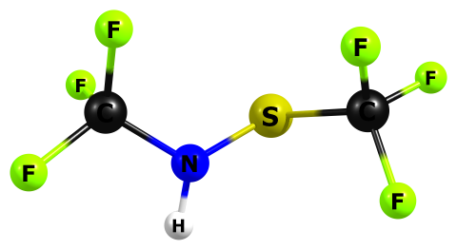

HF/6-311+G(2df,p)

C 1.845669000 -0.108516000 0.002031000

F 1.540123000 -0.905589000 -0.981028000

F 2.509141000 0.904207000 -0.516759000

F 2.658593000 -0.726876000 0.820018000

N 0.705808000 0.282407000 0.722967000

S -0.523163000 1.124439000 -0.031086000

C -1.804348000 -0.153110000 -0.003888000

F -2.096312000 -0.537781000 1.211372000

F -2.874669000 0.379174000 -0.539554000

F -1.483705000 -1.217678000 -0.684673000

H 0.903496000 0.542784000 1.663358000

HF=-1125.201548

Zero-point correction= 0.051934 (Hartree/Particle)

Thermal correction to Energy= 0.060941

Thermal correction to Enthalpy= 0.061885

Thermal correction to Gibbs Free Energy= 0.015551

Sum of electronic and zero-point Energies= -1125.149614

Sum of electronic and thermal Energies= -1125.140607

Sum of electronic and thermal Enthalpies= -1125.139663

Sum of electronic and thermal Free Energies= -1125.185997

Frequencies -- 41.5730 58.8783 73.3282

Frequencies -- 180.5351 191.3097 331.0476

Frequencies -- 352.9367 443.8357 482.3845

Frequencies -- 510.7429 534.9809 600.2781

Frequencies -- 601.6292 629.3521 676.7646

Frequencies -- 738.8217 847.2285 919.9109

Frequencies -- 1057.3361 1278.7090 1320.8813

Frequencies -- 1344.2185 1353.6822 1360.3096

Frequencies -- 1439.5136 1603.5583 3822.7719

|  |  |
| --- | --- |
| Method | Energy |
| Gas-MP2/aug-ccpV(T+d)z | -1127.4723293 |
| Gas-M062X/aug-ccpV(T+d)z | -1128.8895466 |
| PCM-Water-MP2/aug-ccpV(T+d)z | -1127.4765549 |
| PCM-Water-M062X/aug-ccpV(T+d)z | -1128.8940737 |

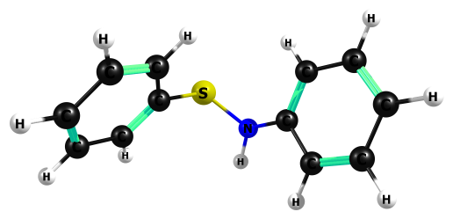

HF/6-311+G(2df,p)

C -2.166987000 0.282607000 -0.975483000

C -1.675485000 0.581043000 0.287449000

C -3.174843000 -0.647531000 -1.122318000

H -3.545484000 -0.865140000 -2.107617000

C -2.216332000 -0.065459000 1.388564000

C -3.718028000 -1.289899000 -0.024821000

H -1.840646000 0.152309000 2.372660000

H -4.504412000 -2.010603000 -0.147826000

C -3.232399000 -0.987427000 1.230954000

H -3.637990000 -1.476009000 2.098135000

H -1.766378000 0.782382000 -1.835663000

N -0.688215000 1.559131000 0.482700000

S 0.596127000 1.822523000 -0.564026000

C 1.711577000 0.462936000 -0.260751000

C 2.716500000 0.594024000 0.685528000

C 1.606802000 -0.715404000 -0.983195000

H 2.812282000 1.512814000 1.233578000

H 0.839144000 -0.817767000 -1.725736000

C 3.595992000 -0.445380000 0.918671000

C 2.485302000 -1.755745000 -0.748413000

H 4.372567000 -0.335190000 1.652868000

H 2.395287000 -2.667409000 -1.309523000

C 3.478517000 -1.621754000 0.202836000

H 4.162910000 -2.430450000 0.382434000

H -0.471491000 1.728717000 1.438066000

HF=-912.952886

Zero-point correction= 0.211671 (Hartree/Particle)

Thermal correction to Energy= 0.222796

Thermal correction to Enthalpy= 0.223740

Thermal correction to Gibbs Free Energy= 0.171119

Sum of electronic and zero-point Energies= -912.741214

Sum of electronic and thermal Energies= -912.730090

Sum of electronic and thermal Enthalpies= -912.729146

Sum of electronic and thermal Free Energies= -912.781767

Frequencies -- 15.6889 23.3734 48.1142

Frequencies -- 121.7950 168.5530 230.2648

Frequencies -- 317.5896 338.3814 411.0553

Frequencies -- 443.2036 454.3268 456.9712

Frequencies -- 530.4495 557.1213 594.9107

Frequencies -- 640.1653 673.9282 675.0262

Frequencies -- 761.5337 768.9150 770.2531

Frequencies -- 835.5855 848.8601 858.5246

Frequencies -- 930.0733 951.9309 977.0786

Frequencies -- 1006.5579 1052.1910 1078.3682

Frequencies -- 1084.4988 1093.3813 1106.6724

Frequencies -- 1108.8578 1113.4834 1119.3366

Frequencies -- 1123.1637 1160.6867 1176.4049

Frequencies -- 1188.8807 1191.9389 1196.0906

Frequencies -- 1287.4629 1288.6667 1311.4661

Frequencies -- 1314.2344 1354.1313 1448.3579

Frequencies -- 1450.6621 1545.5001 1585.8283

Frequencies -- 1633.5708 1636.7232 1651.1878

Frequencies -- 1750.9598 1766.4684 1768.8739

Frequencies -- 1779.9580 3304.0878 3313.3999

Frequencies -- 3314.5690 3324.3034 3325.7136

Frequencies -- 3334.9277 3342.6303 3343.9102

Frequencies -- 3354.0033 3354.2562 3822.9985

|  |  |
| --- | --- |
| Method | Energy |
| Gas-MP2/aug-ccpV(T+d)z | -915.2861347 |
| Gas-M062X/aug-ccpV(T+d)z | -916.7991156 |
| PCM-Water-MP2/aug-ccpV(T+d)z | -915.2929099 |
| PCM-Water-M062X/aug-ccpV(T+d)z | -916.8062517 |

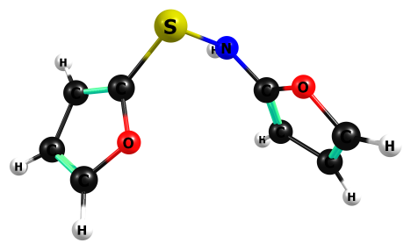

HF/6-311+G(2df,p)

C -3.088920000 -0.702479000 -0.781275000

O -2.203892000 0.319118000 -0.782988000

C -1.629809000 0.346803000 0.413141000

C -2.110838000 -0.620636000 1.205932000

C -3.092823000 -1.308551000 0.404502000

H -3.621983000 -0.865655000 -1.690457000

H -1.814275000 -0.833034000 2.210471000

H -3.695417000 -2.144358000 0.689487000

C 1.669741000 0.333107000 -0.126968000

O 1.423488000 -0.855054000 -0.714904000

C 2.423931000 -1.673551000 -0.396708000

C 3.327970000 -1.056070000 0.373767000

C 2.824592000 0.274279000 0.553289000

H 4.228559000 -1.476613000 0.766359000

H 3.264897000 1.073820000 1.109374000

H 2.367545000 -2.667528000 -0.783617000

N -0.724236000 1.367920000 0.645524000

S 0.571483000 1.661830000 -0.395026000

H -0.503233000 1.478717000 1.609185000

HF=-908.8166896

Zero-point correction= 0.148732 (Hartree/Particle)

Thermal correction to Energy= 0.158356

Thermal correction to Enthalpy= 0.159300

Thermal correction to Gibbs Free Energy= 0.110854

Sum of electronic and zero-point Energies= -908.667957

Sum of electronic and thermal Energies= -908.658334

Sum of electronic and thermal Enthalpies= -908.657390

Sum of electronic and thermal Free Energies= -908.705836

Frequencies -- 34.6653 39.8907 54.8436

Frequencies -- 136.5411 160.8326 293.9631

Frequencies -- 325.2065 418.7324 456.2768

Frequencies -- 519.4202 583.9519 656.2419

Frequencies -- 659.5908 729.9198 750.9943

Frequencies -- 797.5892 835.3652 866.5055

Frequencies -- 889.5152 928.5484 969.8160

Frequencies -- 971.2283 973.9103 998.4760

Frequencies -- 1008.5387 1022.9748 1062.2628

Frequencies -- 1087.0246 1088.6493 1184.9905

Frequencies -- 1190.8127 1227.2449 1269.4262

Frequencies -- 1282.5568 1342.7597 1346.0288

Frequencies -- 1385.2301 1496.0847 1525.4024

Frequencies -- 1585.1179 1625.1303 1703.2765

Frequencies -- 1743.8980 1773.6398 3389.5680

Frequencies -- 3394.0262 3402.3865 3407.3178

Frequencies -- 3426.8723 3439.4382 3823.3066

|  |  |
| --- | --- |
| Method | Energy |
| Gas-MP2/aug-ccpV(T+d)z | -910.9755951 |
| Gas-M062X/aug-ccpV(T+d)z | -912.3799063 |
| PCM-Water-MP2/aug-ccpV(T+d)z | -910.9836722 |
| PCM-Water-M062X/aug-ccpV(T+d)z | -912.3884016 |

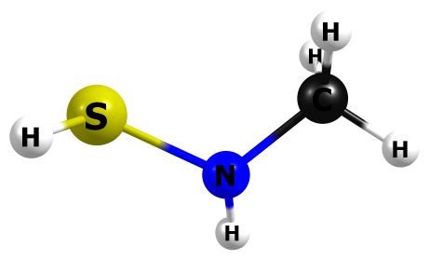

HF/6-311+G(2df,p)

H 1.537587000 0.000620000 1.149252000

S 1.080363000 -0.139533000 -0.092666000

N -0.434708000 0.581325000 0.109887000

C -1.593020000 -0.286148000 0.005820000

H -1.565201000 -1.021480000 0.798943000

H -2.486377000 0.315120000 0.130819000

H -1.658421000 -0.811234000 -0.944944000

H -0.512322000 1.397116000 -0.455547000

HF=-492.7738539

Zero-point correction= 0.067735 (Hartree/Particle)

Thermal correction to Energy= 0.072153

Thermal correction to Enthalpy= 0.073097

Thermal correction to Gibbs Free Energy= 0.041381

Sum of electronic and zero-point Energies= -492.706119

Sum of electronic and thermal Energies= -492.701701

Sum of electronic and thermal Enthalpies= -492.700757

Sum of electronic and thermal Free Energies= -492.732473

Frequencies -- 216.0751 298.5786 369.0747

Frequencies -- 641.0085 859.8602 1076.6903

Frequencies -- 1196.0353 1238.0903 1260.1031

Frequencies -- 1565.9564 1581.0558 1607.6345

Frequencies -- 1631.0018 2807.2259 3136.0226

Frequencies -- 3204.4142 3242.7306 3800.8021

|  |  |
| --- | --- |
| Method | Energy |
| Gas-MP2/aug-ccpV(T+d)z | -493.370595 |
| Gas-M062X/aug-ccpV(T+d)z | -494.0247518 |
| PCM-Water-MP2/aug-ccpV(T+d)z | -493.3745904 |
| PCM-Water-M062X/aug-ccpV(T+d)z | -494.0286684 |

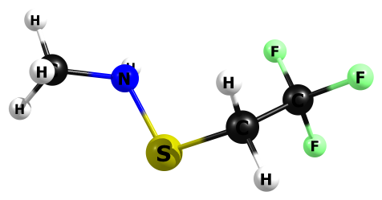

HF/6-311+G(2df,p)

C 1.496828000 0.133138000 0.034311000

F 1.147469000 1.163979000 -0.700627000

F 2.464925000 0.535524000 0.835911000

F 2.010701000 -0.769361000 -0.770983000

C 0.350583000 -0.420121000 0.846454000

H 0.039146000 0.327758000 1.560362000

H 0.721650000 -1.284688000 1.381914000

S -1.071891000 -0.954643000 -0.118860000

N -1.902840000 0.494294000 -0.314491000

C -3.231572000 0.577308000 0.264182000

H -3.168474000 0.451927000 1.337137000

H -3.634568000 1.562367000 0.060276000

H -3.922458000 -0.166503000 -0.126537000

H -1.868048000 0.810166000 -1.258348000

HF=-867.5610231

Zero-point correction= 0.105888 (Hartree/Particle)

Thermal correction to Energy= 0.114538

Thermal correction to Enthalpy= 0.115482

Thermal correction to Gibbs Free Energy= 0.071046

Sum of electronic and zero-point Energies= -867.455135

Sum of electronic and thermal Energies= -867.446485

Sum of electronic and thermal Enthalpies= -867.445541

Sum of electronic and thermal Free Energies= -867.489978

Frequencies -- 58.0172 72.6571 93.2434

Frequencies -- 186.7196 199.8450 293.4158

Frequencies -- 345.4221 389.4098 428.8948

Frequencies -- 582.1014 585.3001 640.9773

Frequencies -- 700.1837 822.2143 872.5604

Frequencies -- 924.8219 965.4948 1166.8936

Frequencies -- 1219.3380 1236.6961 1259.0064

Frequencies -- 1284.6989 1397.0945 1432.4063

Frequencies -- 1470.7163 1566.7484 1569.0019

Frequencies -- 1581.2987 1608.8451 1632.6662

Frequencies -- 3139.5275 3207.8021 3220.0986

Frequencies -- 3242.9847 3284.0334 3798.2037

|  |  |
| --- | --- |
| Method | Energy |
| Gas-MP2/aug-ccpV(T+d)z | -869.2641345 |
| Gas-M062X/aug-ccpV(T+d)z | -870.423625 |
| PCM-Water-MP2/aug-ccpV(T+d)z | -869.2696296 |
| PCM-Water-M062X/aug-ccpV(T+d)z | -870.4292651 |

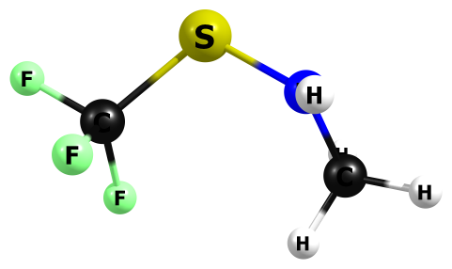

HF/6-311+G(2df,p)

N -1.691005000 -0.359697000 0.437739000

S -0.363496000 -1.087655000 -0.220961000

C 0.953584000 0.133396000 0.003910000

F 1.080014000 0.508196000 1.256740000

F 2.082602000 -0.411014000 -0.378404000

F 0.776678000 1.229998000 -0.698373000

H -1.670061000 -0.299126000 1.431108000

C -2.364583000 0.739732000 -0.230581000

H -3.341742000 0.866520000 0.219048000

H -1.824600000 1.678650000 -0.164270000

H -2.498279000 0.490932000 -1.274329000

HF=-828.503586

Zero-point correction= 0.075641 (Hartree/Particle)

Thermal correction to Energy= 0.083035

Thermal correction to Enthalpy= 0.083979

Thermal correction to Gibbs Free Energy= 0.042983

Sum of electronic and zero-point Energies= -828.427945

Sum of electronic and thermal Energies= -828.420551

Sum of electronic and thermal Enthalpies= -828.419607

Sum of electronic and thermal Free Energies= -828.460603

Frequencies -- 54.3827 122.9929 169.4058

Frequencies -- 240.3758 308.5437 376.6193

Frequencies -- 424.4637 515.7849 584.1027

Frequencies -- 609.2379 622.2851 835.8982

Frequencies -- 867.2467 1179.1519 1238.4450

Frequencies -- 1257.7924 1292.8610 1308.5329

Frequencies -- 1340.8655 1569.0308 1583.0660

Frequencies -- 1612.2896 1636.0382 3164.4683

Frequencies -- 3223.5943 3256.5049 3808.4538

|  |  |
| --- | --- |
| Method | Energy |
| Gas-MP2/aug-ccpV(T+d)z | -830.0298411 |
| Gas-M062X/aug-ccpV(T+d)z | -831.1071233 |
| PCM-Water-MP2/aug-ccpV(T+d)z | -830.033425 |
| PCM-Water-M062X/aug-ccpV(T+d)z | -831.1107178 |

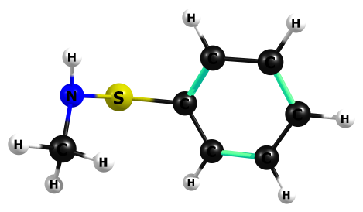

HF/6-311+G(2df,p)

N 2.416106000 -0.365480000 0.374768000

S 1.470855000 -0.271405000 -1.007215000

C -0.211691000 -0.118001000 -0.426680000

C -0.881847000 -1.212065000 0.102615000

C -0.875555000 1.091776000 -0.536879000

H -0.382688000 -2.161389000 0.166664000

H -0.363708000 1.939992000 -0.951096000

C -2.186415000 -1.090621000 0.535097000

C -2.188999000 1.210924000 -0.117441000

H -2.695707000 -1.942916000 0.945875000

H -2.695542000 2.153989000 -0.209422000

C -2.842776000 0.122612000 0.423398000

H -3.861358000 0.215041000 0.752797000

H 2.304445000 -1.230334000 0.856765000

C 2.474339000 0.777703000 1.262182000

H 2.797267000 1.646335000 0.703167000

H 1.522419000 1.006462000 1.736380000

H 3.206111000 0.579692000 2.037179000

HF=-722.3838543

Zero-point correction= 0.155736 (Hartree/Particle)

Thermal correction to Energy= 0.164115

Thermal correction to Enthalpy= 0.165060

Thermal correction to Gibbs Free Energy= 0.121017

Sum of electronic and zero-point Energies= -722.228118

Sum of electronic and thermal Energies= -722.219739

Sum of electronic and thermal Enthalpies= -722.218795

Sum of electronic and thermal Free Energies= -722.262838

Frequencies -- 26.6645 87.2173 156.1872

Frequencies -- 217.8297 263.8748 345.7809

Frequencies -- 393.6451 446.5757 456.5518

Frequencies -- 571.5188 651.3740 674.4091

Frequencies -- 760.9388 772.3653 843.1607

Frequencies -- 867.3097 953.0123 1049.0049

Frequencies -- 1083.1719 1106.2372 1113.3351

Frequencies -- 1121.6441 1160.0506 1170.0065

Frequencies -- 1189.7886 1198.5159 1234.7185

Frequencies -- 1254.6946 1287.5913 1314.2147

Frequencies -- 1449.1083 1560.0942 1577.0410

Frequencies -- 1585.4763 1607.0795 1633.3206

Frequencies -- 1636.5698 1750.9124 1766.9942

Frequencies -- 3140.1416 3203.5458 3240.8918

Frequencies -- 3311.6307 3320.6988 3331.1430

Frequencies -- 3339.5692 3346.6964 3787.8540

|  |  |
| --- | --- |
| Method | Energy |
| Gas-MP2/aug-ccpV(T+d)z | -723.9397438 |
| Gas-M062X/aug-ccpV(T+d)z | -725.0639613 |
| PCM-Water-MP2/aug-ccpV(T+d)z | -723.9455373 |
| PCM-Water-M062X/aug-ccpV(T+d)z | -725.069821 |

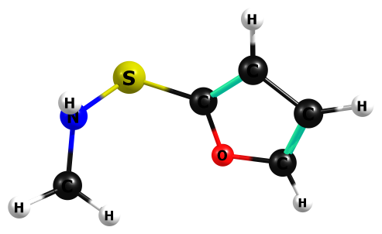

HF/6-311+G(2df,p)

C -0.508752000 -0.373705000 -0.138268000

O -0.913102000 0.832583000 -0.592373000

C -2.178424000 1.002927000 -0.208052000

C -2.621576000 -0.057606000 0.476235000

C -1.513173000 -0.967324000 0.523255000

H -3.596579000 -0.186979000 0.894463000

H -1.474071000 -1.930869000 0.983968000

H -2.641811000 1.923812000 -0.487769000

N 2.141048000 -0.149538000 0.506060000

S 1.096164000 -0.950229000 -0.528827000

H 2.011806000 -0.419079000 1.456911000

C 2.354203000 1.274937000 0.337254000

H 2.635742000 1.472439000 -0.688338000

H 1.479342000 1.874071000 0.574686000

H 3.170757000 1.580993000 0.981328000

HF=-720.316623

Zero-point correction= 0.124295 (Hartree/Particle)

Thermal correction to Energy= 0.131918

Thermal correction to Enthalpy= 0.132862

Thermal correction to Gibbs Free Energy= 0.091054

Sum of electronic and zero-point Energies= -720.192328

Sum of electronic and thermal Energies= -720.184705

Sum of electronic and thermal Enthalpies= -720.183761

Sum of electronic and thermal Free Energies= -720.225569

Frequencies -- 52.4316 103.4250 149.1806

Frequencies -- 221.7578 295.7340 355.1756

Frequencies -- 423.3090 525.0050 650.2453

Frequencies -- 660.3648 744.2468 864.6616

Frequencies -- 866.5241 969.1883 970.5908

Frequencies -- 1006.2096 1019.9239 1088.6272

Frequencies -- 1169.8304 1189.3520 1219.2507

Frequencies -- 1236.1278 1256.3911 1279.9024

Frequencies -- 1343.9202 1523.6587 1560.4846

Frequencies -- 1578.7978 1609.4168 1628.8727

Frequencies -- 1632.9864 1745.2779 3151.1513

Frequencies -- 3208.7276 3247.5527 3392.9086

Frequencies -- 3407.1904 3425.3503 3785.5061

|  |  |
| --- | --- |
| Method | Energy |
| Gas-MP2/aug-ccpV(T+d)z | -721.7870801 |
| Gas-M062X/aug-ccpV(T+d)z | -722.856469 |
| PCM-Water-MP2/aug-ccpV(T+d)z | -721.7926865 |
| PCM-Water-M062X/aug-ccpV(T+d)z | -722.862191 |

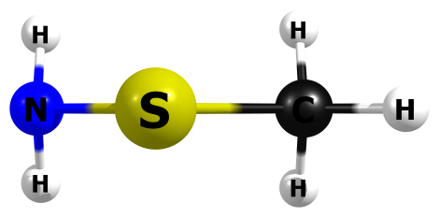

HF/6-311+G(2df,p)

S -0.059153000 -0.613174000 -0.000004000

N -1.365292000 0.439035000 -0.000007000

H -1.457074000 0.990417000 -0.825585000

H -1.457203000 0.990294000 0.825645000

C 1.388246000 0.462500000 0.000006000

H 1.415318000 1.083706000 -0.886294000

H 1.415623000 1.083293000 0.886590000

H 2.257353000 -0.185171000 -0.000273000

HF=-492.7848037

Zero-point correction= 0.068833 (Hartree/Particle)

Thermal correction to Energy= 0.073269

Thermal correction to Enthalpy= 0.074213

Thermal correction to Gibbs Free Energy= 0.042416

Sum of electronic and zero-point Energies= -492.715971

Sum of electronic and thermal Energies= -492.711535

Sum of electronic and thermal Enthalpies= -492.710591

Sum of electronic and thermal Free Energies= -492.742388

Frequencies -- 208.9500 314.7361 415.2171

Frequencies -- 666.0305 758.4612 915.8067

Frequencies -- 1047.5416 1068.6769 1185.0400

Frequencies -- 1474.5017 1576.9075 1597.3314

Frequencies -- 1753.4248 3163.2983 3241.7113

Frequencies -- 3244.2924 3739.9047 3842.1897

|  |  |
| --- | --- |
| Method | Energy |
| Gas-MP2/aug-ccpV(T+d)z | -493.384169 |
| Gas-M062X/aug-ccpV(T+d)z | -494.0373593 |
| PCM-Water-MP2/aug-ccpV(T+d)z | -493.3902788 |
| PCM-Water-M062X/aug-ccpV(T+d)z | -494.0433647 |

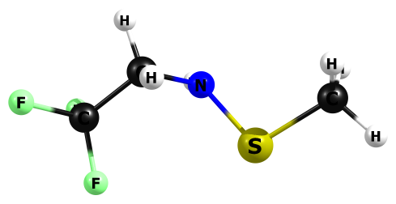

HF/6-311+G(2df,p)

C -1.580679000 -0.003748000 -0.070871000

F -1.324636000 1.254416000 -0.341642000

F -2.590288000 -0.378127000 -0.827840000

F -1.986574000 -0.056964000 1.183653000

C -0.387267000 -0.908547000 -0.297686000

H -0.114374000 -0.840622000 -1.341040000

H -0.728538000 -1.918995000 -0.101075000

N 0.749636000 -0.608562000 0.525693000

S 1.834060000 0.601543000 0.080241000

C 3.299454000 -0.371978000 -0.299723000

H 3.110677000 -1.056347000 -1.115190000

H 4.065234000 0.334768000 -0.598345000

H 3.636998000 -0.916212000 0.571015000

H 0.562026000 -0.635625000 1.503063000

HF=-867.5642251

Zero-point correction= 0.105661 (Hartree/Particle)

Thermal correction to Energy= 0.114318

Thermal correction to Enthalpy= 0.115263

Thermal correction to Gibbs Free Energy= 0.070802

Sum of electronic and zero-point Energies= -867.458564

Sum of electronic and thermal Energies= -867.449907

Sum of electronic and thermal Enthalpies= -867.448963

Sum of electronic and thermal Free Energies= -867.493423

Frequencies -- 62.6688 71.6920 83.2020

Frequencies -- 191.3825 202.5383 288.8122

Frequencies -- 332.8804 405.3052 482.7705

Frequencies -- 560.0406 583.5992 619.4362

Frequencies -- 716.1327 760.7310 867.6492

Frequencies -- 911.5348 1051.9472 1064.3660

Frequencies -- 1071.5218 1227.5969 1289.8231

Frequencies -- 1323.6201 1412.0781 1444.1491

Frequencies -- 1477.1981 1537.1907 1574.3918

Frequencies -- 1592.3240 1598.5072 1609.6490

Frequencies -- 3173.3407 3199.5353 3252.3026

Frequencies -- 3264.1989 3268.1288 3807.5038

|  |  |
| --- | --- |
| Method | Energy |
| Gas-MP2/aug-ccpV(T+d)z | -869.2659258 |
| Gas-M062X/aug-ccpV(T+d)z | -870.4260027 |
| PCM-Water-MP2/aug-ccpV(T+d)z | -869.2713639 |
| PCM-Water-M062X/aug-ccpV(T+d)z | -870.4315599 |

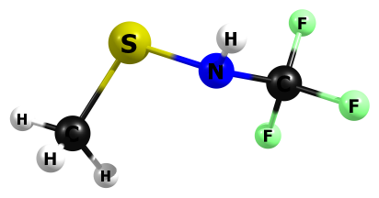

HF/6-311+G(2df,p)

S 1.471084000 -0.692415000 -0.064391000

N 0.075982000 -0.181050000 0.742250000

C -1.088092000 0.073580000 0.012233000

F -1.541902000 -0.962759000 -0.665145000

F -2.040435000 0.431153000 0.841431000

F -0.904485000 1.036503000 -0.853972000

H -0.109968000 -0.648318000 1.601710000

C 2.477500000 0.796187000 0.026883000

H 3.415981000 0.550623000 -0.456036000

H 2.005256000 1.610826000 -0.501738000

H 2.664465000 1.070179000 1.055057000

HF=-828.5261247

Zero-point correction= 0.075195 (Hartree/Particle)

Thermal correction to Energy= 0.082527

Thermal correction to Enthalpy= 0.083471

Thermal correction to Gibbs Free Energy= 0.042534

Sum of electronic and zero-point Energies= -828.450929

Sum of electronic and thermal Energies= -828.443598

Sum of electronic and thermal Enthalpies= -828.442654

Sum of electronic and thermal Free Energies= -828.483591

Frequencies -- 70.8525 94.7471 174.7830

Frequencies -- 211.9593 285.5158 416.0381

Frequencies -- 486.3131 537.3163 599.3129

Frequencies -- 678.3607 734.0216 764.2530

Frequencies -- 911.1557 1038.6867 1060.8397

Frequencies -- 1076.0877 1309.6440 1334.7161

Frequencies -- 1432.0651 1482.0473 1574.5957

Frequencies -- 1591.8950 1600.3659 3180.8977

Frequencies -- 3261.5021 3280.5389 3818.3902

|  |  |
| --- | --- |
| Method | Energy |
| Gas-MP2/aug-ccpV(T+d)z | -830.0298411 |
| Gas-M062X/aug-ccpV(T+d)z | -831.1071233 |
| PCM-Water-MP2/aug-ccpV(T+d)z | -830.033425 |
| PCM-Water-M062X/aug-ccpV(T+d)z | -831.1107178 |

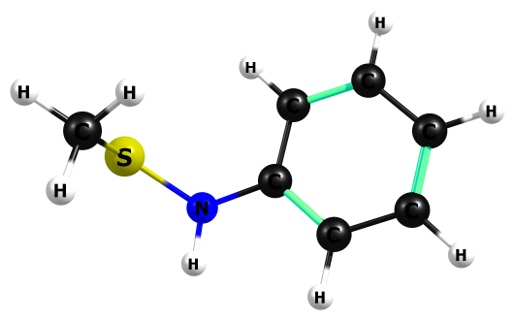

HF/6-311+G(2df,p)

S -2.346775000 0.044646000 -0.520939000

N -0.953337000 -0.866877000 -0.449010000

C 0.335368000 -0.378314000 -0.220970000

C 1.335157000 -1.277971000 0.132625000

C 0.661331000 0.961988000 -0.363076000

H 1.097246000 -2.321096000 0.245259000

H -0.092617000 1.670654000 -0.643106000

C 2.627619000 -0.845024000 0.334665000

C 1.961076000 1.382511000 -0.154909000

H 3.383700000 -1.559218000 0.606103000

H 2.194520000 2.425275000 -0.272149000

C 2.954841000 0.490852000 0.194630000

H 3.961751000 0.827408000 0.354307000

H -1.081478000 -1.830240000 -0.245029000

C -2.691596000 0.429720000 1.208817000

H -2.870718000 -0.471631000 1.779439000

H -1.882799000 0.994822000 1.650932000

H -3.590609000 1.035258000 1.211640000

HF=-722.3922452

Zero-point correction= 0.154658 (Hartree/Particle)

Thermal correction to Energy= 0.163101

Thermal correction to Enthalpy= 0.164045

Thermal correction to Gibbs Free Energy= 0.120163

Sum of electronic and zero-point Energies= -722.237587

Sum of electronic and thermal Energies= -722.229144

Sum of electronic and thermal Enthalpies= -722.228200

Sum of electronic and thermal Free Energies= -722.272082

Frequencies -- 39.0538 77.8243 175.6271

Frequencies -- 221.3538 223.8211 343.9178

Frequencies -- 405.6198 456.4406 471.3193

Frequencies -- 566.8323 627.0917 674.0655

Frequencies -- 751.5952 769.3971 839.5529

Frequencies -- 845.9542 926.9864 989.9367

Frequencies -- 998.8202 1050.1494 1061.0437

Frequencies -- 1076.0233 1092.4320 1106.5413

Frequencies -- 1119.6827 1179.9674 1188.3168

Frequencies -- 1288.1122 1309.6169 1363.0828

Frequencies -- 1450.4413 1473.7525 1548.7436

Frequencies -- 1575.4603 1599.9375 1636.1822

Frequencies -- 1650.4094 1767.2115 1779.4669

Frequencies -- 3171.5623 3249.9096 3261.6153

Frequencies -- 3301.8701 3314.6205 3325.0685

Frequencies -- 3343.5491 3358.5260 3838.7077

|  |  |
| --- | --- |
| Method | Energy |
| Gas-MP2/aug-ccpV(T+d)z | -723.9467265 |
| Gas-M062X/aug-ccpV(T+d)z | -725.073756 |
| PCM-Water-MP2/aug-ccpV(T+d)z | -723.9524669 |
| PCM-Water-M062X/aug-ccpV(T+d)z | -725.0796959 |

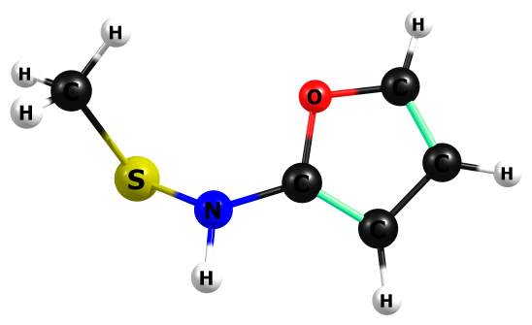

HF/6-311+G(2df,p)

C 0.673055000 -0.391731000 0.202437000

O 0.858432000 0.915295000 0.044732000

C 2.181983000 1.115009000 -0.152683000

C 2.834945000 -0.044239000 -0.105037000

C 1.833750000 -1.057736000 0.118615000

H 3.887650000 -0.185813000 -0.226538000

H 1.972209000 -2.114881000 0.191763000

H 2.487843000 2.123227000 -0.317970000

S -1.896518000 -0.392281000 -0.549990000

N -0.616616000 -0.800004000 0.480381000

H -0.668775000 -1.725496000 0.838550000

C -2.721045000 0.884904000 0.410829000

H -3.058425000 0.494634000 1.360504000

H -2.064754000 1.729276000 0.562448000

H -3.578729000 1.195972000 -0.174415000

HF=-720.3238034

Zero-point correction= 0.123268 (Hartree/Particle)

Thermal correction to Energy= 0.131019

Thermal correction to Enthalpy= 0.131963

Thermal correction to Gibbs Free Energy= 0.089716

Sum of electronic and zero-point Energies= -720.200535

Sum of electronic and thermal Energies= -720.192785

Sum of electronic and thermal Enthalpies= -720.191841

Sum of electronic and thermal Free Energies= -720.234087

Frequencies -- 51.2638 75.2168 151.2720

Frequencies -- 198.0996 283.2483 358.1838

Frequencies -- 462.5903 518.3869 655.8213

Frequencies -- 726.8252 766.5616 796.4600

Frequencies -- 832.5805 886.5860 930.3209

Frequencies -- 969.4297 997.9605 1058.6430

Frequencies -- 1059.5808 1073.3008 1087.1743

Frequencies -- 1183.2135 1269.0108 1342.8904

Frequencies -- 1383.4933 1476.6147 1496.5113

Frequencies -- 1573.4710 1584.3516 1601.1615

Frequencies -- 1704.8982 1773.8256 3177.1432

Frequencies -- 3256.3660 3275.5580 3389.5714

Frequencies -- 3402.4589 3438.9928 3839.3399

|  |  |
| --- | --- |
| Method | Energy |
| Gas-MP2/aug-ccpV(T+d)z | -721.7888527 |
| Gas-M062X/aug-ccpV(T+d)z | -722.8614138 |
| PCM-Water-MP2/aug-ccpV(T+d)z | -721.7949309 |
| PCM-Water-M062X/aug-ccpV(T+d)z | -722.8676714 |

**TRANSISTION STATE GEOMETRIES**

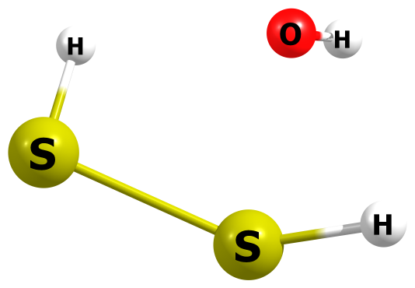

HF/6-311+G(2df,p)

H -1.926769000 -0.588487000 -0.404638000

S -0.686921000 -0.852885000 0.042973000

S 1.396742000 0.080400000 -0.034783000

H 1.196462000 1.276337000 0.498639000

O -1.105871000 1.287633000 -0.097764000

H -1.779860000 1.370851000 0.557079000

HF=-871.6080646

Zero-point correction= 0.030933 (Hartree/Particle)

Thermal correction to Energy= 0.036204

Thermal correction to Enthalpy= 0.037148

Thermal correction to Gibbs Free Energy= 0.002478

Sum of electronic and zero-point Energies= -871.577131

Sum of electronic and thermal Energies= -871.571861

Sum of electronic and thermal Enthalpies= -871.570917

Sum of electronic and thermal Free Energies= -871.605587

Frequencies -- -668.8607 143.8572 242.8065

Frequencies -- 304.1867 355.3372 432.2553

Frequencies -- 662.7968 803.0342 1041.1389

Frequencies -- 2605.4456 2874.9535 4112.2713

|  |  |
| --- | --- |
| Method | Energy |
| Gas-MP2/aug-ccpV(T+d)z | -872.3144726 |
| Gas-M062X/aug-ccpV(T+d)z | -873.3644371 |
| PCM-Water-MP2/aug-ccpV(T+d)z | -872.4033242 |
| PCM-Water-M062X/aug-ccpV(T+d)z | -873.4552275 |

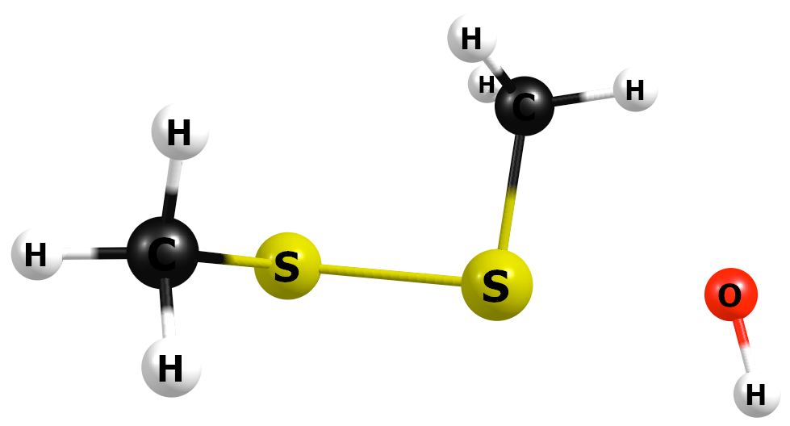

HF/6-311+G(2df,p)

C 0.948986000 1.421633000 -0.031273000

H 1.993646000 1.537779000 0.198761000

H 0.703199000 1.899072000 -0.970076000

H 0.338886000 1.849959000 0.754046000

S 0.668844000 -0.363678000 -0.151767000

S -1.494329000 -0.166471000 -0.648784000

C -2.263671000 -0.049862000 0.988461000

H -1.977746000 0.864675000 1.494840000

H -3.342627000 -0.054466000 0.869843000

H -1.974439000 -0.892854000 1.603619000

O 2.793900000 -0.448320000 0.345180000

H 3.003760000 -1.365850000 0.353207000

|  |  |
| --- | --- |
| Method | Energy |
| Gas-MP2/aug-ccpV(T+d)z |  |
| Gas-M062X/aug-ccpV(T+d)z |  |
| PCM-Water-MP2/aug-ccpV(T+d)z |  |
| PCM-Water-M062X/aug-ccpV(T+d)z |  |

M06-2X/6-311+G(2df,p)

(IEP-PCM)M06-2X/6-311+G(2df,p)

C 0.874834000 1.381276000 -0.366259000

H 1.819453000 1.725188000 0.045491000

H 0.845008000 1.566565000 -1.438455000

H 0.050434000 1.903433000 0.112997000

S 0.765609000 -0.399644000 -0.024882000

S -1.515717000 -0.402157000 -0.581571000

C -2.235677000 0.281618000 0.940533000

H -1.896670000 1.305340000 1.106013000

H -3.322861000 0.290759000 0.859183000

H -1.953712000 -0.324612000 1.801630000

O 2.710630000 -0.298583000 0.406957000

H 2.940092000 -1.226552000 0.515091000

HF=-952.1049427

Zero-point correction= 0.089695 (Hartree/Particle)

Thermal correction to Energy= 0.097888

Thermal correction to Enthalpy= 0.098832

Thermal correction to Gibbs Free Energy= 0.056757

Sum of electronic and zero-point Energies= -952.015248

Sum of electronic and thermal Energies= -952.007055

Sum of electronic and thermal Enthalpies= -952.006111

Sum of electronic and thermal Free Energies= -952.048186

|  |  |
| --- | --- |
| Method | Energy |
| Water-(IEP-PCM)M062X/aug-ccpV(T+d)z | -952.1293193 |

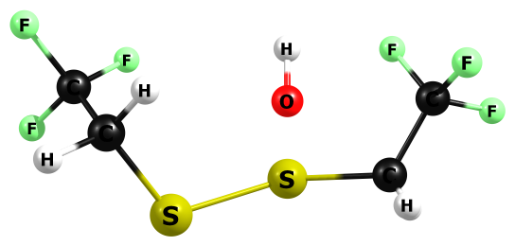

HF/6-311+G(2df,p)

C -2.407380000 0.946398000 0.000655000

H -2.504911000 1.351691000 0.994415000

H -2.906251000 1.609877000 -0.700866000

S -0.667597000 1.062104000 -0.552950000

S 1.320348000 1.612483000 0.282530000

C 2.280388000 0.222037000 0.917153000

H 2.999436000 0.603955000 1.633470000

H 1.588349000 -0.438416000 1.411912000

O -0.589655000 -0.287445000 1.154435000

H -0.599181000 -1.145823000 0.765020000

C 3.062469000 -0.556226000 -0.103430000

F 3.979259000 0.169039000 -0.721250000

F 3.726246000 -1.551259000 0.485641000

F 2.318761000 -1.108861000 -1.033511000

C -3.156919000 -0.375545000 -0.046183000

F -2.589440000 -1.305838000 -0.782023000

F -3.400247000 -0.902525000 1.132478000

F -4.365198000 -0.177790000 -0.594878000

HF=-1621.1883329

Zero-point correction= 0.107811 (Hartree/Particle)

Thermal correction to Energy= 0.121392

Thermal correction to Enthalpy= 0.122336

Thermal correction to Gibbs Free Energy= 0.064249

Sum of electronic and zero-point Energies= -1621.080522

Sum of electronic and thermal Energies= -1621.066941

Sum of electronic and thermal Enthalpies= -1621.065997

Sum of electronic and thermal Free Energies= -1621.124084

Frequencies -- -457.1872 23.0542 32.2792

Frequencies -- 51.5960 68.2996 77.5363

Frequencies -- 110.6142 189.6288 216.2898

Frequencies -- 241.7732 287.6713 300.3102

Frequencies -- 327.1491 370.3940 381.6520

Frequencies -- 400.6587 415.3004 444.4567

Frequencies -- 569.1893 579.1352 585.9891

Frequencies -- 590.5848 693.5165 704.4895

Frequencies -- 739.3459 790.3387 833.6666

Frequencies -- 904.8295 918.0815 923.7997

Frequencies -- 938.9734 1189.7581 1194.4571

Frequencies -- 1234.3450 1238.7943 1368.6441

Frequencies -- 1396.3725 1422.3583 1425.5474

Frequencies -- 1439.4190 1450.1215 1570.5387

Frequencies -- 1589.7149 3167.4886 3193.8767

Frequencies -- 3287.3817 3305.7347 4138.4272

|  |  |
| --- | --- |
| Method | Energy |
| Gas-MP2/aug-ccpV(T+d)z | -1624.111951 |
| Gas-M062X/aug-ccpV(T+d)z | -1626.173435 |
| PCM-Water-MP2/aug-ccpV(T+d)z | -1624.1859 |
| PCM-Water-M062X/aug-ccpV(T+d)z | -1626.248415 |

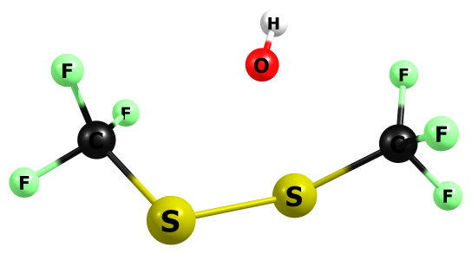

HF/6-311+G(2df,p)

C 2.360240000 0.058550000 -0.012791000

F 2.636220000 0.228595000 1.251427000

F 3.275657000 -0.802319000 -0.480168000

F 2.606947000 1.184102000 -0.642347000

S 0.778449000 -0.783121000 -0.386601000

S -1.115109000 -1.041913000 0.558892000

C -2.342588000 0.126095000 -0.074359000

F -2.090164000 0.575016000 -1.276523000

F -3.498396000 -0.542535000 -0.158883000

F -2.596190000 1.149792000 0.696390000

O 0.229167000 1.249573000 0.426216000

H 0.440669000 1.962228000 -0.152541000

HF=-1543.080888

Zero-point correction= 0.047256 (Hartree/Particle)

Thermal correction to Energy= 0.058283

Thermal correction to Enthalpy= 0.059227

Thermal correction to Gibbs Free Energy= 0.008804

Sum of electronic and zero-point Energies= -1543.033632

Sum of electronic and thermal Energies= -1543.022606

Sum of electronic and thermal Enthalpies= -1543.021662

Sum of electronic and thermal Free Energies= -1543.072085

Frequencies -- -362.5565 40.4668 66.0614

Frequencies -- 94.3678 131.7513 156.6137

Frequencies -- 225.1471 260.0028 295.0956

Frequencies -- 331.4719 357.7447 376.3343

Frequencies -- 389.2275 437.7924 486.2329

Frequencies -- 517.0520 595.6565 600.9011

Frequencies -- 604.8419 613.8350 722.2881

Frequencies -- 821.0131 835.1487 1169.0100

Frequencies -- 1202.6306 1292.8549 1304.6559

Frequencies -- 1334.8781 1339.2552 4140.8455

|  |  |
| --- | --- |
| Method | Energy |
| Gas-MP2/aug-ccpV(T+d)z | -1545.643867 |
| Gas-M062X/aug-ccpV(T+d)z | -1547.543096 |
| PCM-Water-MP2/aug-ccpV(T+d)z | -1545.719997 |
| PCM-Water-M062X/aug-ccpV(T+d)z | -1547.619974 |

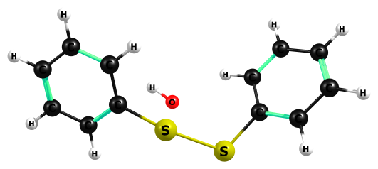

HF/6-311+G(2df,p)

C -3.577157000 -0.598855000 -0.706185000

C -2.446949000 -0.428461000 0.084184000

C -4.552970000 0.380015000 -0.771304000

H -5.422970000 0.224457000 -1.385678000

C -2.301991000 0.758905000 0.796643000

C -4.403796000 1.556336000 -0.063747000

H -1.414509000 0.879305000 1.388379000

H -5.156018000 2.323712000 -0.119294000

C -3.271456000 1.738921000 0.712620000

H -3.144110000 2.654168000 1.264638000

H -3.688616000 -1.504427000 -1.273327000

S -1.268458000 -1.742687000 0.200388000

S 0.673550000 -0.965035000 -0.600120000

C 2.250834000 -0.152142000 -0.279971000

C 3.321289000 -0.859163000 0.249532000

C 2.463551000 1.144556000 -0.721774000

H 3.162216000 -1.864271000 0.592504000

H 1.639525000 1.696961000 -1.133706000

C 4.570350000 -0.277805000 0.347050000

C 3.715412000 1.726277000 -0.627268000

H 5.388626000 -0.838976000 0.764193000

H 3.862098000 2.734661000 -0.973926000

C 4.774958000 1.019355000 -0.090993000

H 5.748465000 1.470939000 -0.016979000

O 0.506579000 -0.114365000 1.493967000

H 1.238748000 0.414311000 1.764434000

HF=-1330.8226634

Zero-point correction= 0.206638 (Hartree/Particle)

Thermal correction to Energy= 0.220193

Thermal correction to Enthalpy= 0.221137

Thermal correction to Gibbs Free Energy= 0.162547

Sum of electronic and zero-point Energies= -1330.616025

Sum of electronic and thermal Energies= -1330.602470

Sum of electronic and thermal Enthalpies= -1330.601526

Sum of electronic and thermal Free Energies= -1330.660117

Frequencies -- -426.5708 11.2036 24.1833

Frequencies -- 36.4013 82.3367 101.1719

Frequencies -- 143.5815 213.3514 243.8382

Frequencies -- 250.3748 293.0749 303.6814

Frequencies -- 325.7176 370.8646 427.0653

Frequencies -- 452.6319 453.1637 461.6727

Frequencies -- 544.3406 567.9169 674.2929

Frequencies -- 674.8834 739.6285 758.6181

Frequencies -- 768.4836 768.7855 821.8239

Frequencies -- 829.8901 840.9443 941.4650

Frequencies -- 951.8814 1018.9046 1035.1846

Frequencies -- 1076.1679 1079.1180 1087.6927

Frequencies -- 1092.7050 1097.0162 1110.7651

Frequencies -- 1115.5961 1142.8387 1156.7813

Frequencies -- 1160.0615 1177.6455 1182.5676

Frequencies -- 1184.5635 1190.5791 1278.0731

Frequencies -- 1284.3096 1303.9345 1304.7813

Frequencies -- 1440.2961 1453.7814 1576.5529

Frequencies -- 1577.7136 1624.6430 1629.1375

Frequencies -- 1735.6843 1740.9840 1752.4518

Frequencies -- 1756.0401 3282.4030 3284.8838

Frequencies -- 3296.1522 3296.9415 3314.3680

Frequencies -- 3316.6073 3329.8258 3333.5233

Frequencies -- 3337.8171 3341.7942 4125.5413

|  |  |
| --- | --- |
| Method | Energy |
| Gas-MP2/aug-ccpV(T+d)z | -1333.45712 |
| Gas-M062X/aug-ccpV(T+d)z |  |
| PCM-Water-MP2/aug-ccpV(T+d)z |  |
| PCM-Water-M062X/aug-ccpV(T+d)z |  |

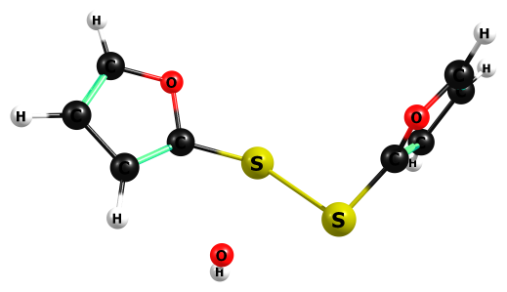

HF/6-311+G(2df,p)

S -1.173661000 1.496603000 0.287522000

S 0.514895000 0.340574000 -0.676853000

C 2.142645000 -0.132503000 -0.167527000

C 3.226101000 0.373057000 0.449058000

O 2.358918000 -1.436770000 -0.466077000

H 3.314663000 1.373835000 0.797205000

C 3.593697000 -1.756212000 -0.055907000

H 3.915851000 -2.757511000 -0.243555000

C 4.177861000 -0.702793000 0.521515000

H 5.161281000 -0.677337000 0.944862000

O 1.271846000 2.242951000 0.112988000

H 1.367317000 2.734541000 -0.685230000

C -3.948309000 -1.209253000 -0.520816000

C -3.158272000 -0.088950000 -0.944094000

C -2.375473000 0.251677000 0.097567000

O -2.632384000 -0.588246000 1.129450000

C -3.571493000 -1.448493000 0.740680000

H -4.680792000 -1.751970000 -1.081218000

H -3.167008000 0.400355000 -1.893886000

H -3.878635000 -2.179400000 1.457376000

HF=-1326.6954826

Zero-point correction= 0.143686 (Hartree/Particle)

Thermal correction to Energy= 0.155631

Thermal correction to Enthalpy= 0.156575

Thermal correction to Gibbs Free Energy= 0.102725

Sum of electronic and zero-point Energies= -1326.551797

Sum of electronic and thermal Energies= -1326.539852

Sum of electronic and thermal Enthalpies= -1326.538908

Sum of electronic and thermal Free Energies= -1326.592758

Frequencies -- -470.1761 33.4941 40.0901

Frequencies -- 51.1395 82.6774 100.1965

Frequencies -- 195.2124 250.4492 258.5459

Frequencies -- 273.6383 305.0424 332.0629

Frequencies -- 354.7082 453.2751 493.5819

Frequencies -- 522.5194 661.5441 662.3931

Frequencies -- 716.0009 738.2963 750.9889

Frequencies -- 819.2600 838.3686 921.1749

Frequencies -- 936.6010 966.8544 970.1693

Frequencies -- 987.9105 988.4312 990.4728

Frequencies -- 1000.5913 1075.9569 1084.8637

Frequencies -- 1151.5807 1182.0258 1195.0014

Frequencies -- 1208.9301 1268.1263 1274.7091

Frequencies -- 1311.8610 1332.4302 1504.5865

Frequencies -- 1519.9063 1620.0655 1625.3339

Frequencies -- 1723.8587 1727.4933 3365.0452

Frequencies -- 3373.0807 3402.3539 3409.7994

Frequencies -- 3411.7961 3465.1835 4141.0393

|  |  |
| --- | --- |
| Method | Energy |
| Gas-MP2/aug-ccpV(T+d)z | -1329.156424 |
| Gas-M062X/aug-ccpV(T+d)z | -1331.033559 |
| PCM-Water-MP2/aug-ccpV(T+d)z | -1329.240748 |
| PCM-Water-M062X/aug-ccpV(T+d)z | -1331.119682 |

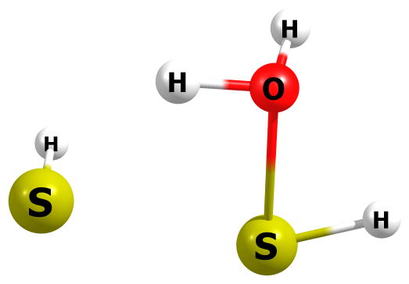

HF/6-311+G(2df,p)

S 1.555450000 -0.041075000 -0.074332000

H 1.714287000 0.011797000 1.246675000

S -0.969409000 -0.751729000 0.009080000

H -2.267459000 -0.391890000 -0.027332000

H 0.007553000 1.375534000 -0.190453000

O -0.952335000 1.257121000 -0.090656000

H -1.212352000 1.632447000 0.740391000

HF=-872.1661743

Zero-point correction= 0.045678 (Hartree/Particle)

Thermal correction to Energy= 0.050717

Thermal correction to Enthalpy= 0.051661

Thermal correction to Gibbs Free Energy= 0.017476

Sum of electronic and zero-point Energies= -872.120496

Sum of electronic and thermal Energies= -872.115457

Sum of electronic and thermal Enthalpies= -872.114513

Sum of electronic and thermal Free Energies= -872.148699

Frequencies -- -507.1890 212.7429 292.6466

Frequencies -- 334.4785 379.8950 500.9195

Frequencies -- 604.9905 807.2143 905.2612

Frequencies -- 1210.6998 1736.7958 2653.9631

Frequencies -- 2821.9918 3498.9739 4089.7796

|  |  |
| --- | --- |
| Method | Energy |
| Gas-MP2/aug-ccpV(T+d)z | -872.8552986 |
| Gas-M062X/aug-ccpV(T+d)z | -873.9114014 |
| PCM-Water-MP2/aug-ccpV(T+d)z | -872.8652843 |
| PCM-Water-M062X/aug-ccpV(T+d)z | -873.923402 |

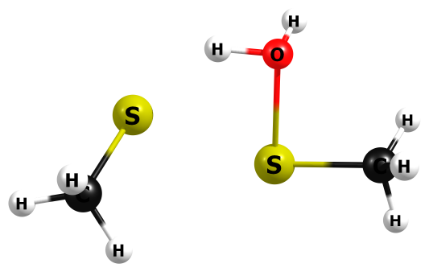

HF/6-311+G(2df,p)

H 3.216186000 0.253680000 -0.230898000

C 2.594072000 -0.526259000 0.186384000

H 2.661079000 -0.532103000 1.263816000

H 2.933327000 -1.485150000 -0.198665000

S 0.879787000 -0.471773000 -0.395877000

S -1.610379000 0.448222000 -0.430035000

C -2.274396000 -0.867298000 0.628110000

H -2.196302000 -0.617467000 1.677740000

H -3.317783000 -1.016562000 0.382429000

H -1.745455000 -1.795878000 0.445437000

H -0.088032000 1.420825000 0.561278000

O 0.883235000 1.315635000 0.554730000

H 1.242509000 1.985742000 -0.011350000

HF=-950.2499289

Zero-point correction= 0.107585 (Hartree/Particle)

Thermal correction to Energy= 0.115777

Thermal correction to Enthalpy= 0.116721

Thermal correction to Gibbs Free Energy= 0.074098

Sum of electronic and zero-point Energies= -950.142343

Sum of electronic and thermal Energies= -950.134152

Sum of electronic and thermal Enthalpies= -950.133207

Sum of electronic and thermal Free Energies= -950.175830

Frequencies -- -439.1843 13.9309 37.2458

Frequencies -- 54.3214 82.3243 157.0244

Frequencies -- 157.4879 180.3220 209.0303

Frequencies -- 235.0648 347.2759 375.1646

Frequencies -- 382.2357 387.5622 428.1454

Frequencies -- 509.3728 558.1743 574.6444

Frequencies -- 656.1640 682.3713 787.5803

Frequencies -- 927.0115 1028.1305 1041.4902

Frequencies -- 1123.7970 1124.9179 1233.3803

Frequencies -- 1254.7701 1515.5656 1521.4634

Frequencies -- 1577.8706 1578.6130 1594.1664

Frequencies -- 1595.8717 1757.3466 1933.8618

Frequencies -- 1970.2289 3177.5874 3188.5718

Frequencies -- 3241.0193 3258.8731 3268.2175

Frequencies -- 3287.0623 3549.2868 4086.3500

|  |  |
| --- | --- |
| Method | Energy |
| Gas-MP2/aug-ccpV(T+d)z | -951.281601 |
| Gas-M062X/aug-ccpV(T+d)z | -952.504448 |
| PCM-Water-MP2/aug-ccpV(T+d)z | -951.2904789 |
| PCM-Water-M062X/aug-ccpV(T+d)z | -952.5163946 |

M06-2X/6-311+G(2df,p)

H -2.722252000 -0.325677000 1.257223000

C -2.605035000 -0.377827000 0.174270000

H -3.126097000 0.444440000 -0.311134000

H -3.026131000 -1.325980000 -0.171031000

S -0.868647000 -0.505582000 -0.366539000

S 1.587422000 0.329008000 -0.555769000

C 2.160349000 -0.725839000 0.803436000

H 1.680689000 -1.703504000 0.737486000

H 3.237208000 -0.860328000 0.705004000

H 1.951553000 -0.289384000 1.779503000

H 0.253355000 1.386606000 0.239700000

O -0.769659000 1.352911000 0.411087000

H -0.923344000 1.297729000 1.365240000

HF=-952.4988531

Zero-point correction= 0.100136 (Hartree/Particle)

Thermal correction to Energy= 0.108453

Thermal correction to Enthalpy= 0.109397

Thermal correction to Gibbs Free Energy= 0.066150

Sum of electronic and zero-point Energies= -952.398766

Sum of electronic and thermal Energies= -952.390449

Sum of electronic and thermal Enthalpies= -952.389504

Sum of electronic and thermal Free Energies= -952.432751

|  |  |
| --- | --- |
| Method | Energy |
| Water-(IEP-PCM)M062X/aug-ccpV(T+d)z | -952.5353671 |

(IEP-PCM)M06-2X/6-311+G(2df,p)

H -2.826340000 -0.408370000 1.083407000

C -2.552287000 -0.582545000 0.043665000

H -3.102742000 0.075762000 -0.624718000

H -2.782368000 -1.621619000 -0.208590000

S -0.762604000 -0.523722000 -0.241124000

S 1.612300000 0.561859000 -0.303697000

C 2.189228000 -0.972027000 0.454888000

H 1.572948000 -1.804673000 0.098653000

H 3.218581000 -1.159922000 0.152053000

H 2.131289000 -0.929401000 1.541389000

H -0.059525000 1.608445000 0.497378000

O -1.003631000 1.429325000 0.264613000

H -1.539567000 1.522412000 1.069343000

HF=-952.5114546

Zero-point correction= 0.101522 (Hartree/Particle)

Thermal correction to Energy= 0.109009

Thermal correction to Enthalpy= 0.109953

Thermal correction to Gibbs Free Energy= 0.069597

Sum of electronic and zero-point Energies= -952.409933

Sum of electronic and thermal Energies= -952.402445

Sum of electronic and thermal Enthalpies= -952.401501

Sum of electronic and thermal Free Energies= -952.441858

|  |  |
| --- | --- |
| Method | Energy |
| Water-(IEP-PCM)M062X/aug-ccpV(T+d)z | -952.5361124 |

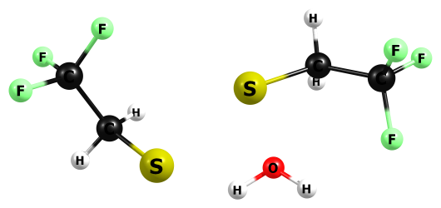

HF/6-311+G(2df,p)

C -3.408844000 -0.392042000 0.051601000

F -3.594114000 0.913794000 0.191522000

F -4.464048000 -0.859991000 -0.575108000

F -3.397278000 -0.908866000 1.253909000

C -2.150656000 -0.709849000 -0.719741000

H -2.254287000 -0.369417000 -1.738167000

H -2.048360000 -1.791230000 -0.727029000

S -0.574233000 -0.192919000 0.039211000

S 1.401292000 1.419450000 0.513826000

C 2.600956000 0.694262000 -0.630650000

H 2.121293000 0.350689000 -1.536980000

H 3.333803000 1.442676000 -0.900461000

C 3.356421000 -0.479246000 -0.057798000

F 4.066157000 -0.159703000 0.998078000

F 2.561576000 -1.471710000 0.285209000

F 4.197330000 -0.957842000 -0.959483000

H -0.297190000 2.096079000 -0.571398000

O -1.122505000 1.617805000 -0.719750000

H -1.822027000 2.024387000 -0.224176000

HF=-1621.732607

Zero-point correction= 0.122301 (Hartree/Particle)

Thermal correction to Energy= 0.136113

Thermal correction to Enthalpy= 0.137057

Thermal correction to Gibbs Free Energy= 0.078086

Sum of electronic and zero-point Energies= -1621.610306

Sum of electronic and thermal Energies= -1621.596494

Sum of electronic and thermal Enthalpies= -1621.595550

Sum of electronic and thermal Free Energies= -1621.654520

Frequencies -- -442.3169 22.9913 31.1463

Frequencies -- 40.2812 62.4562 78.7640

Frequencies -- 130.3964 135.5269 193.6522

Frequencies -- 225.3962 265.8497 278.2852

Frequencies -- 337.7771 361.7241 379.6871

Frequencies -- 402.0067 406.5132 438.7852

Frequencies -- 572.6110 582.3764 585.9349

Frequencies -- 588.1329 695.1354 701.2060

Frequencies -- 777.0804 800.3012 841.3391

Frequencies -- 904.1758 919.1068 926.5500

Frequencies -- 945.3957 985.3608 1196.9707

Frequencies -- 1208.3573 1272.3411 1294.4164

Frequencies -- 1377.0098 1389.7218 1426.4599

Frequencies -- 1429.3547 1464.1669 1468.5339

Frequencies -- 1568.1385 1584.9543 1715.2198

Frequencies -- 3192.6409 3211.9315 3260.7898

Frequencies -- 3286.3628 3638.1883 4082.4548

|  |  |
| --- | --- |
| Method | Energy |
| Gas-MP2/aug-ccpV(T+d)z | -1624.637449 |
| Gas-M062X/aug-ccpV(T+d)z | -1626.702833 |
| PCM-Water-MP2/aug-ccpV(T+d)z | -1624.647908 |
| PCM-Water-M062X/aug-ccpV(T+d)z | -1626.716135 |

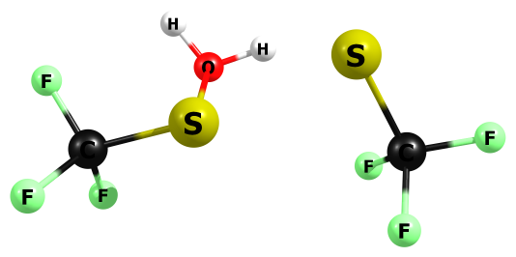

HF/6-311+G(2df,p)

F 3.156185000 0.825973000 0.200854000

C 2.432315000 -0.257907000 0.003584000

F 2.434944000 -0.935557000 1.115656000

F 3.015317000 -0.974398000 -0.923827000

S 0.761887000 0.072353000 -0.701204000

S -1.560284000 1.046293000 -0.735368000

C -2.409635000 -0.292665000 0.105665000

F -1.998066000 -0.443044000 1.354075000

F -3.701500000 -0.067465000 0.154323000

F -2.239721000 -1.454913000 -0.483055000

H -0.212428000 1.494768000 0.957516000

O 0.694401000 1.179596000 0.958989000

H 1.291049000 1.918191000 0.937998000

HF=-1543.6180328

Zero-point correction= 0.061635 (Hartree/Particle)

Thermal correction to Energy= 0.073084

Thermal correction to Enthalpy= 0.074028

Thermal correction to Gibbs Free Energy= 0.021681

Sum of electronic and zero-point Energies= -1543.556398

Sum of electronic and thermal Energies= -1543.544949

Sum of electronic and thermal Enthalpies= -1543.544005

Sum of electronic and thermal Free Energies= -1543.596352

Frequencies -- -381.3191 35.0086 43.3108

Frequencies -- 49.8341 113.1045 138.8066

Frequencies -- 171.0431 250.3249 287.9117

Frequencies -- 334.3274 360.2681 377.4319

Frequencies -- 387.8883 410.8299 432.8850

Frequencies -- 508.5182 592.9827 600.0320

Frequencies -- 605.0700 611.2809 755.8225

Frequencies -- 823.8695 837.1833 921.3739

Frequencies -- 1248.5832 1273.0120 1289.7526

Frequencies -- 1313.5401 1325.6358 1368.4170

Frequencies -- 1729.6030 3783.1064 4073.7393

|  |  |
| --- | --- |
| Method | Energy |
| Gas-MP2/aug-ccpV(T+d)z | -1546.166468 |
| Gas-M062X/aug-ccpV(T+d)z | -1548.068486 |
| PCM-Water-MP2/aug-ccpV(T+d)z | -1546.176153 |
| PCM-Water-M062X/aug-ccpV(T+d)z | -1548.079589 |

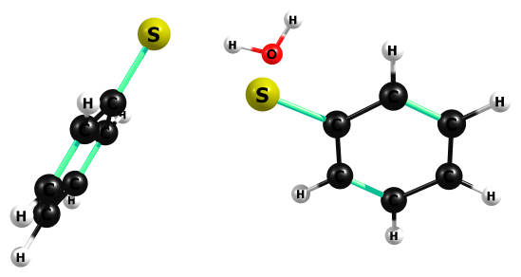

HF/6-311+G(2df,p)

C -3.027828000 0.184224000 1.146605000

C -2.611280000 -0.469853000 -0.011878000

C -3.732760000 1.366408000 1.076868000

H -4.047982000 1.850759000 1.983643000

C -2.931122000 0.103200000 -1.238700000

C -4.040351000 1.929476000 -0.150806000

H -2.635603000 -0.396278000 -2.142120000

H -4.592100000 2.850083000 -0.202452000

C -3.636742000 1.291219000 -1.305571000

H -3.874343000 1.713249000 -2.265483000

H -2.799980000 -0.248061000 2.102834000

S -1.703837000 -1.973224000 0.047352000

S 0.659509000 -0.605995000 -0.524332000

C 2.256140000 0.040188000 -0.201734000

C 3.369120000 -0.533559000 -0.806336000

C 2.402700000 1.203074000 0.549476000

H 3.251188000 -1.423431000 -1.395964000

H 1.539062000 1.646490000 1.007416000

C 4.612900000 0.046701000 -0.662110000

C 3.645612000 1.777660000 0.695819000

H 5.470089000 -0.393581000 -1.135883000

H 3.757816000 2.675782000 1.273560000

C 4.748714000 1.198380000 0.090490000

H 5.716744000 1.651013000 0.202476000

H 1.402870000 -2.439035000 1.195121000

O 0.902239000 -1.644044000 1.313178000

H -0.027020000 -1.889849000 1.410367000

HF=-1331.3850229

Zero-point correction= 0.220856 (Hartree/Particle)

Thermal correction to Energy= 0.234869

Thermal correction to Enthalpy= 0.235813

Thermal correction to Gibbs Free Energy= 0.174778

Sum of electronic and zero-point Energies= -1331.164167

Sum of electronic and thermal Energies= -1331.150154

Sum of electronic and thermal Enthalpies= -1331.149210

Sum of electronic and thermal Free Energies= -1331.210245

Frequencies -- -423.4213 5.2330 23.7905

Frequencies -- 35.0743 60.0212 73.8558

Frequencies -- 89.0828 156.2858 222.8821

Frequencies -- 252.2151 295.9767 309.2343

Frequencies -- 319.5573 370.1163 409.6922

Frequencies -- 450.8795 454.3403 456.4372

Frequencies -- 531.3987 541.4382 670.6960

Frequencies -- 674.4875 696.9723 755.3558

Frequencies -- 764.1957 766.8648 768.1778

Frequencies -- 833.9708 846.3843 900.4993

Frequencies -- 946.0339 951.8408 1025.4632

Frequencies -- 1066.4533 1077.3137 1083.1607

Frequencies -- 1098.7643 1108.6723 1110.1817

Frequencies -- 1112.3617 1113.7713 1129.7916

Frequencies -- 1164.4379 1167.2820 1174.2570

Frequencies -- 1182.9215 1195.8350 1200.6105

Frequencies -- 1285.5566 1287.9826 1306.9541

Frequencies -- 1321.4713 1445.1666 1448.7792

Frequencies -- 1580.2254 1585.0422 1627.2661

Frequencies -- 1628.6342 1735.2037 1739.7211

Frequencies -- 1743.2088 1755.7073 1758.3074

Frequencies -- 3303.5882 3312.8783 3319.8247

Frequencies -- 3329.7737 3330.6970 3336.8224

Frequencies -- 3339.1712 3342.4651 3348.0757

Frequencies -- 3354.3655 3620.5497 4112.7960

|  |  |
| --- | --- |
| Method | Energy |
| Gas-MP2/aug-ccpV(T+d)z | -1333.992388 |
| Gas-M062X/aug-ccpV(T+d)z | -1335.985343 |
| PCM-Water-MP2/aug-ccpV(T+d)z | -1334.00279 |
| PCM-Water-M062X/aug-ccpV(T+d)z | -1336.000422 |

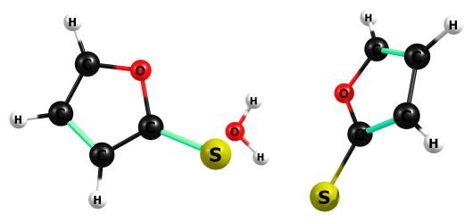

HF/6-311+G(2df,p)

O -2.367451000 0.682740000 0.825423000

C -2.581289000 -0.312579000 -0.075190000

C -3.442403000 0.126851000 -1.013549000

C -3.107085000 1.748007000 0.454011000

H -3.794807000 -0.441740000 -1.846145000

H -3.047164000 2.612889000 1.077206000

C -3.789530000 1.474323000 -0.658215000

H -4.457783000 2.134481000 -1.169805000

S -1.761857000 -1.819421000 0.145660000

S 0.833688000 -0.724377000 -0.590644000

C 2.354950000 -0.101485000 -0.289700000

O 2.586791000 1.238959000 -0.254461000

C 3.541900000 -0.753483000 -0.121656000

H 3.656337000 -1.816004000 -0.095039000

C 4.540546000 0.235258000 -0.002246000

H 5.592302000 0.102575000 0.127230000

C 3.876955000 1.411526000 -0.084217000

H 4.224615000 2.421918000 -0.041306000

H -0.303642000 -0.955294000 1.610007000

O 0.373373000 -0.278842000 1.516863000

H -0.125129000 0.528566000 1.499580000

HF=-1327.2583301

Zero-point correction= 0.157756 (Hartree/Particle)

Thermal correction to Energy= 0.170306

Thermal correction to Enthalpy= 0.171250

Thermal correction to Gibbs Free Energy= 0.115245

Sum of electronic and zero-point Energies= -1327.100574

Sum of electronic and thermal Energies= -1327.088024

Sum of electronic and thermal Enthalpies= -1327.087080

Sum of electronic and thermal Free Energies= -1327.143085

Frequencies -- -390.9991 24.7661 38.9841

Frequencies -- 45.5678 75.8802 87.2829

Frequencies -- 99.1585 135.7536 253.8668

Frequencies -- 258.9287 297.8184 319.4546

Frequencies -- 347.1928 367.9077 500.9927

Frequencies -- 522.7347 635.0648 653.3263

Frequencies -- 708.9952 727.4446 740.1344

Frequencies -- 827.6126 874.3770 883.5896

Frequencies -- 904.8724 964.3311 966.0405

Frequencies -- 994.6239 999.4228 1004.0586

Frequencies -- 1026.5807 1055.0440 1078.4343

Frequencies -- 1085.9184 1180.1270 1184.1594

Frequencies -- 1195.6223 1251.7034 1265.9296

Frequencies -- 1270.9098 1331.3216 1351.6825

Frequencies -- 1510.1555 1522.9579 1559.3492

Frequencies -- 1613.9608 1700.9676 1730.8606

Frequencies -- 1780.7175 3384.3693 3401.5682

Frequencies -- 3408.3454 3412.4780 3423.9591

Frequencies -- 3425.3046 3752.9564 4081.5302

|  |  |
| --- | --- |
| Method | Energy |
| Gas-MP2/aug-ccpV(T+d)z | -1329.693537 |
| Gas-M062X/aug-ccpV(T+d)z | -1331.58053 |
| PCM-Water-MP2/aug-ccpV(T+d)z | -1329.705561 |
| PCM-Water-M062X/aug-ccpV(T+d)z | -1331.594853 |

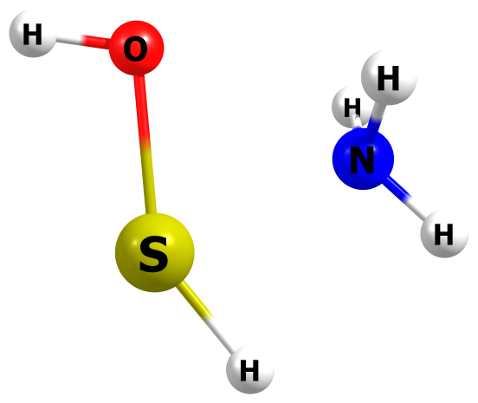

HF/6-311+G(2df,p)

H -1.348092000 0.892725000 0.808460000

N -1.359331000 0.303441000 0.000000000

S 0.430578000 -0.734784000 0.000000000

H -0.540369000 -1.699755000 0.000002000

H -2.163435000 -0.292408000 -0.000007000

O 0.787046000 1.089140000 -0.000002000

H 1.729682000 1.126032000 0.000013000

H -1.348085000 0.892737000 -0.808450000

HF=-529.672866

Zero-point correction= 0.064953 (Hartree/Particle)

Thermal correction to Energy= 0.070027

Thermal correction to Enthalpy= 0.070971

Thermal correction to Gibbs Free Energy= 0.037308

Sum of electronic and zero-point Energies= -529.607913

Sum of electronic and thermal Energies= -529.602839

Sum of electronic and thermal Enthalpies= -529.601895

Sum of electronic and thermal Free Energies= -529.635558

Frequencies -- -508.3256 95.6193 188.8170

Frequencies -- 423.1144 521.7677 522.9096

Frequencies -- 744.7443 820.7246 1101.5843

Frequencies -- 1319.3758 1349.8107 1747.9610

Frequencies -- 1777.5395 2436.7885 3680.3185

Frequencies -- 3817.8803 3821.4452 4140.5123

|  |  |
| --- | --- |
| Method | Energy |
| Gas-MP2/aug-ccpV(T+d)z | -530.399771 |
| Gas-M062X/aug-ccpV(T+d)z | -531.0691069 |
| PCM-Water-MP2/aug-ccpV(T+d)z | -530.414051 |
| PCM-Water-M062X/aug-ccpV(T+d)z | -531.0831531 |

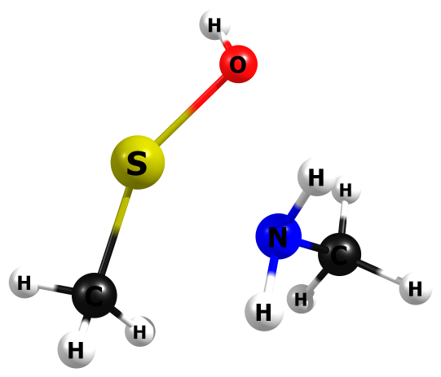

HF/6-311+G(2df,p)

C 1.789331000 -0.890976000 -0.425724000

H 2.056228000 -0.010645000 -0.986800000

H 2.684650000 -1.340329000 -0.007256000

H 1.317339000 -1.605983000 -1.085334000

N 0.847787000 -0.496768000 0.620837000

S -0.892729000 0.522551000 -0.079849000

C -1.557390000 -1.205378000 -0.063172000

H -1.602689000 -1.651396000 0.924252000

H -2.573014000 -1.031974000 -0.411747000

H -1.068610000 -1.877935000 -0.757341000

H 0.582296000 -1.280796000 1.182346000

O 0.508195000 1.733598000 0.042904000

H 0.241216000 2.421927000 -0.543415000

H 1.254523000 0.203025000 1.207161000

HF=-607.7505768

Zero-point correction= 0.126088 (Hartree/Particle)

Thermal correction to Energy= 0.133577

Thermal correction to Enthalpy= 0.134521

Thermal correction to Gibbs Free Energy= 0.094808

Sum of electronic and zero-point Energies= -607.624489

Sum of electronic and thermal Energies= -607.617000

Sum of electronic and thermal Enthalpies= -607.616056

Sum of electronic and thermal Free Energies= -607.655768

Frequencies -- -463.3230 98.8252 134.7132

Frequencies -- 194.5593 214.3573 249.7201

Frequencies -- 311.3103 384.7404 440.1117

Frequencies -- 508.3320 643.2966 783.5347

Frequencies -- 979.4410 999.8259 1073.3985

Frequencies -- 1110.3139 1119.3035 1139.6301

Frequencies -- 1343.9618 1432.9796 1457.6668

Frequencies -- 1566.8618 1575.0954 1596.3071

Frequencies -- 1618.1706 1629.2110 1769.7590

Frequencies -- 3136.2779 3167.1478 3210.4846

Frequencies -- 3229.9100 3242.6305 3303.7685

Frequencies -- 3723.0185 3810.0343 4147.4814

|  |  |
| --- | --- |
| Method | Energy |
| Gas-MP2/aug-ccpV(T+d)z | -608.8394725 |
| Gas-M062X/aug-ccpV(T+d)z | -609.6749794 |
| PCM-Water-MP2/aug-ccpV(T+d)z | -608.8519845 |
| PCM-Water-M062X/aug-ccpV(T+d)z | -609.6871914 |

M06-2X/6-311+G(2df,p)

C 1.748699000 -0.900686000 -0.439126000

H 2.003598000 0.003096000 -0.986485000

H 2.660462000 -1.379770000 -0.074129000

H 1.227987000 -1.589195000 -1.103560000

N 0.852855000 -0.514580000 0.650695000

S -0.905723000 0.545591000 -0.049659000

C -1.531052000 -1.208385000 -0.092102000

H -1.576098000 -1.682883000 0.889881000

H -2.550224000 -1.049510000 -0.456574000

H -1.010646000 -1.849777000 -0.804484000

H 0.572067000 -1.307695000 1.218319000

O 0.528009000 1.740112000 0.034603000

H 0.391670000 2.258294000 -0.764033000

H 1.272806000 0.203567000 1.231282000

HF=-609.6535583

Zero-point correction= 0.118895 (Hartree/Particle)

Thermal correction to Energy= 0.126503

Thermal correction to Enthalpy= 0.127447

Thermal correction to Gibbs Free Energy= 0.087726

Sum of electronic and zero-point Energies= -609.534663

Sum of electronic and thermal Energies= -609.527055

Sum of electronic and thermal Enthalpies= -609.526111

Sum of electronic and thermal Free Energies= -609.565832

|  |  |
| --- | --- |
| Method | Energy |
| Water-(IEP-PCM)M062X/aug-ccpV(T+d)z | -609.6879729 |

(IEP-PCM)M06-2X/6-311+G(2df,p)

C 1.895184000 -0.653250000 -0.438446000

H 2.079223000 0.293452000 -0.941205000

H 2.843558000 -1.055033000 -0.076259000

H 1.465054000 -1.356232000 -1.151064000

N 0.944286000 -0.425906000 0.650521000

S -0.994659000 0.431012000 -0.074364000

C -1.346007000 -1.392853000 -0.078717000

H -1.330263000 -1.834216000 0.917135000

H -2.371842000 -1.391217000 -0.461609000

H -0.715397000 -1.959197000 -0.762749000

H 0.778564000 -1.277914000 1.178393000

O 0.193336000 1.827557000 0.074018000

H 0.434992000 2.027928000 -0.836482000

H 1.278914000 0.293745000 1.280849000

HF=-609.6661924

Zero-point correction= 0.118870 (Hartree/Particle)

Thermal correction to Energy= 0.126490

Thermal correction to Enthalpy= 0.127434

Thermal correction to Gibbs Free Energy= 0.087547

Sum of electronic and zero-point Energies= -609.547322

Sum of electronic and thermal Energies= -609.539703

Sum of electronic and thermal Enthalpies= -609.538759

Sum of electronic and thermal Free Energies= -609.578645

|  |  |
| --- | --- |
| Method | Energy |
| Water-(IEP-PCM)M062X/aug-ccpV(T+d)z | -609.6885549 |

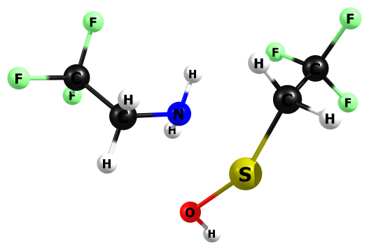

HF/6-311+G(2df,p)

C 2.586723000 -0.726787000 0.031665000

F 1.826092000 -1.234449000 0.995155000

F 3.216143000 -1.747703000 -0.518068000

F 3.492449000 0.019859000 0.612844000

C 1.777163000 0.027006000 -0.989361000

H 1.127844000 -0.672701000 -1.500567000

H 2.478618000 0.426267000 -1.716363000

S 0.962289000 1.624433000 -0.434448000

N -0.510017000 0.295012000 0.299920000

C -1.693066000 0.365647000 -0.544149000

H -2.039121000 1.386084000 -0.570339000

H -1.443862000 0.049417000 -1.547321000

C -2.809798000 -0.519963000 -0.041751000

F -2.436593000 -1.784038000 0.000671000

F -3.188516000 -0.186421000 1.171431000

F -3.852126000 -0.436203000 -0.830597000

H -0.184534000 -0.645372000 0.402153000

H -0.701952000 0.677596000 1.203908000

O -0.252854000 2.617743000 0.496699000

H 0.276154000 3.225932000 0.985336000

HF=-1279.2347128

Zero-point correction= 0.140299 (Hartree/Particle)

Thermal correction to Energy= 0.153576

Thermal correction to Enthalpy= 0.154520

Thermal correction to Gibbs Free Energy= 0.097950

Sum of electronic and zero-point Energies= -1279.094414

Sum of electronic and thermal Energies= -1279.081137

Sum of electronic and thermal Enthalpies= -1279.080193

Sum of electronic and thermal Free Energies= -1279.136763

Frequencies -- -415.5230 37.4181 38.5812

Frequencies -- 46.4072 89.1786 118.0464

Frequencies -- 128.5822 165.0874 181.3782

Frequencies -- 204.5756 239.3166 319.8231

Frequencies -- 350.7833 389.9310 420.7248

Frequencies -- 453.9385 468.3290 542.7447

Frequencies -- 563.2099 588.9472 590.6430

Frequencies -- 605.4978 693.6798 723.9116

Frequencies -- 742.1528 798.3524 913.5184

Frequencies -- 918.8532 947.3993 1014.7033

Frequencies -- 1094.2799 1151.8969 1177.1656

Frequencies -- 1225.0286 1260.8980 1282.1398

Frequencies -- 1351.6301 1364.0537 1393.6528

Frequencies -- 1413.5680 1416.1493 1444.6377

Frequencies -- 1510.3411 1564.5052 1575.3422

Frequencies -- 1613.7127 1776.0676 3181.1072

Frequencies -- 3240.6341 3242.5046 3313.4787

Frequencies -- 3727.3342 3813.8924 4154.2023

|  |  |
| --- | --- |
| Method | Energy |
| Gas-MP2/aug-ccpV(T+d)z | -1282.176459 |
| Gas-M062X/aug-ccpV(T+d)z | -1283.856585 |
| PCM-Water-MP2/aug-ccpV(T+d)z | -1282.187932 |
| PCM-Water-M062X/aug-ccpV(T+d)z | -1283.868092 |

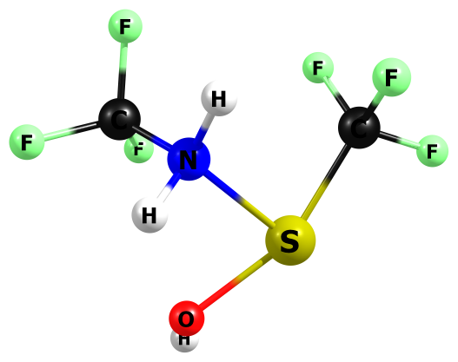

HF/6-311+G(2df,p)

C 1.676281000 -0.482311000 -0.029800000

F 1.591034000 -0.129999000 -1.265879000

F 2.845410000 -0.138478000 0.431438000

F 1.566426000 -1.779365000 0.049721000

N 0.636917000 0.123996000 0.794984000

S -0.739558000 1.267818000 -0.059228000

C -1.723914000 -0.329195000 -0.011733000

F -1.904310000 -0.849749000 1.199930000

F -2.901994000 -0.010370000 -0.483981000

F -1.239547000 -1.313064000 -0.748153000

H 0.220908000 -0.589615000 1.366439000

O 0.739744000 2.334732000 0.116500000

H 0.837201000 2.803084000 -0.695440000

H 1.071078000 0.813880000 1.381277000

HF=-1201.1279568

Zero-point correction= 0.079635 (Hartree/Particle)

Thermal correction to Energy= 0.090403

Thermal correction to Enthalpy= 0.091347

Thermal correction to Gibbs Free Energy= 0.040743

Sum of electronic and zero-point Energies= -1201.048321

Sum of electronic and thermal Energies= -1201.037554

Sum of electronic and thermal Enthalpies= -1201.036610

Sum of electronic and thermal Free Energies= -1201.087213

Frequencies -- -288.6242 18.1854 57.5172

Frequencies -- 70.8281 151.6527 162.8234

Frequencies -- 187.7003 207.7639 308.2634

Frequencies -- 369.3484 373.4515 405.5325

Frequencies -- 465.6444 498.2058 568.6917

Frequencies -- 584.6377 609.0642 615.5271

Frequencies -- 692.4166 702.4625 800.1474

Frequencies -- 912.8115 957.9634 1055.3938

Frequencies -- 1234.2377 1257.2931 1271.9867

Frequencies -- 1320.0477 1347.1163 1360.8520

Frequencies -- 1498.6195 1535.5794 1754.9972

Frequencies -- 3682.7545 3757.4358 4158.9583

|  |  |
| --- | --- |
| Method | Energy |
| Gas-MP2/aug-ccpV(T+d)z | -1203.712823 |
| Gas-M062X/aug-ccpV(T+d)z | -1205.228848 |
| PCM-Water-MP2/aug-ccpV(T+d)z | -1203.723898 |
| PCM-Water-M062X/aug-ccpV(T+d)z | -1205.239943 |

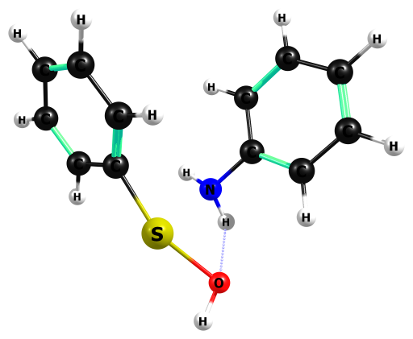

HF/6-311+G(2df,p)

N 0.551032000 0.977808000 1.021720000

S -0.666599000 1.902791000 -0.518621000

H -0.060944000 0.580120000 1.704167000

O 0.748718000 3.095003000 -0.034530000

H 0.381239000 3.940440000 -0.232309000

H 0.961533000 1.823951000 1.364344000

C -1.649877000 0.390372000 -0.266874000

C -1.481346000 -0.691304000 -1.116485000

C -2.675248000 0.358924000 0.669508000

C -2.321099000 -1.788263000 -1.029822000

C -3.507179000 -0.739463000 0.764219000

C -3.329615000 -1.816106000 -0.087082000

H -0.698356000 -0.670468000 -1.850949000

H -2.832237000 1.207069000 1.311714000

H -2.185795000 -2.618655000 -1.698514000

H -4.301184000 -0.750551000 1.488520000

H -3.981436000 -2.667837000 -0.020213000

C 1.532671000 0.037140000 0.592573000

C 2.606712000 0.474749000 -0.166075000

C 1.403457000 -1.299236000 0.911533000

C 3.551124000 -0.435083000 -0.588525000

C 2.354477000 -2.205440000 0.477275000

C 3.430494000 -1.777918000 -0.270845000

H 2.678764000 1.513998000 -0.424030000

H 0.565594000 -1.636982000 1.494196000

H 4.385064000 -0.095159000 -1.174324000

H 2.249054000 -3.244416000 0.729286000

H 4.169892000 -2.481067000 -0.606162000

HF=-988.8800623

Zero-point correction= 0.238638 (Hartree/Particle)

Thermal correction to Energy= 0.251729

Thermal correction to Enthalpy= 0.252674

Thermal correction to Gibbs Free Energy= 0.196760

Sum of electronic and zero-point Energies= -988.641424

Sum of electronic and thermal Energies= -988.628333

Sum of electronic and thermal Enthalpies= -988.627389

Sum of electronic and thermal Free Energies= -988.683303

Frequencies -- -442.0337 25.9649 39.0733

Frequencies -- 58.5161 99.9198 105.1283

Frequencies -- 108.4586 207.4705 231.6085

Frequencies -- 301.8552 322.8312 348.7436

Frequencies -- 371.9427 387.0535 454.6895

Frequencies -- 458.4540 502.0680 566.8810

Frequencies -- 587.4906 589.0814 672.9839

Frequencies -- 677.6557 736.3471 769.2544

Frequencies -- 773.9624 810.5031 845.1384

Frequencies -- 860.4727 871.3109 946.9004

Frequencies -- 955.8244 1027.4351 1034.2384

Frequencies -- 1050.1834 1080.6044 1082.4457

Frequencies -- 1102.5750 1107.6757 1110.6522

Frequencies -- 1118.9868 1122.1841 1122.8090

Frequencies -- 1155.9053 1163.9209 1168.7519

Frequencies -- 1170.9854 1177.8892 1189.4397

Frequencies -- 1265.9702 1285.2997 1289.9419

Frequencies -- 1311.4501 1332.1155 1357.6439

Frequencies -- 1444.8611 1490.5583 1580.9117

Frequencies -- 1623.2208 1629.1507 1654.3854

Frequencies -- 1744.8723 1758.4481 1775.8217

Frequencies -- 1779.3479 1789.5341 3307.0062

Frequencies -- 3313.2607 3315.4415 3321.8952

Frequencies -- 3326.3158 3332.7233 3337.1526

Frequencies -- 3345.0307 3345.2436 3356.4376

Frequencies -- 3705.5668 3807.8316 4148.4591

|  |  |
| --- | --- |
| Method | Energy |
| Gas-MP2/aug-ccpV(T+d)z | -991.5307477 |
| Gas-M062X/aug-ccpV(T+d)z | -993.1382681 |
| PCM-Water-MP2/aug-ccpV(T+d)z | -991.542706 |
| PCM-Water-M062X/aug-ccpV(T+d)z | -993.1504412 |

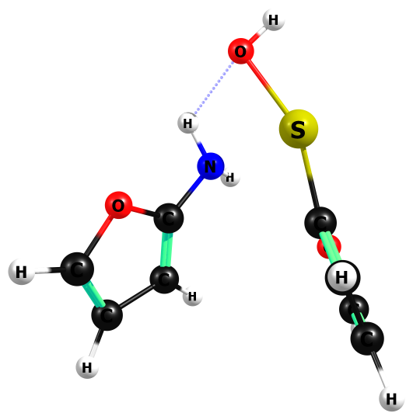

HF/6-311+G(2df,p)

N -0.624601000 1.062653000 -0.871290000

S 0.984837000 1.691966000 0.386844000

H -0.195934000 0.885719000 -1.757403000

O -0.070979000 3.222732000 -0.048544000

H 0.566586000 3.892924000 -0.228647000

H -1.098949000 1.948220000 -0.891713000

C 1.428560000 -0.032227000 0.263265000

C 1.632445000 -0.919877000 1.246894000

O 1.823707000 -0.558741000 -0.916750000

C 2.219186000 -2.079194000 0.628834000

C 2.291846000 -1.791867000 -0.672758000

H 1.396904000 -0.775345000 2.279172000

H 2.526866000 -2.988805000 1.098824000

H 2.644199000 -2.344867000 -1.515988000

C -1.440835000 -0.003125000 -0.484272000

O -2.270249000 0.250093000 0.520847000

C -1.545421000 -1.266298000 -0.904071000

C -2.556046000 -1.854003000 -0.062437000

C -2.947728000 -0.887632000 0.768557000

H -0.987618000 -1.731512000 -1.687273000

H -2.922298000 -2.857462000 -0.091256000

H -3.666804000 -0.846226000 1.555311000

HF=-984.7449789

Zero-point correction= 0.175175 (Hartree/Particle)

Thermal correction to Energy= 0.186891

Thermal correction to Enthalpy= 0.187835

Thermal correction to Gibbs Free Energy= 0.134849

Sum of electronic and zero-point Energies= -984.569804

Sum of electronic and thermal Energies= -984.558088

Sum of electronic and thermal Enthalpies= -984.557143

Sum of electronic and thermal Free Energies= -984.610130

Frequencies -- -396.9647 20.4883 66.8416

Frequencies -- 68.9576 83.6591 111.1802

Frequencies -- 131.9871 164.8218 275.8526

Frequencies -- 327.5314 362.4195 391.2476

Frequencies -- 412.3253 443.6870 486.5352

Frequencies -- 653.8350 656.8486 734.6150

Frequencies -- 739.1059 761.9197 825.5605

Frequencies -- 850.6517 858.4456 924.6037

Frequencies -- 951.9521 965.7751 970.6121

Frequencies -- 991.2535 998.7267 1008.0255

Frequencies -- 1014.1410 1053.1329 1084.1001

Frequencies -- 1088.2989 1165.5995 1171.3484

Frequencies -- 1178.8468 1198.5156 1234.3682

Frequencies -- 1270.5253 1274.3687 1335.5280

Frequencies -- 1361.5663 1417.3840 1514.2539

Frequencies -- 1575.9972 1631.4910 1691.4047

Frequencies -- 1739.5033 1762.0839 1804.5160

Frequencies -- 3390.0921 3398.1364 3406.8665

Frequencies -- 3412.2416 3423.5776 3440.7519

Frequencies -- 3663.0176 3795.7746 4155.8470

|  |  |
| --- | --- |
| Method | Energy |
| Gas-MP2/aug-ccpV(T+d)z | -987.2228959 |
| Gas-M062X/aug-ccpV(T+d)z | -988.7218366 |
| PCM-Water-MP2/aug-ccpV(T+d)z | -987.2374314 |
| PCM-Water-M062X/aug-ccpV(T+d)z | -988.7365286 |

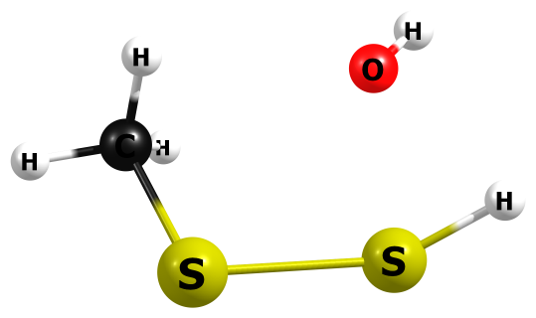

HF/6-311+G(2df,p)

H -2.397725000 0.116066000 0.094082000

S -1.249920000 -0.575533000 0.281850000

S 0.895593000 -0.678308000 -0.381775000

C 1.790005000 0.638675000 0.470573000

H 1.521399000 0.661591000 1.520093000

H 2.854305000 0.430091000 0.386950000

H 1.550280000 1.588253000 0.020904000

O -0.899206000 1.435150000 -0.428074000

H -1.405410000 1.952204000 0.177933000

HF = -910.6483586

Zero-point correction= 0.062457 (Hartree/Particle)

Thermal correction to Energy= 0.069049

Thermal correction to Enthalpy= 0.069993

Thermal correction to Gibbs Free Energy= 0.031744

Sum of electronic and zero-point Energies= -910.585902

Sum of electronic and thermal Energies= -910.579309

Sum of electronic and thermal Enthalpies= -910.578365

Sum of electronic and thermal Free Energies= -910.616615

Frequencies -- -631.4909 86.4693 140.2259

Frequencies -- 193.9675 230.8353 308.7010

Frequencies -- 365.5130 482.2630 772.1212

Frequencies -- 815.4298 1033.9108 1047.0588

Frequencies -- 1092.7876 1443.2510 1564.2168

Frequencies -- 1605.7251 2512.8203 3134.4239

Frequencies -- 3201.0097 3283.9028 4100.7958

|  |  |
| --- | --- |
| Method | Energy |
| Gas-MP2/aug-ccpV(T+d)z | -911.5370005 |
| Gas-M062X/aug-ccpV(T+d)z | -912.6693594 |
| PCM-Water-MP2/aug-ccpV(T+d)z | -911.6265017 |
| PCM-Water-M062X/aug-ccpV(T+d)z | -912.7605133 |

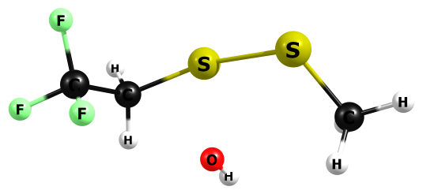

HF/6-311+G(2df,p)

C -1.128569000 0.242158000 1.010836000

H -1.543563000 -0.334475000 1.836803000

H -1.138080000 1.291464000 1.237582000

S 0.568541000 -0.474276000 0.865455000

S 2.341215000 -0.774598000 -0.429837000

C 3.532547000 0.568806000 -0.224909000

H 3.666295000 0.808385000 0.823230000

H 3.198847000 1.444775000 -0.756407000

O 0.773197000 1.514953000 -0.009130000

H 1.152480000 1.992321000 0.710055000

C -2.050502000 -0.004477000 -0.151497000

F -1.653207000 0.489119000 -1.293269000

F -2.282770000 -1.293496000 -0.348150000

F -3.250816000 0.537647000 0.093573000

H 4.482621000 0.221534000 -0.624076000

HF=-1285.4361542

Zero-point correction= 0.100275 (Hartree/Particle)

Thermal correction to Energy= 0.111190

Thermal correction to Enthalpy= 0.112135

Thermal correction to Gibbs Free Energy= 0.062036

Sum of electronic and zero-point Energies= -1285.335879

Sum of electronic and thermal Energies= -1285.324964

Sum of electronic and thermal Enthalpies= -1285.324020

Sum of electronic and thermal Free Energies= -1285.374118

Frequencies -- -470.4129 43.9240 47.9780

Frequencies -- 80.5617 123.8605 167.6218

Frequencies -- 189.2041 213.6254 263.1749

Frequencies -- 300.2268 315.4645 341.6865

Frequencies -- 379.5297 477.2508 571.7056

Frequencies -- 586.9894 689.1160 733.0593

Frequencies -- 761.2380 770.6315 910.5573

Frequencies -- 951.5543 1029.2691 1042.8587

Frequencies -- 1175.3519 1214.8935 1365.3324

Frequencies -- 1412.7978 1442.2460 1447.4668

Frequencies -- 1567.9819 1568.8002 1607.1136

Frequencies -- 3139.6265 3145.6109 3203.7560

Frequencies -- 3283.9247 3326.7744 4122.9511

|  |  |
| --- | --- |
| Method | Energy |
| Gas-MP2/aug-ccpV(T+d)z | -1287.434422 |
| Gas-M062X/aug-ccpV(T+d)z | -1289.071973 |
| PCM-Water-MP2/aug-ccpV(T+d)z | -1287.51631 |
| PCM-Water-M062X/aug-ccpV(T+d)z | -1289.155409 |

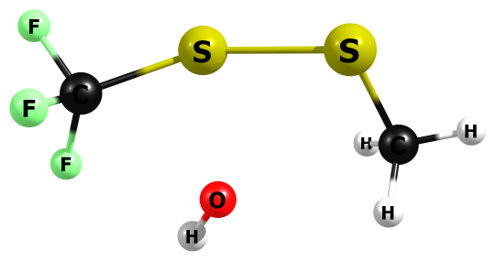

HF/6-311+G(2df,p)

C 1.597259000 -0.018669000 -0.013074000

F 1.936163000 0.191738000 1.234189000

F 2.394640000 -1.006573000 -0.444631000

F 1.973850000 1.039496000 -0.709105000

S -0.093255000 -0.682094000 -0.311832000

S -2.134289000 -0.673065000 0.377476000

C -3.015477000 0.648966000 -0.476319000

H -2.725883000 0.682361000 -1.518650000

H -4.076212000 0.418618000 -0.411784000

H -2.793106000 1.592464000 -0.008219000

O -0.375286000 1.396411000 0.411186000

H 0.005629000 2.014079000 -0.188857000

HF=-1246.3922238

Zero-point correction= 0.070607 (Hartree/Particle)

Thermal correction to Energy= 0.080055

Thermal correction to Enthalpy= 0.080999

Thermal correction to Gibbs Free Energy= 0.035161

Sum of electronic and zero-point Energies= -1246.321617

Sum of electronic and thermal Energies= -1246.312169

Sum of electronic and thermal Enthalpies= -1246.311225

Sum of electronic and thermal Free Energies= -1246.357063

Frequencies -- -389.8450 55.6248 99.2382

Frequencies -- 134.3779 177.7373 209.5239

Frequencies -- 230.4755 271.4937 333.2770

Frequencies -- 366.2743 371.6917 420.9733

Frequencies -- 484.7044 596.8060 603.3545

Frequencies -- 766.7268 781.8998 811.5010

Frequencies -- 1038.5459 1050.0773 1174.2746

Frequencies -- 1274.4365 1314.5619 1445.3558

Frequencies -- 1560.7597 1604.6859 3143.5560

Frequencies -- 3220.0734 3301.3741 4149.5603

|  |  |
| --- | --- |
| Method | Energy |
| Gas-MP2/aug-ccpV(T+d)z | -1248.208856 |
| Gas-M062X/aug-ccpV(T+d)z | -1249.766178 |
| PCM-Water-MP2/aug-ccpV(T+d)z | -1248.291276 |
| PCM-Water-M062X/aug-ccpV(T+d)z | -1249.849609 |

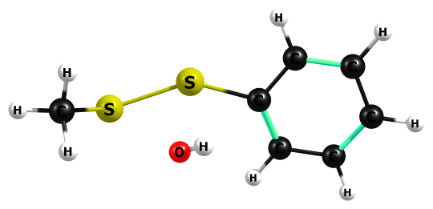

HF/6-311+G(2df,p)

S 2.840163000 0.067095000 -0.704696000

S 0.753088000 -0.633620000 -0.463410000

C -0.971770000 -0.192040000 -0.120974000

C -1.531404000 1.054583000 -0.395187000

C -1.811881000 -1.222681000 0.255996000

H -0.880417000 1.862187000 -0.665155000

H -1.393982000 -2.190231000 0.471132000

C -2.888484000 1.248463000 -0.292708000

C -3.184115000 -1.024873000 0.361236000

H -3.303591000 2.218512000 -0.507313000

H -3.817254000 -1.841469000 0.664333000

C -3.730037000 0.207776000 0.088052000

H -4.790783000 0.367447000 0.170383000

O 0.937438000 0.942941000 1.047576000

H 0.370729000 0.708579000 1.764368000

C 3.667814000 0.003294000 0.899889000

H 3.392458000 -0.900476000 1.428529000

H 4.739483000 -0.010468000 0.713667000

H 3.391083000 0.859656000 1.491305000

HF=-1140.2538282

Zero-point correction= 0.149870 (Hartree/Particle)

Thermal correction to Energy= 0.160693

Thermal correction to Enthalpy= 0.161638

Thermal correction to Gibbs Free Energy= 0.111502

Sum of electronic and zero-point Energies= -1140.103958

Sum of electronic and thermal Energies= -1140.093135

Sum of electronic and thermal Enthalpies= -1140.092191

Sum of electronic and thermal Free Energies= -1140.142326

Frequencies -- -440.5067 23.4616 54.7250

Frequencies -- 90.1050 131.2433 160.9600

Frequencies -- 217.7122 255.7738 271.7453

Frequencies -- 308.4788 333.2279 377.6593

Frequencies -- 431.1412 451.5686 567.2704

Frequencies -- 673.7064 729.4180 765.8142

Frequencies -- 767.5461 807.5577 829.1293

Frequencies -- 938.3165 1007.2737 1032.5786

Frequencies -- 1047.2969 1070.2815 1083.0687

Frequencies -- 1096.7521 1107.7721 1151.3521

Frequencies -- 1171.2287 1196.9114 1277.0223

Frequencies -- 1308.8117 1440.1340 1444.6982

Frequencies -- 1561.7619 1574.7973 1601.2794

Frequencies -- 1622.1171 1734.9164 1753.7326

Frequencies -- 3137.1553 3213.4279 3278.5894

Frequencies -- 3290.2741 3293.0231 3308.5704

Frequencies -- 3318.3721 3361.4594 4114.1144

|  |  |
| --- | --- |
| Method | Energy |
| Gas-MP2/aug-ccpV(T+d)z | -1142.106589 |
| Gas-M062X/aug-ccpV(T+d)z | -1143.706877 |
| PCM-Water-MP2/aug-ccpV(T+d)z | -1142.190107 |
| PCM-Water-M062X/aug-ccpV(T+d)z | -1143.79203 |

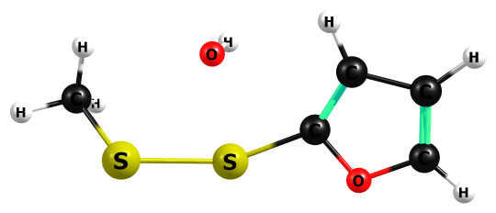

HF/6-311+G(2df,p)

S 2.442332000 -0.607998000 -0.567639000

S 0.428251000 -0.674748000 0.314737000

C -1.228170000 -0.025514000 0.085177000

C -1.883285000 1.086118000 -0.300483000

O -2.121484000 -1.025062000 0.278815000

H -1.424636000 2.017438000 -0.532956000

C -3.348656000 -0.546293000 0.029206000

H -4.163563000 -1.225077000 0.159353000

C -3.278675000 0.736048000 -0.336978000

H -4.104812000 1.366014000 -0.597940000

O 0.800874000 1.453550000 0.193309000

H 0.504727000 1.779886000 1.027338000

C 3.510108000 0.555767000 0.314163000

H 3.350688000 0.479996000 1.381417000

H 4.538000000 0.277103000 0.090497000

H 3.307208000 1.563913000 -0.004790000

HF=-1138.1870539

Zero-point correction= 0.118654 (Hartree/Particle)

Thermal correction to Energy= 0.128515

Thermal correction to Enthalpy= 0.129460

Thermal correction to Gibbs Free Energy= 0.082271

Sum of electronic and zero-point Energies= -1138.068400

Sum of electronic and thermal Energies= -1138.058538

Sum of electronic and thermal Enthalpies= -1138.057594

Sum of electronic and thermal Free Energies= -1138.104783

Frequencies -- -451.9793 45.0568 71.7472

Frequencies -- 115.5725 158.2205 189.1733

Frequencies -- 244.3441 272.5881 291.5595

Frequencies -- 328.4571 354.0137 429.6310

Frequencies -- 464.4131 661.4772 722.4383

Frequencies -- 763.0211 788.1382 814.2101

Frequencies -- 924.4458 965.7492 981.7052

Frequencies -- 984.5202 1032.7801 1046.0145

Frequencies -- 1075.9913 1139.0464 1195.4340

Frequencies -- 1264.9339 1311.9407 1445.6564

Frequencies -- 1502.9817 1562.4819 1598.4370

Frequencies -- 1622.8560 1720.5652 3134.7982

Frequencies -- 3220.8748 3294.7947 3361.9681

Frequencies -- 3408.0531 3455.6842 4117.1229

|  |  |
| --- | --- |
| Method | Energy |
| Gas-MP2/aug-ccpV(T+d)z | -1139.952679 |
| Gas-M062X/aug-ccpV(T+d)z | -1141.499986 |
| PCM-Water-MP2/aug-ccpV(T+d)z | -1140.036 |
| PCM-Water-M062X/aug-ccpV(T+d)z | -1141.584754 |

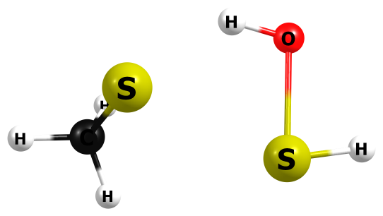

HF/6-311+G(2df,p)

S 1.084261000 0.342162000 -0.637851000

S -1.242635000 -0.774374000 -0.137616000

H -2.508017000 -0.688319000 0.325536000

H -0.490273000 1.378943000 0.136278000

O -1.410844000 1.121633000 0.363153000

H -1.543984000 1.223099000 1.296830000

C 1.974603000 -0.389604000 0.767041000

H 1.811296000 0.160598000 1.684844000

H 1.670586000 -1.418961000 0.912681000

H 3.033514000 -0.375416000 0.543834000

HF=-911.2031878

Zero-point correction= 0.076895 (Hartree/Particle)

Thermal correction to Energy= 0.083504

Thermal correction to Enthalpy= 0.084448

Thermal correction to Gibbs Free Energy= 0.045537

Sum of electronic and zero-point Energies= -911.126293

Sum of electronic and thermal Energies= -911.119684

Sum of electronic and thermal Enthalpies= -911.118740

Sum of electronic and thermal Free Energies= -911.157651

Frequencies -- -504.9500 59.8463 100.6625

Frequencies -- 146.2835 295.8277 340.9871

Frequencies -- 411.7359 553.5082 763.8826

Frequencies -- 839.7629 930.1054 1037.7498

Frequencies -- 1048.6447 1234.3942 1472.4601

Frequencies -- 1594.3189 1595.6894 1713.0335

Frequencies -- 2627.2132 3162.5214 3229.3443

Frequencies -- 3238.5089 3275.6833 4080.8798

|  |  |
| --- | --- |
| Method | Energy |
| Gas-MP2/aug-ccpV(T+d)z | -912.0755664 |
| Gas-M062X/aug-ccpV(T+d)z | -913.2134815 |
| PCM-Water-MP2/aug-ccpV(T+d)z | -912.0857972 |
| PCM-Water-M062X/aug-ccpV(T+d)z | -913.2257956 |

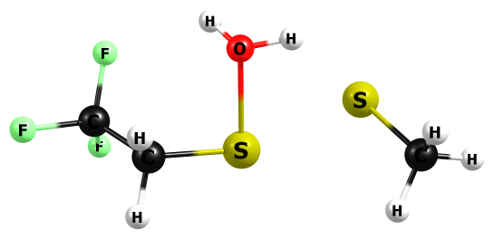

HF/6-311+G(2df,p)

S -2.858744000 0.427349000 0.577786000

S -0.525146000 -0.596797000 0.137798000

H 0.067105000 1.799105000 -0.273666000

O -0.506365000 1.191570000 -0.724495000

H -1.437533000 1.418565000 -0.543905000

C -3.769149000 -0.692431000 -0.522457000

H -4.794569000 -0.748648000 -0.181396000

H -3.761397000 -0.345739000 -1.546942000

H -3.341055000 -1.687103000 -0.480156000

C 1.114821000 -0.759038000 -0.658404000

H 1.098069000 -0.475040000 -1.699470000

H 1.299221000 -1.826753000 -0.595583000

C 2.268191000 -0.072313000 0.030374000

F 2.434879000 -0.492548000 1.259425000

F 3.391239000 -0.285330000 -0.618549000

F 2.105010000 1.243092000 0.089199000

HF=-1285.9896798

Zero-point correction= 0.114898 (Hartree/Particle)

Thermal correction to Energy= 0.125874

Thermal correction to Enthalpy= 0.126819

Thermal correction to Gibbs Free Energy= 0.076276

Sum of electronic and zero-point Energies= -1285.874781

Sum of electronic and thermal Energies= -1285.863805

Sum of electronic and thermal Enthalpies= -1285.862861

Sum of electronic and thermal Free Energies= -1285.913404

Frequencies -- -445.9371 42.7319 62.7434

Frequencies -- 65.4598 100.5398 133.6829

Frequencies -- 149.2116 226.7327 266.6411

Frequencies -- 282.9960 356.7580 363.5254

Frequencies -- 420.0975 455.2373 572.1720

Frequencies -- 588.0360 700.3817 766.2340

Frequencies -- 780.6656 849.4874 917.4881

Frequencies -- 923.7941 1019.3898 1041.6007

Frequencies -- 1051.0127 1197.0721 1290.5810

Frequencies -- 1377.0288 1424.3275 1461.9887

Frequencies -- 1472.5509 1570.8442 1591.7975

Frequencies -- 1596.4962 1707.6338 3163.3362

Frequencies -- 3199.1303 3231.3440 3245.5660

Frequencies -- 3282.4938 3413.8826 4071.8765

|  |  |
| --- | --- |
| Method | Energy |
| Gas-MP2/aug-ccpV(T+d)z | -1287.970674 |
| Gas-M062X/aug-ccpV(T+d)z | -1289.613129 |
| PCM-Water-MP2/aug-ccpV(T+d)z | -1287.979639 |
| PCM-Water-M062X/aug-ccpV(T+d)z | -1289.624283 |

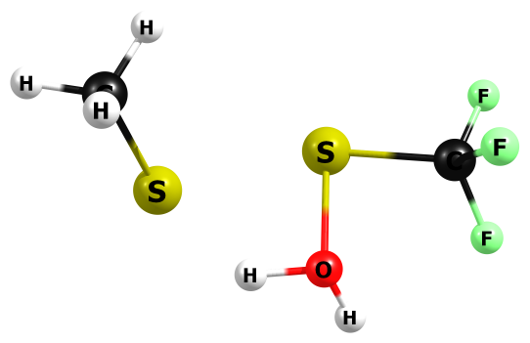

HF/6-311+G(2df,p)

S 2.501240000 0.366302000 -0.453093000

S 0.027252000 -0.258881000 -0.489906000

H -0.303682000 2.052494000 0.174924000

O 0.118357000 1.305943000 0.585356000

H 1.099742000 1.406451000 0.563703000

C 3.057045000 -0.960679000 0.657334000

H 4.119480000 -1.101460000 0.510727000

H 2.877290000 -0.717728000 1.695404000

H 2.551110000 -1.886728000 0.414755000

C -1.744297000 -0.179064000 0.016428000

F -1.959901000 -0.385732000 1.289037000

F -2.327085000 -1.137629000 -0.659665000

F -2.337810000 0.958821000 -0.295700000

HF=-1246.9310223

Zero-point correction= 0.084437 (Hartree/Particle)

Thermal correction to Energy= 0.094161

Thermal correction to Enthalpy= 0.095106

Thermal correction to Gibbs Free Energy= 0.047876

Sum of electronic and zero-point Energies= -1246.846585

Sum of electronic and thermal Energies= -1246.836861

Sum of electronic and thermal Enthalpies= -1246.835917

Sum of electronic and thermal Free Energies= -1246.883147

Frequencies -- -373.8223 52.0200 75.0255

Frequencies -- 87.2055 125.0703 157.5730

Frequencies -- 182.1591 305.8420 365.4323

Frequencies -- 378.2811 399.7458 420.2133

Frequencies -- 464.9406 593.4361 609.8633

Frequencies -- 763.1203 820.0741 903.8616

Frequencies -- 1038.4599 1051.0748 1060.2524

Frequencies -- 1276.5034 1315.6904 1354.4790

Frequencies -- 1475.8286 1593.2365 1596.6195

Frequencies -- 1689.7576 3170.6708 3192.5582

Frequencies -- 3242.5445 3252.5137 4049.6296

|  |  |
| --- | --- |
| Method | Energy |
| Gas-MP2/aug-ccpV(T+d)z | -1248.734482 |
| Gas-M062X/aug-ccpV(T+d)z | -1250.294778 |
| PCM-Water-MP2/aug-ccpV(T+d)z | -1248.74366 |
| PCM-Water-M062X/aug-ccpV(T+d)z | -1250.305144 |

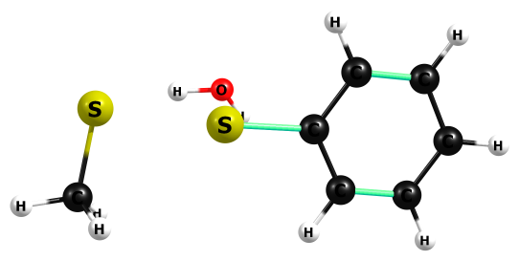

HF/6-311+G(2df,p)

S -3.243195000 -0.486757000 -0.077791000

S -0.631583000 -0.129273000 -0.615075000

C 1.097840000 -0.010167000 -0.230455000

C 1.935685000 -1.112497000 -0.363825000

C 1.640026000 1.229663000 0.074479000

H 1.514868000 -2.069379000 -0.608578000

H 0.994147000 2.083441000 0.163712000

C 3.294273000 -0.973016000 -0.185602000

C 3.005165000 1.369162000 0.247438000

H 3.939410000 -1.825247000 -0.290642000

H 3.421087000 2.332389000 0.477022000

C 3.828586000 0.268715000 0.120118000

H 4.889361000 0.375533000 0.253301000

H -1.764979000 -0.873162000 1.326969000

O -0.791522000 -0.891707000 1.283042000

H -0.421915000 -0.321611000 1.943623000

C -3.641263000 1.284292000 -0.044941000

H -4.683486000 1.411333000 -0.308813000

H -3.480569000 1.719424000 0.933397000

H -3.041167000 1.820517000 -0.771746000

HF=-1140.8134552

Zero-point correction= 0.164005 (Hartree/Particle)

Thermal correction to Energy= 0.175199

Thermal correction to Enthalpy= 0.176143

Thermal correction to Gibbs Free Energy= 0.124841

Sum of electronic and zero-point Energies= -1140.649451

Sum of electronic and thermal Energies= -1140.638256

Sum of electronic and thermal Enthalpies= -1140.637312

Sum of electronic and thermal Free Energies= -1140.688614

Frequencies -- -449.9644 38.1610 52.8796

Frequencies -- 72.4414 90.3944 97.8817

Frequencies -- 146.5768 217.4936 279.6192

Frequencies -- 326.5605 340.2909 384.8617

Frequencies -- 416.7935 453.7089 547.4063

Frequencies -- 671.9954 753.0163 762.2264

Frequencies -- 766.5558 770.9128 845.7092

Frequencies -- 954.0096 955.5197 1033.7559

Frequencies -- 1045.7101 1061.0419 1082.2353

Frequencies -- 1110.4707 1111.9985 1128.5996

Frequencies -- 1163.1286 1178.1293 1198.1658

Frequencies -- 1287.3923 1318.9845 1448.8402

Frequencies -- 1468.5467 1585.0272 1592.9839

Frequencies -- 1596.4867 1630.8723 1694.6911

Frequencies -- 1746.2002 1759.7005 3154.4409

Frequencies -- 3217.7203 3231.9633 3317.7222

Frequencies -- 3327.3858 3336.3001 3345.1697

Frequencies -- 3351.5959 3424.5490 4094.8519

|  |  |
| --- | --- |
| Method | Energy |
| Gas-MP2/aug-ccpV(T+d)z | -1142.643328 |
| Gas-M062X/aug-ccpV(T+d)z | -1144.250533 |
| PCM-Water-MP2/aug-ccpV(T+d)z | -1142.653261 |
| PCM-Water-M062X/aug-ccpV(T+d)z | -1144.263701 |

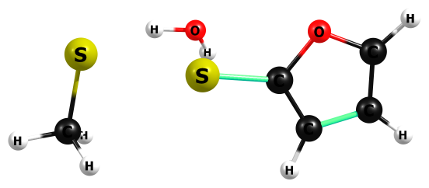

HF/6-311+G(2df,p)

S -2.957059000 -0.474920000 -0.222243000

S -0.314686000 0.019336000 -0.620667000

C 1.347023000 0.139953000 -0.179425000

O 2.193863000 -0.896042000 -0.361876000

C 2.043685000 1.225799000 0.219311000

H 1.627474000 2.186837000 0.434002000

C 3.416028000 -0.465570000 -0.083117000

H 4.206577000 -1.177844000 -0.180636000

C 3.412829000 0.829073000 0.274703000

H 4.260622000 1.422575000 0.539866000

H -1.486415000 -1.130986000 1.081654000

O -0.511318000 -1.091806000 1.106128000

H -0.235949000 -0.611404000 1.875180000

C -3.388607000 1.229051000 0.237637000

H -4.427370000 1.404196000 -0.011970000

H -3.258166000 1.410276000 1.297282000

H -2.784973000 1.938636000 -0.317499000

HF=-1138.7465121

Zero-point correction= 0.132344 (Hartree/Particle)

Thermal correction to Energy= 0.142815

Thermal correction to Enthalpy= 0.143759

Thermal correction to Gibbs Free Energy= 0.094223

Sum of electronic and zero-point Energies= -1138.614168

Sum of electronic and thermal Energies= -1138.603697

Sum of electronic and thermal Enthalpies= -1138.602753

Sum of electronic and thermal Free Energies= -1138.652289

Frequencies -- -437.6158 47.4445 52.5728

Frequencies -- 85.8705 97.3466 106.3834

Frequencies -- 138.2666 202.2575 309.2023

Frequencies -- 344.7799 357.8849 395.8215

Frequencies -- 467.6177 652.3300 725.3338

Frequencies -- 764.3385 768.2733 875.0660

Frequencies -- 946.9521 969.8550 996.1701

Frequencies -- 1007.8604 1032.9310 1036.1818

Frequencies -- 1044.4233 1086.4084 1190.4878

Frequencies -- 1240.3424 1275.4271 1345.4648

Frequencies -- 1468.5992 1528.1803 1589.7503

Frequencies -- 1593.6346 1596.9389 1713.2431

Frequencies -- 1723.8594 3153.4265 3215.4594

Frequencies -- 3230.5743 3388.0089 3397.6496

Frequencies -- 3408.6303 3426.5066 4094.7223

|  |  |
| --- | --- |
| Method | Energy |
| Gas-MP2/aug-ccpV(T+d)z | -1140.492448 |
| Gas-M062X/aug-ccpV(T+d)z | -1142.044804 |
| PCM-Water-MP2/aug-ccpV(T+d)z | -1140.503743 |
| PCM-Water-M062X/aug-ccpV(T+d)z | -1142.059221 |

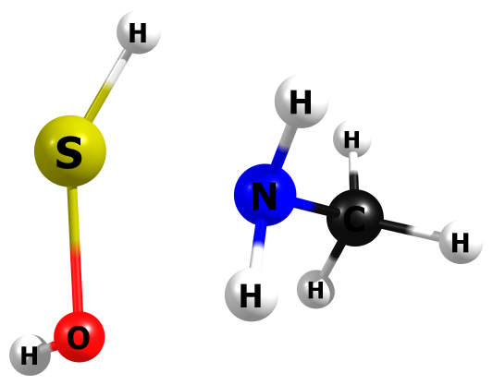

HF/6-311+G(2df,p)

H 0.309172000 -1.777309000 -0.129589000

S 1.021649000 -0.604352000 -0.129654000

N -0.888211000 -0.150208000 0.613741000

C -1.872756000 0.138278000 -0.425803000

H -1.520154000 0.979767000 -1.000823000

H -1.965665000 -0.722907000 -1.073763000

H -2.845587000 0.368165000 -0.003231000

H -1.172383000 -0.924409000 1.181412000

H -0.737047000 0.647962000 1.196235000

O 0.930722000 1.222225000 0.083587000

H 1.593512000 1.542349000 -0.505852000

HF=-568.7112527

Zero-point correction= 0.095508 (Hartree/Particle)

Thermal correction to Energy= 0.101601

Thermal correction to Enthalpy= 0.102545

Thermal correction to Gibbs Free Energy= 0.065983

Sum of electronic and zero-point Energies= -568.615745

Sum of electronic and thermal Energies= -568.609652

Sum of electronic and thermal Enthalpies= -568.608708

Sum of electronic and thermal Free Energies= -568.645269

Frequencies -- -527.0701 84.3556 174.1533

Frequencies -- 233.0138 251.7525 447.4025

Frequencies -- 506.0598 544.9513 781.7934

Frequencies -- 1062.4428 1087.6717 1117.5850

Frequencies -- 1144.9480 1326.9531 1345.8984

Frequencies -- 1453.6181 1573.8344 1616.6432

Frequencies -- 1625.2925 1772.2561 2406.0664

Frequencies -- 3169.1350 3238.7877 3293.9911

Frequencies -- 3712.6684 3805.9862 4145.8816

|  |  |
| --- | --- |
| Method | Energy |
| Gas-MP2/aug-ccpV(T+d)z | -569.6166045 |
| Gas-M062X/aug-ccpV(T+d)z | -570.3700233 |
| PCM-Water-MP2/aug-ccpV(T+d)z | -569.6292452 |
| PCM-Water-M062X/aug-ccpV(T+d)z | -570.3823185 |

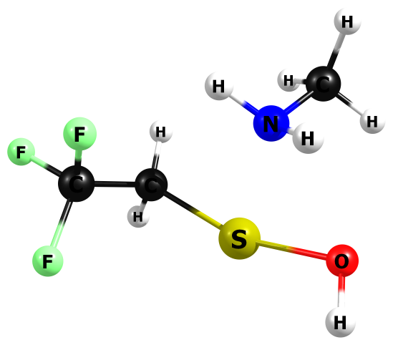

HF/6-311+G(2df,p)

C 1.720057000 0.069107000 -0.025739000

F 1.403953000 0.780440000 -1.101663000

F 2.784935000 0.650256000 0.497836000

F 2.095267000 -1.113598000 -0.446952000

C 0.592814000 0.005417000 0.969271000

H 0.409966000 1.002003000 1.349431000

H 0.937652000 -0.613351000 1.793111000

S -0.940384000 -0.958455000 0.477829000

N -1.424831000 0.904594000 -0.475657000

C -2.431608000 1.626514000 0.302608000

H -3.283862000 0.981447000 0.443966000

H -2.020608000 1.883641000 1.269433000

H -2.743253000 2.536068000 -0.200195000

H -0.631081000 1.481742000 -0.664183000

H -1.811710000 0.600004000 -1.344196000

O -2.428592000 -1.235678000 -0.503256000

H -2.253373000 -2.043104000 -0.956819000

HF=-943.494108

Zero-point correction= 0.133419 (Hartree/Particle)

Thermal correction to Energy= 0.143727

Thermal correction to Enthalpy= 0.144671

Thermal correction to Gibbs Free Energy= 0.096801

Sum of electronic and zero-point Energies= -943.360689

Sum of electronic and thermal Energies= -943.350381

Sum of electronic and thermal Enthalpies= -943.349437

Sum of electronic and thermal Free Energies= -943.397307

Frequencies -- -457.8328 48.2305 80.3436

Frequencies -- 108.5009 136.4646 199.4893

Frequencies -- 221.1073 242.8125 250.6974

Frequencies -- 311.4703 352.3488 443.2861

Frequencies -- 466.2615 533.0821 563.2175

Frequencies -- 590.9521 693.2838 731.8251

Frequencies -- 781.9309 913.4230 952.9878

Frequencies -- 1081.1096 1106.1989 1123.8323

Frequencies -- 1139.5915 1177.5552 1255.5259

Frequencies -- 1349.3008 1366.0731 1411.0135

Frequencies -- 1442.3673 1458.2982 1575.2046

Frequencies -- 1578.5827 1616.4888 1628.2462

Frequencies -- 1774.8068 3172.1698 3180.2997

Frequencies -- 3240.9198 3246.1679 3297.5978

Frequencies -- 3740.7678 3826.4511 4154.0981

|  |  |
| --- | --- |
| Method | Energy |
| Gas-MP2/aug-ccpV(T+d)z | -945.5104917 |
| Gas-M062X/aug-ccpV(T+d)z | -946.7686957 |
| PCM-Water-MP2/aug-ccpV(T+d)z | -945.5224534 |
| PCM-Water-M062X/aug-ccpV(T+d)z | -946.7805335 |

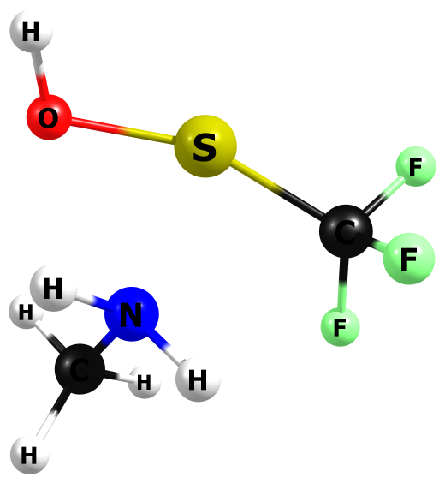

HF/6-311+G(2df,p)

F -1.527320000 0.322262000 1.243848000

C -1.207670000 0.039716000 -0.009399000

F -1.217621000 1.197912000 -0.650069000

F -2.172680000 -0.695214000 -0.508288000

S 0.318720000 -1.010663000 -0.230582000

N 1.148268000 0.787599000 0.583378000

C 1.930512000 1.521743000 -0.419378000

H 2.656289000 0.850713000 -0.848312000

H 1.266162000 1.876350000 -1.192332000

H 2.439301000 2.367198000 0.030992000

H 0.479955000 1.395748000 1.014081000

H 1.753111000 0.432696000 1.294199000

O 2.021246000 -1.365223000 0.063131000

H 2.019353000 -2.136903000 0.605229000

HF=-904.4471852

Zero-point correction= 0.103877 (Hartree/Particle)

Thermal correction to Energy= 0.112812

Thermal correction to Enthalpy= 0.113756

Thermal correction to Gibbs Free Energy= 0.069793

Sum of electronic and zero-point Energies= -904.343308

Sum of electronic and thermal Energies= -904.334373

Sum of electronic and thermal Enthalpies= -904.333429

Sum of electronic and thermal Free Energies= -904.377392

Frequencies -- -403.1982 87.2276 115.3808

Frequencies -- 162.4550 203.1251 227.8001

Frequencies -- 254.4621 268.9965 352.9964

Frequencies -- 368.5976 439.2479 481.1899

Frequencies -- 583.4488 588.2111 621.5943

Frequencies -- 798.0998 812.8749 1084.7513

Frequencies -- 1108.6398 1146.5367 1159.1081

Frequencies -- 1259.8816 1264.3116 1326.8654

Frequencies -- 1380.4310 1459.7616 1577.6356

Frequencies -- 1622.0148 1628.9040 1767.3476

Frequencies -- 3178.6948 3265.6889 3310.8562

Frequencies -- 3728.1965 3815.3342 4145.9472

|  |  |
| --- | --- |
| Method | Energy |
| Gas-MP2/aug-ccpV(T+d)z | -906.2843393 |
| Gas-M062X/aug-ccpV(T+d)z | -907.4614112 |
| PCM-Water-MP2/aug-ccpV(T+d)z | -906.2952676 |
| PCM-Water-M062X/aug-ccpV(T+d)z | -907.4721868 |

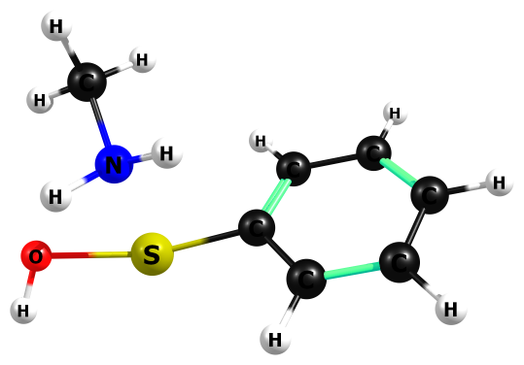

HF/6-311+G(2df,p)

N -1.560290000 0.581998000 0.983508000

S -1.199506000 -0.790104000 -0.648041000

H -0.733534000 0.711374000 1.531715000

O -3.002628000 -0.825433000 -0.235578000

H -3.236299000 -1.720011000 -0.419358000

H -2.248283000 0.090962000 1.515795000

C 0.528496000 -0.324396000 -0.246127000

C 1.155258000 0.686277000 -0.958311000

C 1.272291000 -1.064854000 0.661955000

C 2.497732000 0.959502000 -0.759740000

C 2.610633000 -0.788404000 0.867590000

C 3.225576000 0.226984000 0.157427000

H 0.596236000 1.248911000 -1.683296000

H 0.803112000 -1.870259000 1.197858000

H 2.973871000 1.740285000 -1.324652000

H 3.176300000 -1.371689000 1.571314000

H 4.267821000 0.438102000 0.311578000

C -2.090493000 1.864513000 0.522118000

H -2.349107000 2.509340000 1.356326000

H -1.344296000 2.360189000 -0.082821000

H -2.967632000 1.676211000 -0.075208000

HF=-798.3139971

Zero-point correction= 0.182795 (Hartree/Particle)

Thermal correction to Energy= 0.193259

Thermal correction to Enthalpy= 0.194203

Thermal correction to Gibbs Free Energy= 0.145761

Sum of electronic and zero-point Energies= -798.131202

Sum of electronic and thermal Energies= -798.120738

Sum of electronic and thermal Enthalpies= -798.119794

Sum of electronic and thermal Free Energies= -798.168236

Frequencies -- -449.6888 39.3914 72.9852

Frequencies -- 112.9486 126.3060 155.0413

Frequencies -- 218.4441 241.7188 300.9037

Frequencies -- 322.0540 371.8023 445.1951

Frequencies -- 454.2984 498.4264 585.0295

Frequencies -- 673.4499 729.7087 772.6867

Frequencies -- 784.0490 853.3196 955.9006

Frequencies -- 1044.3373 1064.1885 1080.7646

Frequencies -- 1102.4680 1107.2631 1108.3446

Frequencies -- 1111.0048 1121.3448 1127.0274

Frequencies -- 1155.9586 1169.7492 1186.4147

Frequencies -- 1284.2530 1310.1225 1336.7290

Frequencies -- 1442.6958 1459.9219 1572.6196

Frequencies -- 1580.3709 1618.3767 1627.7023

Frequencies -- 1628.5645 1744.6533 1758.0681

Frequencies -- 1763.6358 3167.0423 3244.6923

Frequencies -- 3302.4373 3306.3883 3313.4407

Frequencies -- 3324.5589 3331.9726 3341.5164

Frequencies -- 3718.8766 3816.0605 4150.4893

|  |  |
| --- | --- |
| Method | Energy |
| Gas-MP2/aug-ccpV(T+d)z | -800.18347 |
| Gas-M062X/aug-ccpV(T+d)z | -801.4045496 |
| PCM-Water-MP2/aug-ccpV(T+d)z | -800.1954297 |
| PCM-Water-M062X/aug-ccpV(T+d)z | -801.4164424 |

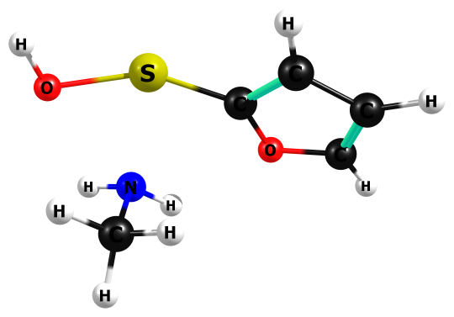

HF/6-311+G(2df,p)

N 1.339624000 1.069377000 -0.394937000

S 0.958276000 -1.024708000 -0.232671000

H 0.646830000 1.464126000 -0.998309000

O 2.768476000 -0.771849000 -0.076240000

H 3.037384000 -1.452977000 0.516911000

H 2.223372000 1.059876000 -0.860000000

C -0.713195000 -0.413129000 -0.015545000

C -1.609392000 -0.816531000 0.897524000

O -1.312481000 0.419931000 -0.898153000

C -2.862423000 -0.206431000 0.537663000

C -2.602875000 0.529871000 -0.544362000

H -1.410310000 -1.466685000 1.721859000

H -3.806404000 -0.304515000 1.029823000

H -3.212108000 1.162334000 -1.152377000

C 1.425566000 1.797168000 0.868004000

H 2.199763000 1.347389000 1.469783000

H 0.479944000 1.724499000 1.387460000

H 1.657704000 2.845294000 0.707589000

HF=-796.2527433

Zero-point correction= 0.151990 (Hartree/Particle)

Thermal correction to Energy= 0.161384

Thermal correction to Enthalpy= 0.162328

Thermal correction to Gibbs Free Energy= 0.116796

Sum of electronic and zero-point Energies= -796.100753

Sum of electronic and thermal Energies= -796.091359

Sum of electronic and thermal Enthalpies= -796.090415

Sum of electronic and thermal Free Energies= -796.135947

Frequencies -- -436.4314 64.3256 79.1983

Frequencies -- 133.1491 168.6265 214.7231

Frequencies -- 240.1556 244.5774 343.8422

Frequencies -- 379.1406 445.7293 473.8768

Frequencies -- 513.0158 656.3750 740.9196

Frequencies -- 824.1296 857.1018 950.9660

Frequencies -- 965.6257 990.6582 1013.4288

Frequencies -- 1077.8297 1084.1877 1103.2484

Frequencies -- 1118.9160 1146.7724 1175.2093

Frequencies -- 1192.5883 1267.8724 1332.9175

Frequencies -- 1347.1025 1460.8239 1514.1345

Frequencies -- 1571.9526 1619.7910 1626.0842

Frequencies -- 1633.7754 1739.4999 1773.1926

Frequencies -- 3168.0757 3240.8633 3290.0004

Frequencies -- 3390.1989 3406.9403 3424.2173

Frequencies -- 3733.8860 3820.6841 4155.5162

|  |  |
| --- | --- |
| Method | Energy |
| Gas-MP2/aug-ccpV(T+d)z | -798.0368926 |
| Gas-M062X/aug-ccpV(T+d)z | -799.2036505 |
| PCM-Water-MP2/aug-ccpV(T+d)z | -798.0484377 |
| PCM-Water-M062X/aug-ccpV(T+d)z | -799.2150565 |

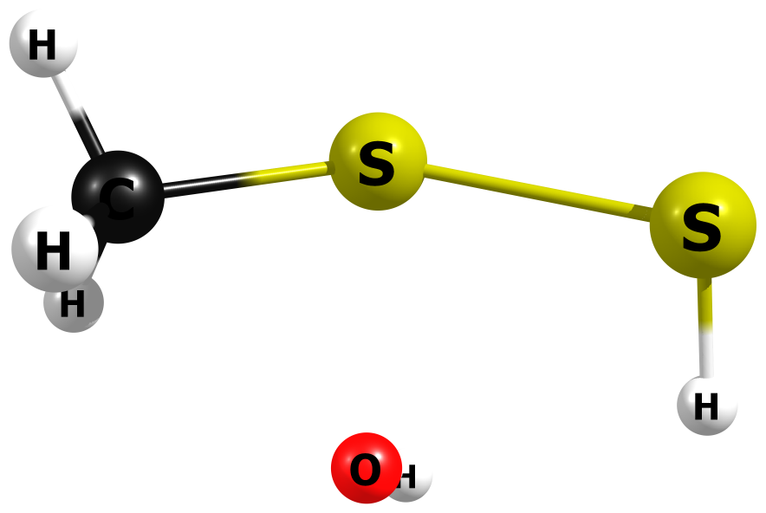

HF/6-311+G(2df,p)

S 0.428092000 -0.622455000 -0.315259000

S -1.774714000 -0.199473000 0.169693000

H -1.994768000 1.077100000 -0.120187000

O 0.448997000 1.559062000 -0.002076000

H 0.131478000 1.856663000 -0.837431000

C 2.093938000 -0.262043000 0.323083000

H 2.614762000 0.469930000 -0.273277000

H 2.046418000 0.079689000 1.346892000

H 2.592467000 -1.232775000 0.291165000

Frequencies -- -534.5975 114.2228 152.6264

Frequencies -- 226.8910 271.0282 296.8746

Frequencies -- 347.0021 408.0564 699.0990

Frequencies -- 716.3826 734.9317 997.2478

Frequencies -- 1040.3017 1429.6917 1551.9090

Frequencies -- 1586.3985 2845.1922 3102.7731

Frequencies -- 3230.7584 3275.8910 4138.6591

Zero-point correction= 0.061889 (Hartree/Particle)

Thermal correction to Energy= 0.068537

Thermal correction to Enthalpy= 0.069481

Thermal correction to Gibbs Free Energy= 0.031451

Sum of electronic and zero-point Energies= -910.584733

Sum of electronic and thermal Energies= -910.578085

Sum of electronic and thermal Enthalpies= -910.577141

Sum of electronic and thermal Free Energies= -910.615172

HF=-910.646622

|  |  |
| --- | --- |
| Method | Energy |
| Gas-MP2/aug-ccpV(T+d)z | -911.5349782 |
| Gas-M062X/aug-ccpV(T+d)z | -912.6670788 |
| PCM-Water-MP2/aug-ccpV(T+d)z | -911.6225477 |
| PCM-Water-M062X/aug-ccpV(T+d)z | -912.7566136 |

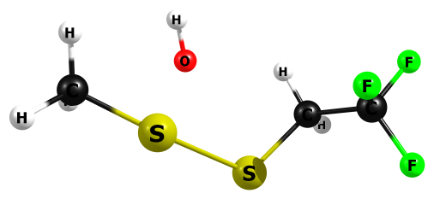

HF/6-311+G(2df,p)

C -3.672403000 0.423080000 0.368682000

H -4.077527000 0.236354000 -0.614012000

H -4.270623000 -0.099830000 1.117177000

S -2.027776000 -0.350555000 0.565899000

S -0.266010000 -1.203440000 -0.571762000

C 0.991994000 0.045822000 -0.908556000

H 1.499613000 -0.195360000 -1.835895000

H 0.468706000 0.981195000 -1.021758000

O -1.688567000 1.171722000 -0.981863000

H -1.843978000 1.997802000 -0.555078000

C 2.059337000 0.195388000 0.137575000

F 2.786681000 -0.897355000 0.305649000

F 2.924437000 1.149066000 -0.216161000

F 1.604456000 0.536991000 1.321949000

H -3.680804000 1.485921000 0.569131000

Frequencies -- -493.4602 25.3406 38.9207

Frequencies -- 70.2264 124.4327 203.6489

Frequencies -- 225.0544 252.9496 298.4220

Frequencies -- 313.0782 325.7423 380.0599

Frequencies -- 401.8758 429.5716 579.5566

Frequencies -- 585.6220 684.5441 693.6155

Frequencies -- 768.8274 837.1114 918.5305

Frequencies -- 939.8019 989.9098 1031.3861

Frequencies -- 1182.6535 1228.9702 1361.6545

Frequencies -- 1418.0194 1429.9315 1450.6193

Frequencies -- 1563.7700 1586.4945 1592.1094

Frequencies -- 3105.1455 3191.6888 3209.9063

Frequencies -- 3268.3234 3295.9810 4124.2828

Zero-point correction= 0.100530 (Hartree/Particle)

Thermal correction to Energy= 0.111254

Thermal correction to Enthalpy= 0.112198

Thermal correction to Gibbs Free Energy= 0.061892

Sum of electronic and zero-point Energies= -1285.340478

Sum of electronic and thermal Energies= -1285.329754

Sum of electronic and thermal Enthalpies= -1285.328810

Sum of electronic and thermal Free Energies= -1285.379116

HF=-1285.4410084

|  |  |
| --- | --- |
| Method | Energy |
| Gas-MP2/aug-ccpV(T+d)z | -1287.437499 |
| Gas-M062X/aug-ccpV(T+d)z | -1289.075088 |
| PCM-Water-MP2/aug-ccpV(T+d)z | -1287.518511 |
| PCM-Water-M062X/aug-ccpV(T+d)z | -1289.157335 |

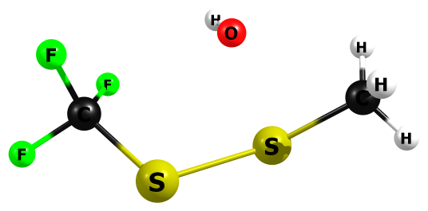

HF/6-311+G(2df,p)

C -3.245186000 0.283779000 -0.232706000

H -3.151117000 0.466846000 -1.292187000

H -4.051292000 -0.430806000 -0.057668000

H -3.423063000 1.217388000 0.275194000

S -1.771399000 -0.571881000 0.396986000

S 0.248934000 -1.057559000 -0.414443000

C 1.583856000 0.074310000 0.015258000

F 1.452891000 0.650085000 1.192266000

F 2.719582000 -0.630817000 0.082192000

F 1.825018000 1.026466000 -0.854992000

O -1.030983000 1.429174000 -0.214831000

H -0.776672000 1.824090000 0.602109000

Frequencies -- -488.5044 42.7142 86.1449

Frequencies -- 117.5920 167.1915 189.6728

Frequencies -- 272.1124 286.9639 301.3928

Frequencies -- 363.5733 399.0159 416.2139

Frequencies -- 499.1653 596.9108 608.0633

Frequencies -- 687.8045 718.2621 827.8594

Frequencies -- 1000.6367 1039.5238 1203.5426

Frequencies -- 1277.2479 1301.3069 1436.8488

Frequencies -- 1553.2155 1581.4227 3107.1281

Frequencies -- 3243.0743 3288.1803 4139.1468

Zero-point correction= 0.070058 (Hartree/Particle)

Thermal correction to Energy= 0.079615

Thermal correction to Enthalpy= 0.080559

Thermal correction to Gibbs Free Energy= 0.034178

Sum of electronic and zero-point Energies= -1246.312479

Sum of electronic and thermal Energies= -1246.302922

Sum of electronic and thermal Enthalpies= -1246.301978

Sum of electronic and thermal Free Energies= -1246.348359

HF=-1246.3825368

|  |  |
| --- | --- |
| Method | Energy |
| Gas-MP2/aug-ccpV(T+d)z | -1248.200067 |
| Gas-M062X/aug-ccpV(T+d)z | -1249.756975 |
| PCM-Water-MP2/aug-ccpV(T+d)z | -1248.280845 |
| PCM-Water-M062X/aug-ccpV(T+d)z | -1249.839401 |

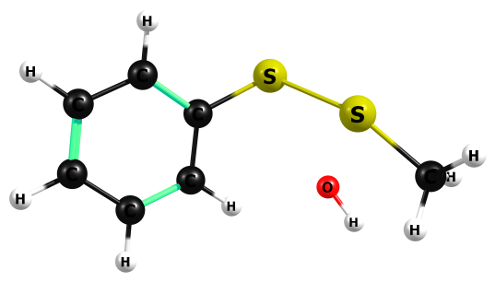

C -2.076432000 -1.162586000 -0.204252000

C -0.989136000 -0.420774000 0.243696000

C -3.277417000 -0.549966000 -0.515257000

H -4.106743000 -1.146684000 -0.854654000

C -1.126332000 0.960930000 0.353319000

C -3.407134000 0.820550000 -0.406277000

H -0.273691000 1.518695000 0.691168000

H -4.336655000 1.301660000 -0.656284000

C -2.322444000 1.567234000 0.023475000

H -2.411254000 2.636758000 0.109466000

H -1.976123000 -2.227093000 -0.310301000

S 0.498236000 -1.260819000 0.701271000

S 2.167894000 -0.445604000 -0.563067000

O 1.812310000 1.107867000 1.031735000

H 2.387789000 1.853436000 0.992112000

C 3.545149000 0.735328000 -0.794927000

H 3.202314000 1.725143000 -1.061825000

H 4.198313000 0.777903000 0.064536000

H 4.081963000 0.295721000 -1.638012000

HF=-1140.2561487

Zero-point correction= 0.150261 (Hartree/Particle)

Thermal correction to Energy= 0.160785

Thermal correction to Enthalpy= 0.161729

Thermal correction to Gibbs Free Energy= 0.112337

Sum of electronic and zero-point Energies= -1140.105887

Sum of electronic and thermal Energies= -1140.095364

Sum of electronic and thermal Enthalpies= -1140.094419

Sum of electronic and thermal Free Energies= -1140.143811

Frequencies -- -467.5410 30.2332 39.0361

Frequencies -- 114.8581 140.7169 207.4255

Frequencies -- 224.0008 242.1197 322.2070

Frequencies -- 354.7704 380.6855 406.1870

Frequencies -- 449.0826 460.1323 542.2787

Frequencies -- 674.9972 687.3966 758.0374

Frequencies -- 766.0541 805.9746 826.5091

Frequencies -- 950.8672 989.2759 1027.9563

Frequencies -- 1032.6465 1075.0720 1083.9381

Frequencies -- 1115.6174 1144.1601 1159.4989

Frequencies -- 1184.6045 1190.2451 1283.6158

Frequencies -- 1303.0642 1419.8216 1453.4452

Frequencies -- 1567.3876 1576.4160 1601.7130

Frequencies -- 1628.2368 1733.9213 1754.4979

Frequencies -- 3102.8620 3212.4003 3260.7066

Frequencies -- 3279.3701 3292.6955 3312.0441

Frequencies -- 3327.2953 3340.9592 4120.0343

|  |  |
| --- | --- |
| Method | Energy |
| Gas-MP2/aug-ccpV(T+d)z | -1142.10804 |
| Gas-M062X/aug-ccpV(T+d)z | -1143.708818 |
| PCM-Water-MP2/aug-ccpV(T+d)z | -1142.19337 |
| PCM-Water-M062X/aug-ccpV(T+d)z | -1143.795614 |

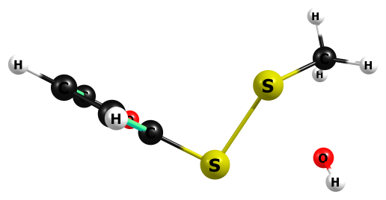

HF/6-311+G(2df,p)

S 0.256801000 -1.211707000 -0.065273000

S 1.511778000 0.684489000 0.285338000

O 2.880150000 -1.061317000 -0.041013000

H 2.882799000 -1.493120000 0.796414000

C -3.177785000 0.636732000 0.604876000

C -1.979758000 0.037085000 1.118394000

C -1.284647000 -0.419249000 0.057500000

O -1.978921000 -0.131763000 -1.072293000

C -3.103660000 0.491777000 -0.723149000

H -3.969904000 1.105479000 1.151175000

H -1.671767000 -0.048064000 2.137864000

H -3.760724000 0.776733000 -1.516556000

C 3.050733000 1.405278000 -0.348691000

H 3.231139000 1.095303000 -1.366926000

H 2.846729000 2.477899000 -0.328855000

H 3.905333000 1.156160000 0.258708000

Frequencies -- -486.0344 38.5683 64.1740

Frequencies -- 80.8532 97.7385 197.4776

Frequencies -- 253.6120 273.0658 279.8087

Frequencies -- 346.4078 393.2351 401.1601

Frequencies -- 523.4159 662.1554 687.5543

Frequencies -- 725.6034 742.1502 833.7226

Frequencies -- 913.2467 969.4445 983.3483

Frequencies -- 998.5263 1011.1251 1040.1219

Frequencies -- 1084.2530 1178.1411 1206.0862

Frequencies -- 1272.6646 1330.1757 1437.3439

Frequencies -- 1518.2080 1550.6399 1588.1277

Frequencies -- 1617.0687 1724.5308 3102.1665

Frequencies -- 3238.4461 3284.4194 3370.0650

Frequencies -- 3402.2557 3410.0162 4138.4036

Zero-point correction= 0.118395 (Hartree/Particle)

Thermal correction to Energy= 0.128405

Thermal correction to Enthalpy= 0.129350

Thermal correction to Gibbs Free Energy= 0.081190

Sum of electronic and zero-point Energies= -1138.078569

Sum of electronic and thermal Energies= -1138.068558

Sum of electronic and thermal Enthalpies= -1138.067614

Sum of electronic and thermal Free Energies= -1138.115774

HF=-1138.1969639

|  |  |
| --- | --- |
| Method | Energy |
| Gas-MP2/aug-ccpV(T+d)z | -1139.961199 |
| Gas-M062X/aug-ccpV(T+d)z | -1141.506974 |
| PCM-Water-MP2/aug-ccpV(T+d)z | -1140.049831 |
| PCM-Water-M062X/aug-ccpV(T+d)z | -1141.597191 |

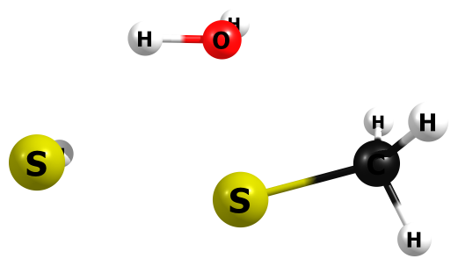

HF/6-311+G(2df,p)

S 2.011827000 -0.169596000 -0.078831000

H 2.186864000 -0.114006000 1.240258000

S -0.596249000 -0.643527000 0.018592000

H 0.613434000 1.404415000 -0.206533000

O -0.348031000 1.411955000 -0.086331000

H -0.527277000 1.815225000 0.752036000

C -2.340558000 -0.166268000 -0.012848000

H -2.652053000 0.395732000 0.857006000

H -2.612082000 0.348460000 -0.921578000

H -2.830526000 -1.137890000 0.010377000

Frequencies -- -462.2305 117.2242 222.4016

Frequencies -- 252.6848 280.5951 285.8328

Frequencies -- 372.4128 391.8568 525.3055

Frequencies -- 706.0636 754.9900 904.0766

Frequencies -- 1040.8011 1045.9534 1468.1093

Frequencies -- 1558.8826 1596.9847 1748.2545

Frequencies -- 2818.8618 3149.7322 3233.0519

Frequencies -- 3283.8160 3554.9774 4101.7734

Zero-point correction= 0.076124 (Hartree/Particle)

Thermal correction to Energy= 0.082744

Thermal correction to Enthalpy= 0.083689

Thermal correction to Gibbs Free Energy= 0.045815

Sum of electronic and zero-point Energies= -911.135963

Sum of electronic and thermal Energies= -911.129343

Sum of electronic and thermal Enthalpies= -911.128399

Sum of electronic and thermal Free Energies= -911.166272

HF=-911.2120872

|  |  |
| --- | --- |
| Method | Energy |
| Gas-MP2/aug-ccpV(T+d)z | -912.0803437 |
| Gas-M062X/aug-ccpV(T+d)z | -913.219467 |
| PCM-Water-MP2/aug-ccpV(T+d)z | -912.0908817 |
| PCM-Water-M062X/aug-ccpV(T+d)z | -913.2324233 |

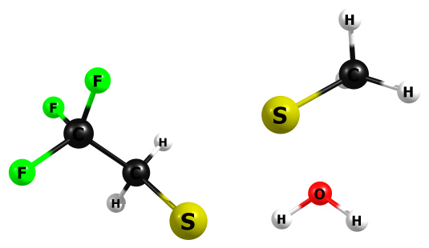

HF/6-311+G(2df,p)

H 4.241624000 -0.959829000 -0.354658000

C 3.375184000 -1.356493000 0.155307000

H 3.519966000 -1.348549000 1.224570000

H 3.212850000 -2.380411000 -0.176826000

S 1.824969000 -0.571954000 -0.339074000

S 0.042837000 1.410500000 -0.321884000

C -1.140492000 0.608880000 0.786316000

H -0.635050000 -0.003053000 1.521336000

H -1.713710000 1.361405000 1.310955000

C -2.128682000 -0.284526000 0.079236000

F -2.877312000 0.363358000 -0.782247000

F -1.545372000 -1.271806000 -0.568532000

F -2.947223000 -0.839085000 0.959678000

H 1.947252000 1.629363000 0.596571000

O 2.741625000 1.086744000 0.498163000

H 3.302263000 1.511023000 -0.137160000

Frequencies -- -458.3503 30.5381 36.8450

Frequencies -- 54.5708 113.3691 159.6114

Frequencies -- 182.3943 264.5495 276.0117

Frequencies -- 287.1855 339.4471 377.3096

Frequencies -- 383.0968 411.3236 582.3065

Frequencies -- 585.9167 694.4648 708.5130

Frequencies -- 748.1617 842.6563 896.5060

Frequencies -- 926.2978 945.7842 1038.7352

Frequencies -- 1045.0908 1207.2682 1268.1808

Frequencies -- 1389.5388 1428.4261 1466.9526

Frequencies -- 1469.8571 1557.4687 1585.7369

Frequencies -- 1595.8151 1746.6536 3149.7994

Frequencies -- 3209.1066 3238.1001 3257.4171

Frequencies -- 3286.6226 3604.0602 4100.9315

Zero-point correction= 0.115031 (Hartree/Particle)

Thermal correction to Energy= 0.126038

Thermal correction to Enthalpy= 0.126983

Thermal correction to Gibbs Free Energy= 0.075800

Sum of electronic and zero-point Energies= -1285.879018

Sum of electronic and thermal Energies= -1285.868011

Sum of electronic and thermal Enthalpies= -1285.867066

Sum of electronic and thermal Free Energies= -1285.918249

HF=-1285.994049

|  |  |
| --- | --- |
| Method | Energy |
| Gas-MP2/aug-ccpV(T+d)z | -1287.970674 |
| Gas-M062X/aug-ccpV(T+d)z | -1289.613129 |
| PCM-Water-MP2/aug-ccpV(T+d)z | -1287.979639 |
| PCM-Water-M062X/aug-ccpV(T+d)z | -1289.624283 |

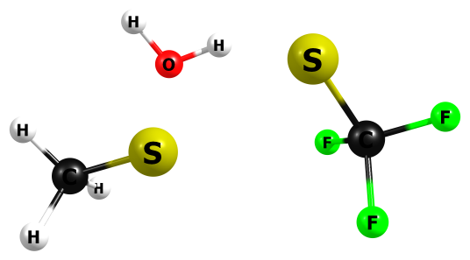

HF/6-311+G(2df,p)

H 3.932356000 0.025112000 0.212080000

C 3.179281000 -0.746025000 0.286709000

H 3.007805000 -1.027185000 1.313630000

H 3.514348000 -1.618754000 -0.273248000

S 1.650337000 -0.357167000 -0.582767000

S -0.654481000 0.924758000 -0.862233000

C -1.634264000 -0.197263000 0.127103000

F -1.250009000 -0.228436000 1.396389000

F -2.904410000 0.145944000 0.131272000

F -1.580622000 -1.443672000 -0.298335000

H 0.727028000 1.502430000 0.767295000

O 1.628490000 1.191564000 0.867952000

H 2.202125000 1.899648000 0.609837000

Frequencies -- -444.8180 39.6704 50.9935

Frequencies -- 63.5362 137.0225 226.5373

Frequencies -- 241.7715 266.7153 297.0958

Frequencies -- 344.6949 374.8046 393.6716

Frequencies -- 508.8540 599.0433 602.7520

Frequencies -- 690.8945 712.0914 816.0574

Frequencies -- 835.0783 1024.9731 1046.8144

Frequencies -- 1245.5984 1271.7289 1294.2583

Frequencies -- 1468.9559 1551.7850 1595.7683

Frequencies -- 1751.5911 3142.7712 3239.7235

Frequencies -- 3295.4629 3799.6997 4111.5076

Zero-point correction= 0.084388 (Hartree/Particle)

Thermal correction to Energy= 0.094326

Thermal correction to Enthalpy= 0.095270

Thermal correction to Gibbs Free Energy= 0.047246

Sum of electronic and zero-point Energies= -1246.857463

Sum of electronic and thermal Energies= -1246.847524

Sum of electronic and thermal Enthalpies= -1246.846580

Sum of electronic and thermal Free Energies= -1246.894605

HF=-1140.8196185

|  |  |
| --- | --- |
| Method | Energy |
| Gas-MP2/aug-ccpV(T+d)z | -1248.734482 |
| Gas-M062X/aug-ccpV(T+d)z | -1250.294778 |
| PCM-Water-MP2/aug-ccpV(T+d)z | -1248.74366 |
| PCM-Water-M062X/aug-ccpV(T+d)z | -1250.305144 |

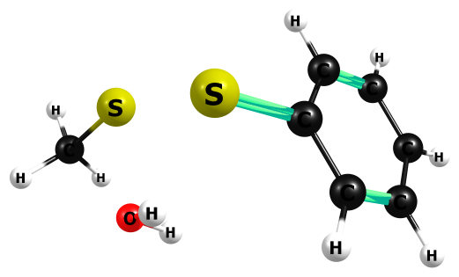

F/6-311+G(2df,p)

S 0.355397000 -1.377769000 -0.929266000

S 2.287128000 0.402219000 -0.447988000

H 1.371033000 -1.282412000 0.959063000

O 1.896725000 -0.564515000 1.337112000

H 1.297343000 -0.033186000 1.844490000

C 3.529486000 1.234605000 0.565723000

H 3.997465000 1.897746000 -0.159404000

H 3.103788000 1.834935000 1.357619000

H 4.269760000 0.552518000 0.954599000

C -1.075698000 -0.496533000 -0.376465000

C -1.555642000 0.595280000 -1.093757000

C -1.758924000 -0.874291000 0.775549000

C -2.668502000 1.290911000 -0.665161000

C -2.873032000 -0.177207000 1.202977000

C -3.332172000 0.911819000 0.487117000

H -1.052487000 0.891558000 -1.994604000

H -1.425502000 -1.733901000 1.328092000

H -3.021174000 2.130394000 -1.236678000

H -3.387470000 -0.492505000 2.092873000

H -4.200062000 1.452248000 0.817215000

Frequencies -- -467.0620 31.6340 42.8678

Frequencies -- 48.5014 133.9908 192.6913

Frequencies -- 232.2117 278.5592 285.5389

Frequencies -- 312.1270 353.4726 374.4314

Frequencies -- 445.8477 456.2336 538.2956

Frequencies -- 674.9133 711.2716 759.4568

Frequencies -- 767.8628 774.1181 835.5007

Frequencies -- 898.4123 949.3059 1026.8705

Frequencies -- 1039.4604 1044.5777 1078.8109

Frequencies -- 1100.6377 1110.9093 1114.2039

Frequencies -- 1164.9874 1181.5021 1192.5336

Frequencies -- 1287.0363 1306.4639 1446.4015

Frequencies -- 1469.1393 1558.2508 1581.1103

Frequencies -- 1595.7443 1629.7535 1739.4587

Frequencies -- 1758.9801 1763.7371 3150.5208

Frequencies -- 3236.1026 3285.0011 3304.3201

Frequencies -- 3312.9034 3324.9740 3336.1265

Frequencies -- 3344.4793 3612.6392 4094.4292

Zero-point correction= 0.164687 (Hartree/Particle)

Thermal correction to Energy= 0.175512

Thermal correction to Enthalpy= 0.176456

Thermal correction to Gibbs Free Energy= 0.125944

Sum of electronic and zero-point Energies= -1140.654931

Sum of electronic and thermal Energies= -1140.644107

Sum of electronic and thermal Enthalpies= -1140.643162

Sum of electronic and thermal Free Energies= -1140.693674

HF=-1140.8196185

|  |  |
| --- | --- |
| Method | Energy |
| Gas-MP2/aug-ccpV(T+d)z | -1142.649483 |
| Gas-M062X/aug-ccpV(T+d)z | -1144.256783 |
| PCM-Water-MP2/aug-ccpV(T+d)z | -1142.659244 |
| PCM-Water-M062X/aug-ccpV(T+d)z | -1144.269578 |

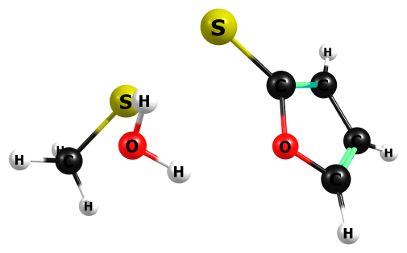

HF/6-311+G(2df,p)

O 1.296791000 -0.727856000 0.629498000

C 1.322323000 0.498696000 0.039170000

C 2.393088000 0.574254000 -0.767475000

C 2.370051000 -1.421991000 0.190189000

H 2.665449000 1.419601000 -1.360552000

H 2.487244000 -2.412107000 0.571587000

C 3.082039000 -0.683435000 -0.658890000

H 3.982257000 -0.979487000 -1.154377000

S 0.062482000 1.624471000 0.424961000

S -1.978768000 0.260984000 -0.600184000

H -1.191052000 0.110754000 1.699943000

O -1.499354000 -0.649500000 1.210337000

H -0.696550000 -1.134099000 1.039792000

C -3.241512000 -1.029275000 -0.597298000

H -3.756114000 -0.828192000 -1.535724000

H -2.828196000 -2.026409000 -0.630519000

H -3.937885000 -0.927995000 0.220547000

Frequencies -- -444.8849 47.3331 59.4496

Frequencies -- 101.2536 140.1821 223.1637

Frequencies -- 226.8087 277.7145 279.7076

Frequencies -- 290.8162 350.8972 389.0480

Frequencies -- 519.9978 651.4628 713.0028

Frequencies -- 726.6697 832.6736 835.9621

Frequencies -- 914.5866 917.7562 964.5714

Frequencies -- 995.5470 1004.9508 1032.1802

Frequencies -- 1046.1669 1086.2852 1174.5801

Frequencies -- 1183.6122 1266.1676 1334.8622

Frequencies -- 1469.4073 1508.7203 1555.6526

Frequencies -- 1595.4908 1633.0580 1741.4572

Frequencies -- 1789.4339 3147.2664 3243.6349

Frequencies -- 3290.9014 3388.6843 3411.0644

Frequencies -- 3427.6156 3910.7291 4003.2038

Zero-point correction= 0.133737 (Hartree/Particle)

Thermal correction to Energy= 0.143751

Thermal correction to Enthalpy= 0.144696

Thermal correction to Gibbs Free Energy= 0.096927

Sum of electronic and zero-point Energies= -1138.624584

Sum of electronic and thermal Energies= -1138.614570

Sum of electronic and thermal Enthalpies= -1138.613626

Sum of electronic and thermal Free Energies= -1138.661395

HF=-1138.7583214

|  |  |
| --- | --- |
| Method | Energy |
| Gas-MP2/aug-ccpV(T+d)z | -1140.500968 |
| Gas-M062X/aug-ccpV(T+d)z | -1142.055803 |
| PCM-Water-MP2/aug-ccpV(T+d)z | -1140.508591 |
| PCM-Water-M062X/aug-ccpV(T+d)z | -1142.066147 |

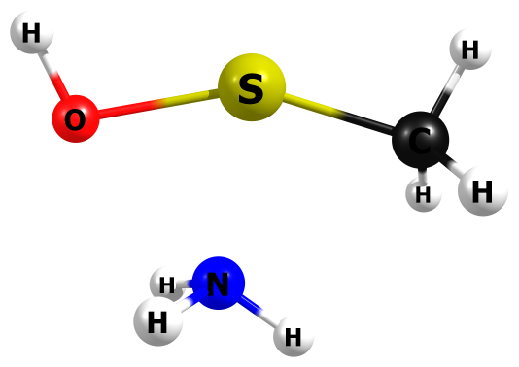

HF/6-311+G(2df,p)

H 0.725686000 1.592522000 0.855401000

N 0.252714000 1.409326000 -0.006552000

S -0.082326000 -0.659405000 -0.039512000

H -0.551990000 1.994432000 -0.105860000

O 1.757440000 -0.306573000 0.009800000

H 2.127022000 -1.145438000 0.230434000

H 0.907438000 1.566896000 -0.746113000

C -1.847258000 -0.112044000 0.035788000

H -2.104831000 0.408565000 0.951315000

H -2.166611000 0.461854000 -0.827234000

H -2.364461000 -1.068786000 0.026980000

Frequencies -- -463.5392 59.7318 165.9210

Frequencies -- 230.2003 318.2113 372.8890

Frequencies -- 422.3046 508.1278 649.3944

Frequencies -- 712.7834 823.7050 986.1298

Frequencies -- 1026.4342 1087.6597 1336.5377

Frequencies -- 1435.6158 1570.1521 1598.7935

Frequencies -- 1749.0535 1775.6319 3133.0099

Frequencies -- 3210.5564 3220.7320 3689.5735

Frequencies -- 3821.0867 3831.6274 4146.7740

Zero-point correction= 0.095416 (Hartree/Particle)

Thermal correction to Energy= 0.101874

Thermal correction to Enthalpy= 0.102818

Thermal correction to Gibbs Free Energy= 0.065554

Sum of electronic and zero-point Energies= -568.617889

Sum of electronic and thermal Energies= -568.611431

Sum of electronic and thermal Enthalpies= -568.610487

Sum of electronic and thermal Free Energies= -568.647751

HF=-568.713305

|  |  |
| --- | --- |
| Method | Energy |
| Gas-MP2/aug-ccpV(T+d)z | -569.6228707 |
| Gas-M062X/aug-ccpV(T+d)z | -570.3745548 |
| PCM-Water-MP2/aug-ccpV(T+d)z | -569.6370743 |
| PCM-Water-M062X/aug-ccpV(T+d)z | -570.3885535 |

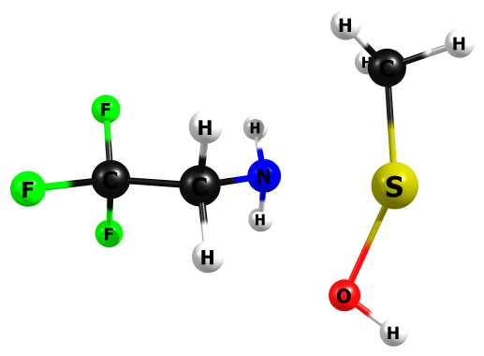

HF/6-311+G(2df,p)

H 2.317400000 2.059053000 -1.018890000

C 2.385117000 1.712608000 0.006132000

H 1.635743000 2.201534000 0.618517000

H 3.368509000 1.972228000 0.390937000

S 2.425580000 -0.129054000 0.171237000

N 0.448298000 0.071013000 -0.536314000

C -0.513527000 -0.077712000 0.543465000

H -0.373762000 -1.047650000 0.991723000

H -0.346419000 0.687431000 1.288460000

C -1.941023000 0.046689000 0.064739000

F -2.159184000 1.222710000 -0.494111000

F -2.240152000 -0.866926000 -0.831065000

F -2.776044000 -0.079098000 1.066858000

H 0.325182000 0.936580000 -1.023480000

H 0.386340000 -0.697192000 -1.174978000

O 1.665543000 -1.838860000 -0.054033000

H 2.410311000 -2.413006000 0.013231000

Frequencies -- -430.5481 47.5470 58.5274

Frequencies -- 91.1866 130.6419 148.8087

Frequencies -- 208.8720 232.5879 316.4456

Frequencies -- 364.5310 388.3369 418.8428

Frequencies -- 455.2332 528.2680 588.3531

Frequencies -- 604.4690 645.6820 729.5025

Frequencies -- 793.8018 915.4775 973.8690

Frequencies -- 986.7227 1035.8795 1074.6420

Frequencies -- 1159.2770 1222.4677 1252.7945

Frequencies -- 1347.5337 1390.2492 1415.0432

Frequencies -- 1438.8175 1508.7753 1558.4606

Frequencies -- 1570.9939 1598.0693 1614.4704

Frequencies -- 1773.4057 3136.2373 3213.9709

Frequencies -- 3224.2700 3242.7351 3315.8713

Frequencies -- 3712.1300 3803.0894 4149.0783

Zero-point correction= 0.133013 (Hartree/Particle)

Thermal correction to Energy= 0.143388

Thermal correction to Enthalpy= 0.144332

Thermal correction to Gibbs Free Energy= 0.095780

Sum of electronic and zero-point Energies= -943.359411

Sum of electronic and thermal Energies= -943.349036

Sum of electronic and thermal Enthalpies= -943.348091

Sum of electronic and thermal Free Energies= -943.396644

HF=-943.4924237

|  |  |
| --- | --- |
| Method | Energy |
| Gas-MP2/aug-ccpV(T+d)z | -945.5063506 |
| Gas-M062X/aug-ccpV(T+d)z | -946.7640979 |
| PCM-Water-MP2/aug-ccpV(T+d)z | -945.5179352 |
| PCM-Water-M062X/aug-ccpV(T+d)z | -946.7755 |

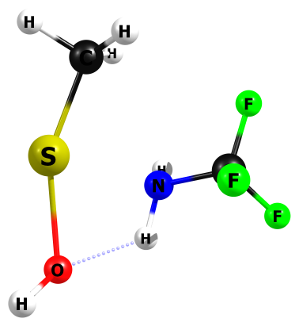

HF/6-311+G(2df,p)

C 1.314527000 -0.062013000 0.012986000

F 1.162143000 -0.161892000 1.298669000

F 2.273489000 -0.880266000 -0.348172000

F 1.702838000 1.151367000 -0.277292000

N 0.103149000 -0.375870000 -0.664528000

S -1.812992000 0.150582000 0.041988000

C -1.205922000 1.876563000 -0.015013000

H -0.861009000 2.195957000 -0.990137000

H -2.128995000 2.405888000 0.217280000

H -0.474720000 2.116412000 0.742955000

H 0.172855000 -0.106757000 -1.627850000

O -1.647696000 -1.840892000 -0.070222000

H -2.013816000 -2.167930000 0.733217000

H -0.124775000 -1.364833000 -0.580475000

Frequencies -- -470.8545 28.4998 78.5396

Frequencies -- 152.1005 176.0027 230.9640

Frequencies -- 270.9703 318.2687 332.1805

Frequencies -- 372.3801 458.4072 512.7576

Frequencies -- 602.4808 669.2676 676.4791

Frequencies -- 700.1228 818.0606 889.3855

Frequencies -- 962.9185 1011.7907 1023.5676

Frequencies -- 1180.7655 1216.4893 1361.8124

Frequencies -- 1415.7211 1461.3903 1515.6401

Frequencies -- 1563.4600 1599.8559 1780.5836

Frequencies -- 3140.7504 3222.5718 3270.0397

Frequencies -- 3417.8472 3753.7882 4169.2839

Zero-point correction= 0.101048 (Hartree/Particle)

Thermal correction to Energy= 0.110165

Thermal correction to Enthalpy= 0.111110

Thermal correction to Gibbs Free Energy= 0.065662

Sum of electronic and zero-point Energies= -904.335871

Sum of electronic and thermal Energies= -904.326754

Sum of electronic and thermal Enthalpies= -904.325810

Sum of electronic and thermal Free Energies= -904.371258

HF=-904.4369199

|  |  |
| --- | --- |
| Method | Energy |
| Gas-MP2/aug-ccpV(T+d)z | -906.2737748 |
| Gas-M062X/aug-ccpV(T+d)z | -907.4477682 |
| PCM-Water-MP2/aug-ccpV(T+d)z | -906.2851233 |
| PCM-Water-M062X/aug-ccpV(T+d)z | -907.4594459 |

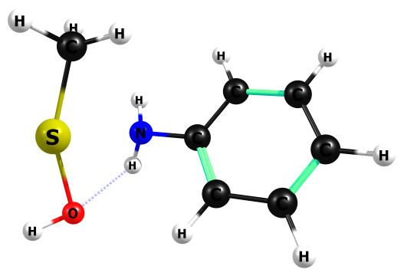

HF/6-311+G(2df,p)

N 0.719762000 0.125801000 0.993843000

S 2.291073000 0.024674000 -0.457845000

H 0.845794000 0.949809000 1.545498000

O 2.124642000 -1.679443000 0.403493000

H 2.979800000 -2.057689000 0.285049000

H 0.992448000 -0.683838000 1.516519000

C -0.617956000 0.025900000 0.504720000

C -1.026862000 -1.146361000 -0.109510000

C -1.489288000 1.088764000 0.626838000

C -2.314997000 -1.243900000 -0.589005000

C -2.778522000 0.983395000 0.135862000

C -3.195891000 -0.181783000 -0.471038000

H -0.329575000 -1.955787000 -0.211979000

H -1.170667000 1.997838000 1.105564000

H -2.632574000 -2.153739000 -1.063727000

H -3.452376000 1.814208000 0.234248000

H -4.196967000 -0.265134000 -0.850873000

C 1.878684000 1.810519000 -0.639677000

H 0.864082000 1.996798000 -0.964658000

H 2.115091000 2.406385000 0.234828000

H 2.561296000 2.092100000 -1.438931000

Frequencies -- -466.5893 44.2506 73.0440

Frequencies -- 102.5741 116.1649 234.8117

Frequencies -- 245.4703 310.1503 327.0669

Frequencies -- 375.5434 388.2872 457.9515

Frequencies -- 507.4296 580.3303 590.9601

Frequencies -- 655.5362 678.6709 768.9021

Frequencies -- 801.3749 849.5805 867.2209

Frequencies -- 946.4248 991.9635 1006.0448

Frequencies -- 1029.9260 1051.0920 1082.7534

Frequencies -- 1101.9971 1118.9624 1123.0348

Frequencies -- 1165.5764 1169.2627 1189.3998

Frequencies -- 1265.1511 1289.3586 1331.4564

Frequencies -- 1357.3747 1438.6894 1488.8019

Frequencies -- 1568.0678 1599.9236 1622.5065

Frequencies -- 1654.5728 1775.9863 1781.4163

Frequencies -- 1790.9999 3138.3613 3209.3666

Frequencies -- 3250.7765 3307.6737 3320.6129

Frequencies -- 3332.2885 3345.4987 3356.3420

Frequencies -- 3697.6965 3799.8550 4152.2574

Zero-point correction= 0.181859 (Hartree/Particle)

Thermal correction to Energy= 0.191975

Thermal correction to Enthalpy= 0.192919

Thermal correction to Gibbs Free Energy= 0.145317

Sum of electronic and zero-point Energies= -798.134625

Sum of electronic and thermal Energies= -798.124509

Sum of electronic and thermal Enthalpies= -798.123565

Sum of electronic and thermal Free Energies= -798.171167

HF=-798.3164841

|  |  |
| --- | --- |
| Method | Energy |
| Gas-MP2/aug-ccpV(T+d)z | -800.1845263 |
| Gas-M062X/aug-ccpV(T+d)z | -801.4080323 |
| PCM-Water-MP2/aug-ccpV(T+d)z | -800.1967059 |
| PCM-Water-M062X/aug-ccpV(T+d)z | -801.4202857 |

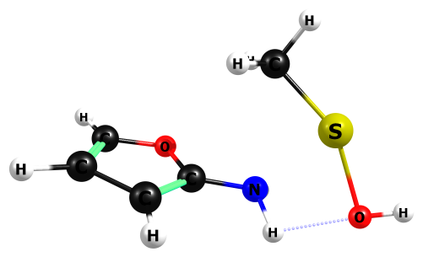

HF/6-311+G(2df,p)

N 0.480107000 -0.754445000 -0.335258000

S 2.081077000 0.507867000 0.200234000

H 0.821705000 -1.571039000 0.133883000

O 2.691701000 -1.318195000 -0.185539000

H 3.628184000 -1.223075000 -0.210238000

H 0.654628000 -0.895184000 -1.311462000

C -0.867202000 -0.497750000 -0.070677000

O -1.539387000 0.140498000 -1.023089000

C -1.636205000 -0.749310000 0.991525000

C -2.924720000 -0.200823000 0.654269000

C -2.797200000 0.318607000 -0.567033000

H -1.343700000 -1.242977000 1.892991000

H -3.809362000 -0.206929000 1.253751000

H -3.471614000 0.818939000 -1.224562000

C 0.838728000 1.859156000 0.239612000

H 0.403986000 2.084010000 -0.724555000

H 0.067381000 1.752005000 0.989066000

H 1.491893000 2.681781000 0.527034000

Frequencies -- -421.2137 26.1141 84.2873

Frequencies -- 104.0858 120.1103 236.3195

Frequencies -- 289.7591 312.7120 356.1690

Frequencies -- 364.5746 381.9747 490.6458

Frequencies -- 654.3225 666.9002 730.1074

Frequencies -- 752.7246 788.1554 850.2986

Frequencies -- 923.0421 960.6249 970.4263

Frequencies -- 1002.5846 1010.4268 1014.8584

Frequencies -- 1060.2908 1087.9965 1165.5571

Frequencies -- 1224.8327 1249.3115 1273.3585

Frequencies -- 1363.2783 1418.3996 1443.4683

Frequencies -- 1561.2687 1576.1409 1605.2048

Frequencies -- 1689.8281 1742.5785 1798.2933

Frequencies -- 3141.7216 3227.8652 3268.2447

Frequencies -- 3397.2606 3409.1423 3441.8065

Frequencies -- 3716.3640 3787.2121 4165.0907

Zero-point correction= 0.150144 (Hartree/Particle)

Thermal correction to Energy= 0.159648

Thermal correction to Enthalpy= 0.160592

Thermal correction to Gibbs Free Energy= 0.113983

Sum of electronic and zero-point Energies= -796.095937

Sum of electronic and thermal Energies= -796.086433

Sum of electronic and thermal Enthalpies= -796.085489

Sum of electronic and thermal Free Energies= -796.132099

HF=-796.2460812

|  |  |
| --- | --- |
| Method | Energy |
| Gas-MP2/aug-ccpV(T+d)z | -798.026576 |
| Gas-M062X/aug-ccpV(T+d)z | -799.1958106 |
| PCM-Water-MP2/aug-ccpV(T+d)z | -798.0396 |
| PCM-Water-M062X/aug-ccpV(T+d)z | -799.2087661 |